**CMA’s XBRL Based Electronic Filing Platform**

**IFSAH**

**Case Study for Real Estate firm**

Version 1.0



Contents

1. Creating a filing 3

2. Filing information 4

3. Statement of financial position 5

4. Income Statement 8

5. Statement of Comprehensive Income 11

6. Statement of Cash Flows, Indirect method 13

7. Statement of Changes in Equity 16

## Creating a filing

On opening the iFile Tool, the filer can click on the ‘Click here to Create Filing’ button.

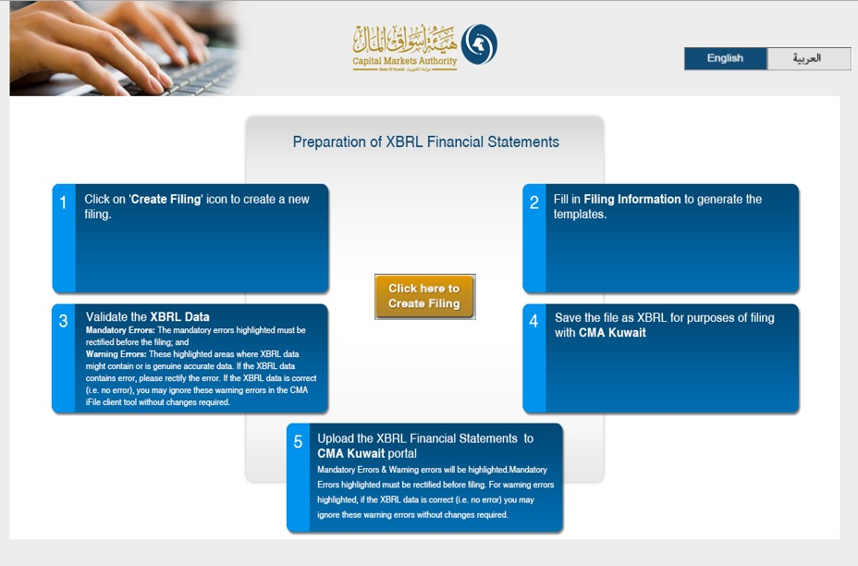

## Filing information

By clicking on the ‘Click here to Create Filing’ button, the user will be redirected to the CMA iFile pop-up, where he/she will be required to input information about the reporting entity.

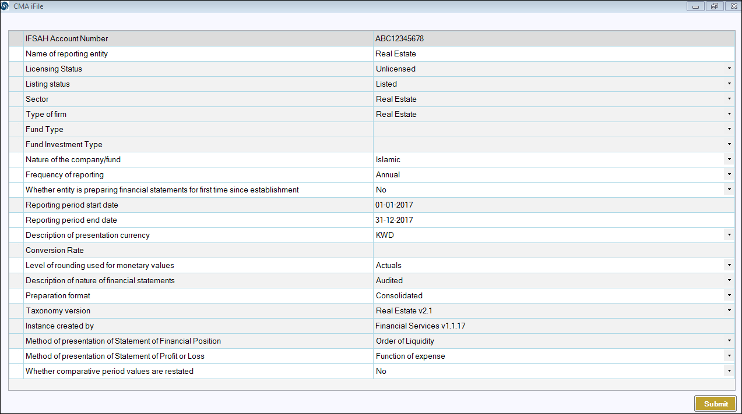

For Real Estate firms, ‘Method of presentation of Statement of Financial Position’, are restricted to ‘Order of Liquidity’, and are selected by default.



## Statement of financial position

Following is a snapshot of the company’s Statement of Final Position, from their annual report.

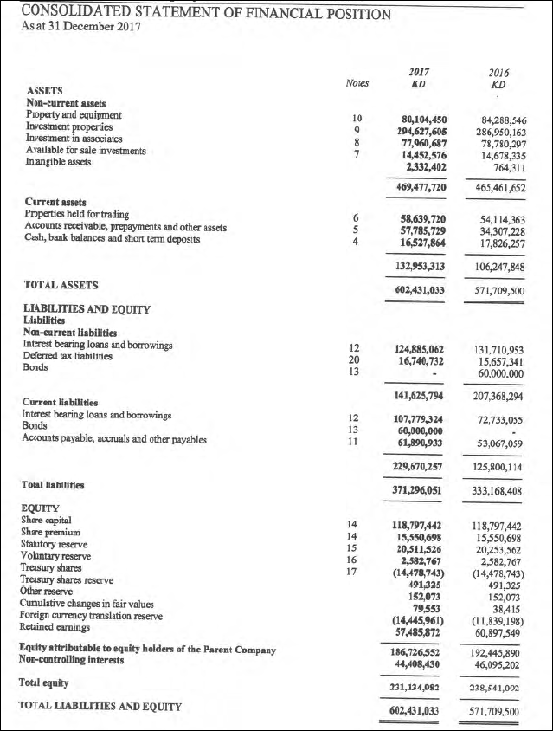

The company also reports a Treasury shares in the Statement of financial position. As the financial concept for ‘Treasury shares’ used in iFile has a debit balance, representing a negative impact on total equity (which has Credit balance). Hence, even though value of treasury shares is shown as negative in the report (as shown in the extract of report above), it is entered as positive in iFile. This is shown as follows:

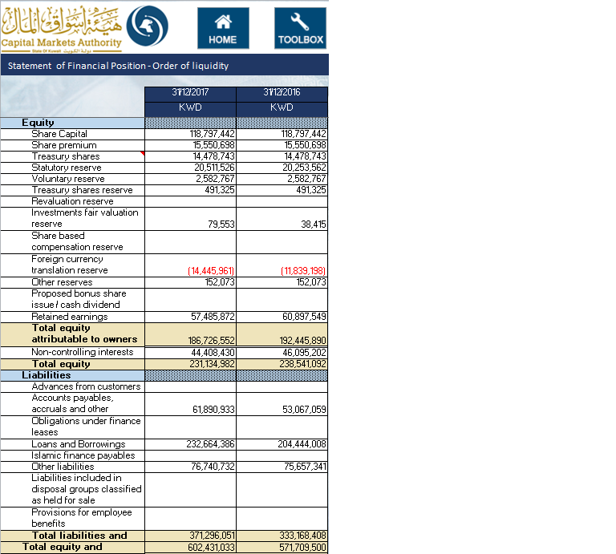

Following is the list of business concepts for which mandatory inputs are required. In the event that the company does not have any inputs, the user can input ‘0’, and the same will be displayed in the final filing document.

* Total assets
* Total equity
* Total liabilities
* Cash and cash equivalents
* Issued capital
* Retained earnings

Additionally, for the following concepts, when the user enters a positive value in the CMA iFile, that value will be deducted from the total, and vice-versa. For example, if the user enters positive value for ‘Treasury shares cost’, the value will be deducted from the total concept ‘Total equity’, and vice versa.

An element that has a negative effect on the total is “Treasury shares”.

## Income Statement

Following is the Statement of Income from the Report:

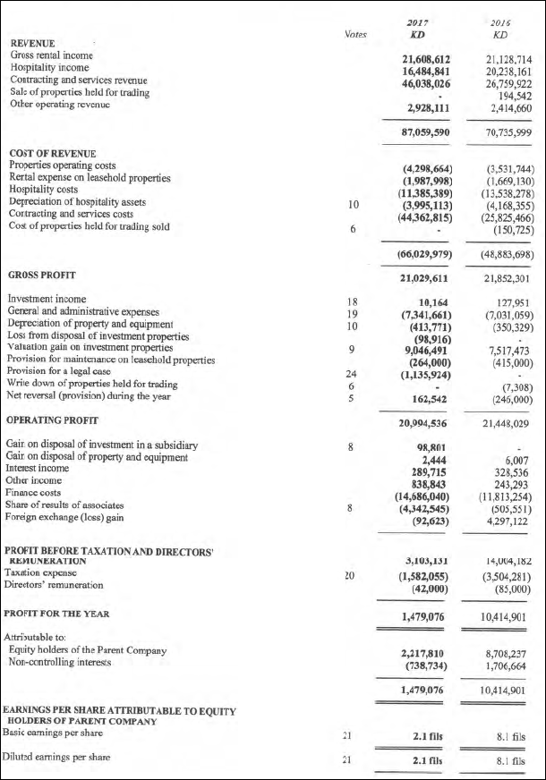

The iFile tool contains two statements for the Consolidated Statement of Income, User can prepare Income Statement by any one method: (a) Function of expense, or (b) Nature of expense

The details in CMA iFile are inputted as follows:

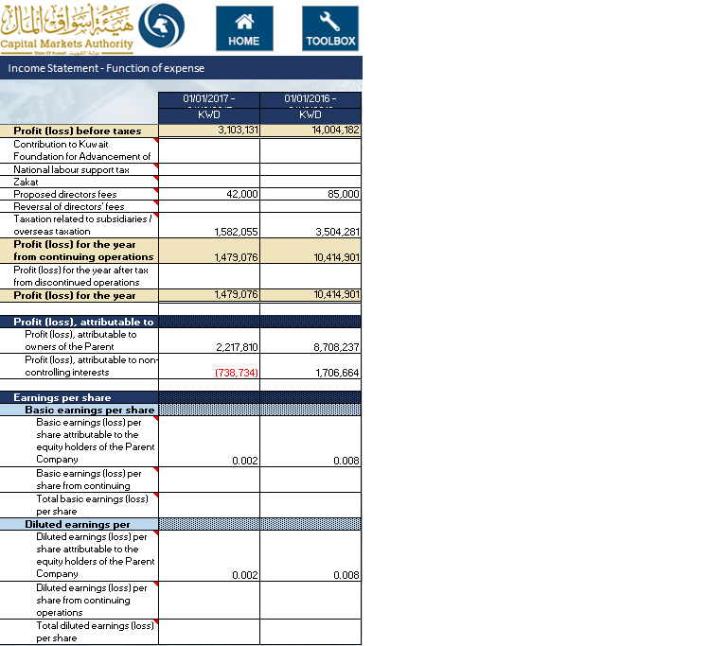

Profit (loss) for the year after tax from discontinued operations is shown after ‘PROFIT (LOSS) FOR THE YEAR FROM CONTINUING OPERATIONS’. However, as per the format of CMA iFile, profit (loss) from continuing operations is shown as part of Revenue (as shown above).

*Kindly note that in the CMA iFile, the earnings per share are shown in Kuwaiti Dinar (KWD). As the company has reported earnings per share in fils, the same has been converted in KWD and entered in iFile as shown above.*

Following is the list of business concepts for which mandatory inputs are required. In the event that the company does not have any inputs, the user can input ‘0’, and the same will be displayed in the final filing document.

* Total revenue
* Total expenses
* Net profit (loss)

Following is the list of elements that have a negative effect on the total:

* Total costs and expenses
* Zakat

## Statement of Comprehensive Income

Following is the Statement of Comprehensive Income from the Report:

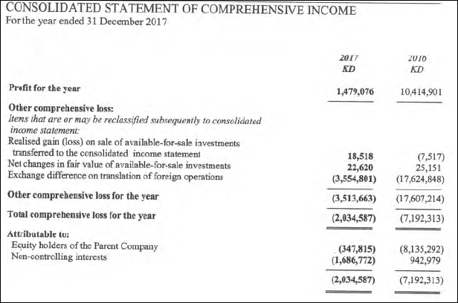

*Kindly note the following:*

* *The concept ‘Realised gain (loss) on sale of available- for-sale investments’, is the same as the following concept in CMA iFile – ‘Net transfer to consolidated income statement on disposal.*
* *The concept in CMA iFile – ‘Net transfer to consolidated income statement on impairment’. Both these concepts have debit balance. As a result, these concepts will have negative impact on other comprehensive income, which has credit balance. Hence, the values entered in iFile are added taking into account the calculation relationship as per the balance type as shown below:*

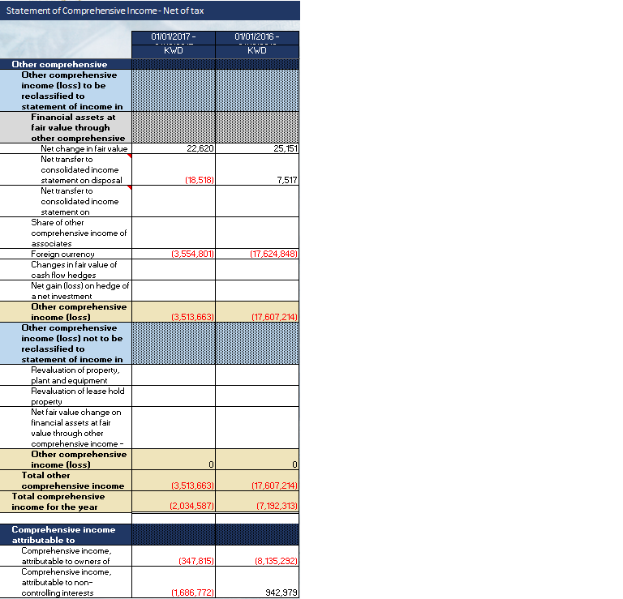

Following is the list of elements that have a negative effect on the total:

* Net transfer to consolidated income statement on disposal
* Net transfer to consolidated income statement on impairment

## Statement of Cash Flows, Indirect method

Following is the Statement of Cash Flows from the Report:

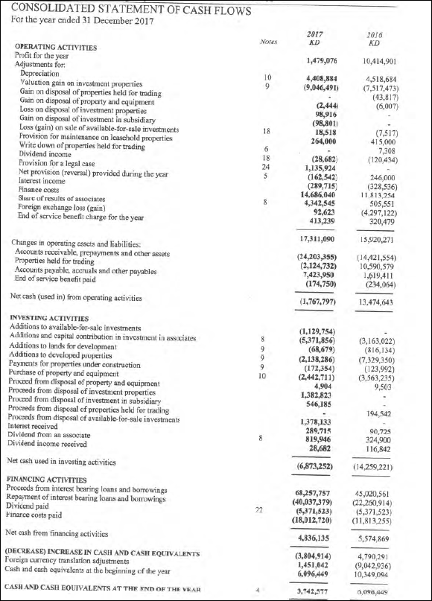

The details in CMA iFile are inputted as follows:

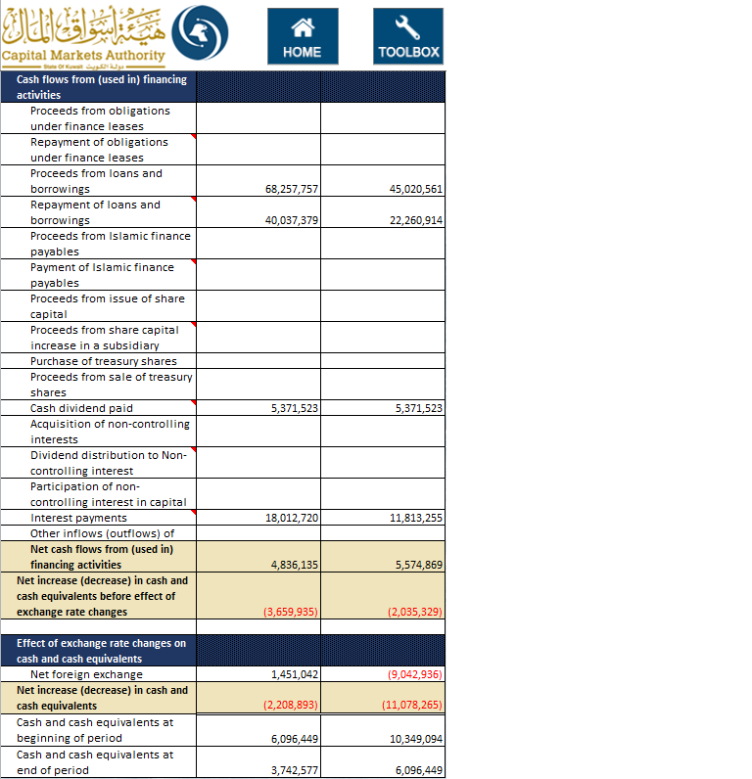

*Kindly note the following:*

List of elements that have a negative effect on the totals:

* Employees end of service benefits paid
* Purchase of investments securities
* Purchase of trading properties
* Purchase / addition of investment properties
* Purchase of property, plant and equipment
* Purchase of intangible assets
* Purchase of leasehold rights
* Acquisition of Investments in associates
* Net cash inflow (outflow) on acquisition of subsidiary
* Repayment of obligations under finance leases
* Repayment of loans and borrowings
* Payment of Islamic finance payables
* Proceeds from share capital increase in a subsidiary
* Cash dividend paid
* Dividend distribution to Non-controlling interest
* Interest payments

## Statement of Changes in Equity

Following is the Statement of Changes in Equity from the Report:

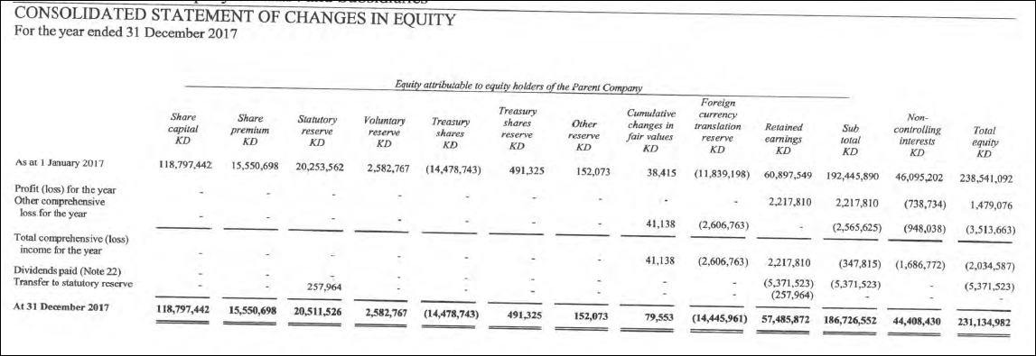

The details inputted in CMA iFile are as follows:

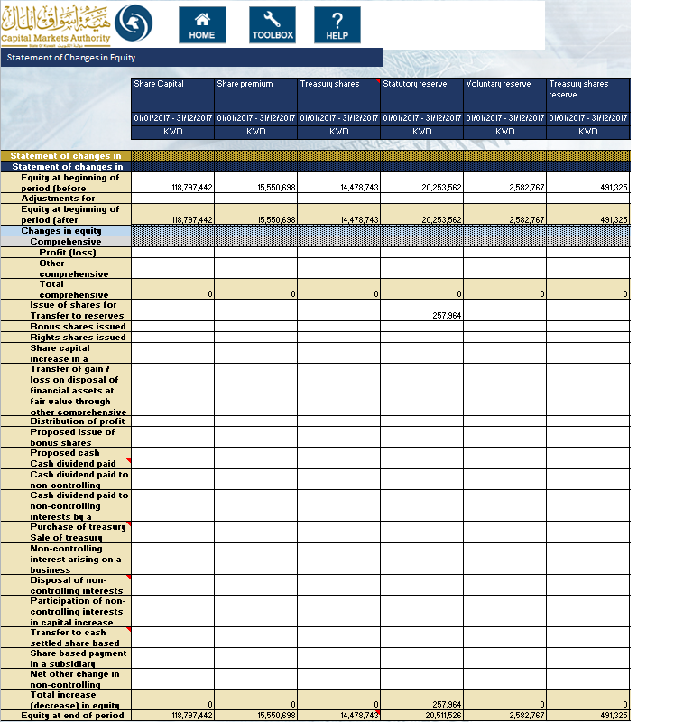

*Note: The concept ‘Treasury shares cost’ Column is subtracted from the Total equity calculation; therefore the amounts have been entered in positive as shown above.*

Kindly note the following:

List of elements that have a negative effect on the totals:

* Proposed issue of bonus shares
* Proposed cash dividends
* Cash dividend paid
* Purchase of treasury shares
* Disposal of non-controlling interests
* Transfer to cash settled share based compensation
* Total of Treasury Shares Column is deducted from the Total of Equity.

When the value for ‘Preparation format’ in Filing information selected is “Standalone” then Total equity attributable to the parent company and Non-Controlling interests column will be disabled.

The information input in this template will have to match that inputted as part of the information inputted in the Balance Sheet.

* The value reported for ‘Share capital’ in the Statement of changes in equity template must equal the value for ‘Share capital’ in the Statement of financial position template
* The value reported for ‘Share premium’ in the Statement of changes in equity template must equal the value for ‘Share premium’ in the Statement of financial position template
* The value reported for ‘Treasury shares’ in the Statement of changes in equity template must equal the value for ‘Treasury shares’ in the Statement of financial position template
* The value reported for ‘Statutory reserve’ in the Statement of changes in equity template must equal the value for ‘Statutory reserve’ in the Statement of financial position template
* The value reported for ‘Voluntary reserve’ in the Statement of changes in equity template must equal the value for ‘Voluntary reserve’ the Statement of financial position template
* The value reported for ‘Treasury share reserve’ in the Statement of changes in equity template must equal the value for ‘Treasury share reserve’ the Statement of financial position template
* The value reported for ‘Revaluation reserve’ in the Statement of changes in equity template must equal the value for ‘Revaluation reserve’ the Statement of financial position template
* The value reported for ‘Investment fair valuation reserve’ in the Statement of changes in equity template must equal the value for ‘Investment fair valuation reserve’ the Statement of financial position template
* The value reported for ‘Share based compensation reserve’ in the Statement of changes in equity template must equal the value for ‘Share based compensation reserve’ the Statement of financial position template
* The value reported for ‘Foreign currency translation reserve’ in the Statement of changes in equity template must equal the value for ‘Foreign currency translation reserve’ the Statement of financial position template
* The value reported for ‘Other reserves’ in the Statement of changes in equity template must equal the value for ‘Other reserves’ the Statement of financial position template
* The value reported for ‘Proposed bonus issue or cash dividend’ in the Statement of changes in equity template must equal the value for ‘Proposed bonus issue or cash dividend’ the Statement of financial position template
* The value reported for ‘Retained earnings’ in the Statement of changes in equity template must equal the value for ‘Retained earnings’ the Statement of financial position template
* The value reported for ‘Total equity attributable to the Parent Company’ in the Statement of changes in equity template must equal the value for ‘Total equity attributable to the Parent Company’ the Statement of financial position template (only in case of Consolidated)
* The value reported for ‘Non-controlling interests’ in the Statement of changes in equity template must equal the value for ‘Non-controlling interests’ the Statement of financial position template (only in case of Consolidated)