**CMA’s XBRL Based Electronic Filing Platform**

**IFSAH**

**Case Study for Mutual Fund Firms**

Version 1.0



Contents

1. Creating a filing 3

2. Filing information 4

3. Statement of financial position 5

4. Income Statement 12

5. Statement of Comprehensive Income 15

6. Statement of Cash Flows 17

7. Statement of Changes in Equity 18

8. Notes to Financial Statements 22

9. Fair Value through Profit and Loss Investments 23

10. Financial Assets at Fair Value through Other Comprehensive Income 25

11. Financial Assets Carried at Amortized Cost 26

12. Investments in Associates 26

13. Investment and Held for Trading Properties 27

14. Money Market Products 28

## Creating a filing

On opening the iFile Tool, the filer can click on the ‘Click here to Create Filing’ button.

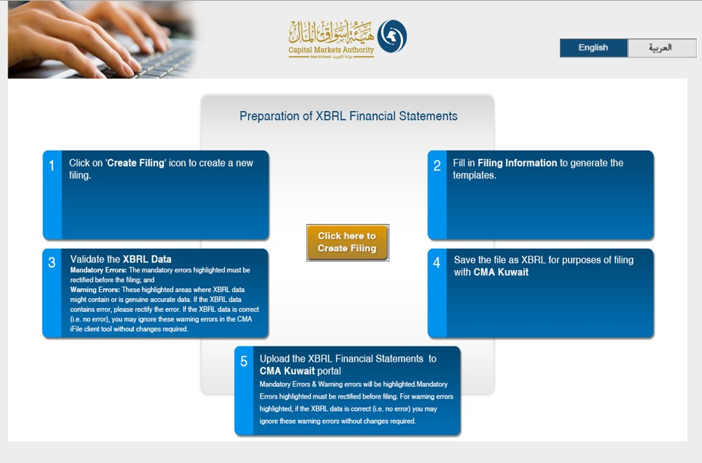

## Filing information

By clicking on the ‘Click here to Create Filing’ button, the user will be redirected to the CMA iFile pop-up, where he/she will be required to input information about the reporting entity.

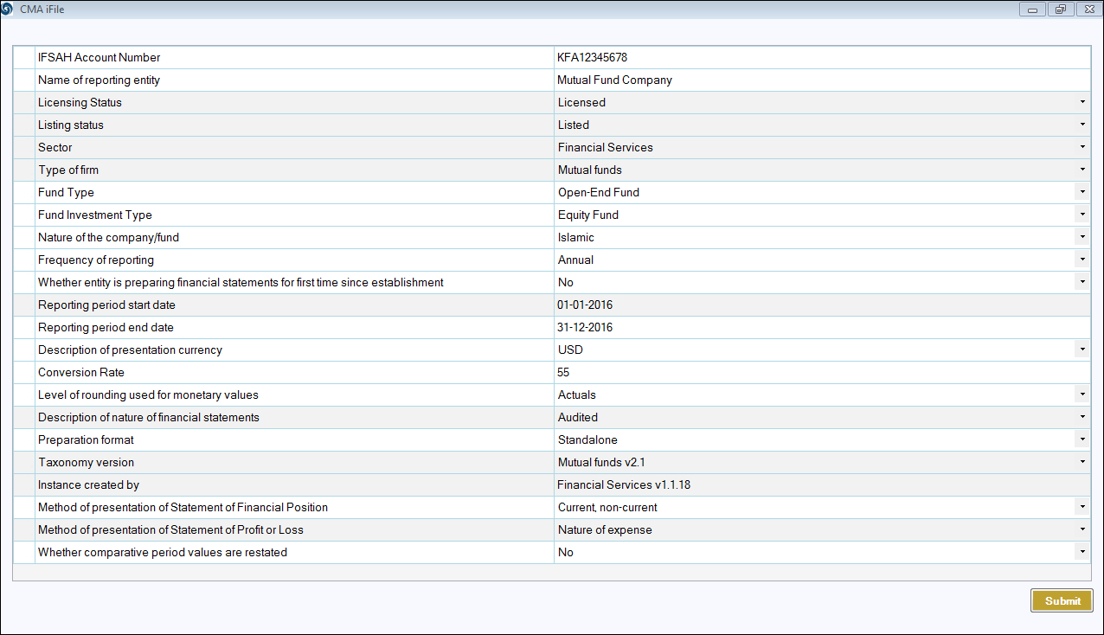

Based on the ‘Method of presentation of Statement of Financial Position’, the filing templates will be generated. In this case, the filer has input current, non-current.



## Statement of financial position

Following is a snapshot of the company’s Statement of Final Position, from their annual report.

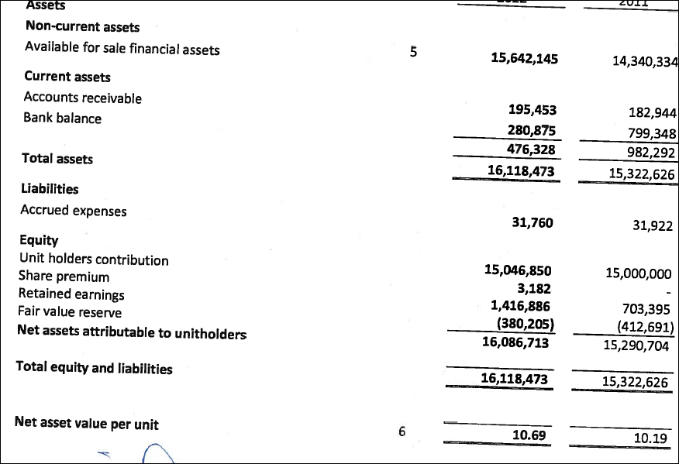

The iFile tool contains two statements for the Statement of Financial Position:

* Statement of financial position, the main statement.
* Subclassifications of assets, liabilities and equity, the sub-classification statement.

Some of the concepts in the main statement will be linked to the subclassification statement. For example, ‘Cash and Cash Equivalents’ is linked to the subclassification.

Following is the extract of the subclassification of ‘Cash and Cash Equivalents’ as filled in iFile based on the data available in report:

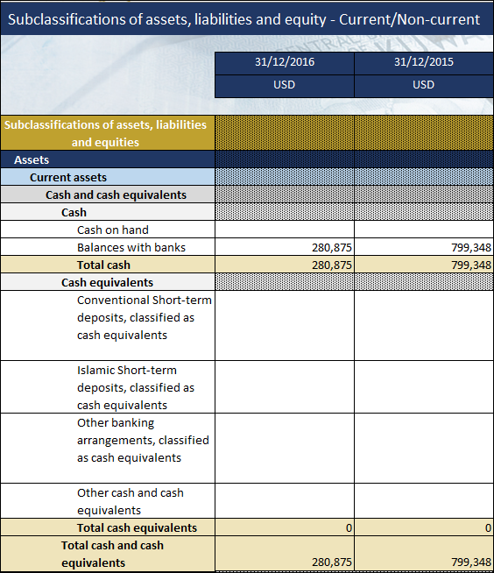

The total will be reflected as shown in the report and will be shown in the main statement of iFile as follows:

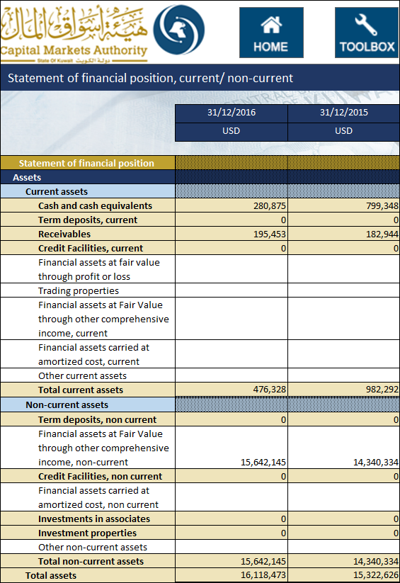

Similarly, the user can fill other details in statement ‘Subclassification of assets, liabilities and equity’. Following is an example of ‘Current liabilities and equity’ provided in the subclassification:

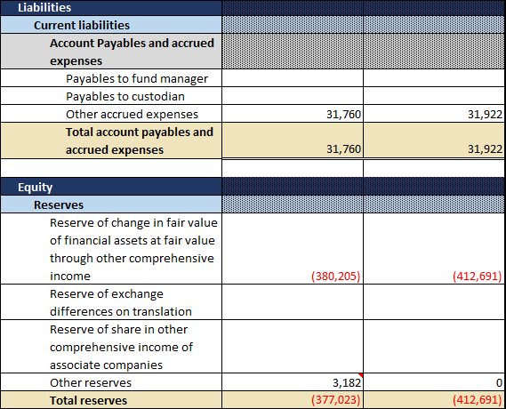

Note : Share premium value is mapped in Other reserves, with a footnote to it stating it’s a share premium.

The above details are reflected in the main statement as follows:

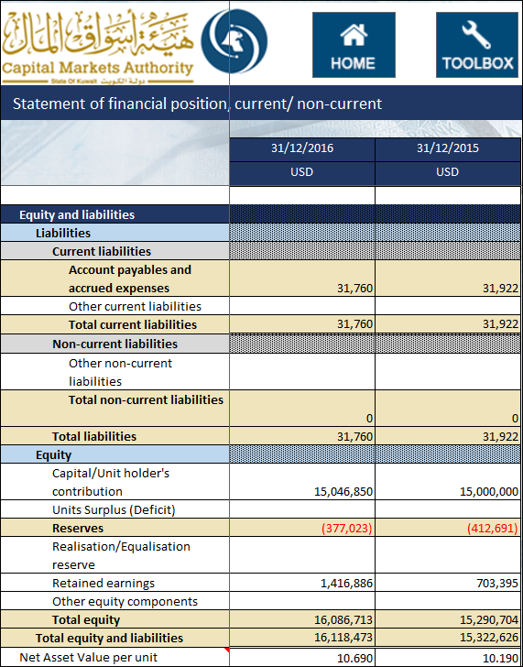

The User can input the values for all other concepts directly in the main statement where sub-classification is not required.

The Values in the concepts highlighted in light brown are automatically updated in the main statement when the value is entered in the sub classification statement, except the Totals. By the side of the concepts, linking have been done as ‘*Go to the relevant concepts*’. When the user clicks at ‘Go to the relevant concepts’ the user is directed to the statement from where the values has been derived and vice-versa.

List is as follows:-

* Cash and cash equivalents
* Term deposits
* Term deposits, current
* Receivables
* Credit facilities
* Term deposits, non-current
* Investment in associates
* Investment Properties
* Reserves
* Accounts Payables and accrued expenses

Addition to above, some concepts are linked to the non-standard statements those are as follows:

* Financial assets at fair value through profit or loss
* Financial assets at fair value through other comprehensive income, current
* Financial assets carried at amortized cost, current
* Financial assets at fair value through other comprehensive income, non-current
* Financial assets carried at amortized cost, non-current
* Financial assets at fair value through other comprehensive income
* Financial assets carried at amortized cost
* Trading properties
* Other Assets
* Other Liabilities

Following is the list of business concepts for which mandatory inputs are required. In the event that the company does not have any inputs, the user can input ‘0’, and the same will be displayed in the final filing document.

* Total assets
* Total equity
* Total liabilities
* Cash and cash equivalents
* Capital/Unit holder’s contribution
* Net Asset Value per unit
* Retained earnings

Additionally, for the following concepts, when the user enters a positive value in the CMA iFile, that value will be deducted from the total, and vice-versa. For example, if the user enters a positive value for ‘Provisions on term deposits’, the value will be deducted from the total concept ‘Total term deposits’

Following is the list of elements that have a negative effect on the total:

* Provisions on term deposits
* Provisions on term deposits, current
* Provisions on term deposits, non-current

## Income Statement

Following is the Statement of Income from the Report:

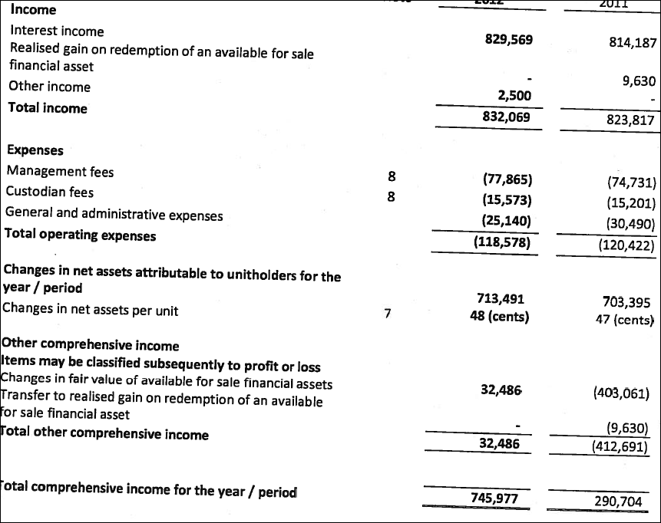

The i-File tool contains two statements for the Statement of Comprehensive Income:

* Income statement, the main statement
* Analysis of income and expenses, the analysis statement

Some of the concepts in the main statement will be linked to the sub classification statement. For example, ‘Interest Income’ is linked to the sub classification.

Following is the extract of the sub classification of ‘Interest Income’ as filled in i-File based on the data available in report:

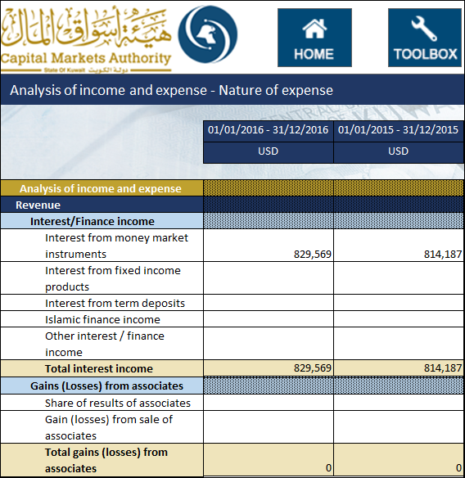

As a result, all the details are filled in the main income statement as follows:

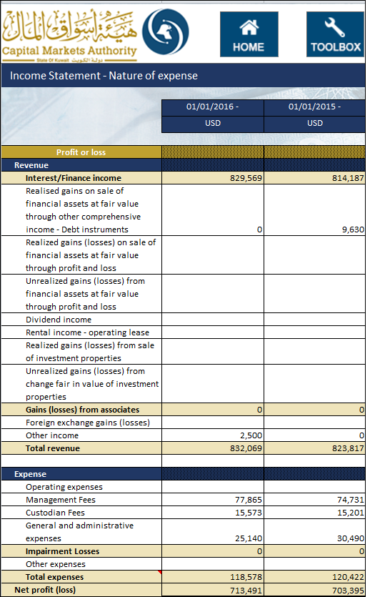

*Though expenses are shown in negative in the extract of the report, as these are the concepts with debit balance having debit effect, the values have been entered in positive in iFile. Similar treatment is to be given elsewhere taking into account the balance type of the concept and the effect of the value in calculation.*

The Values in the concepts highlighted in light brown are automatically updated in the main statement when the value is entered in the Analysis statement, except the totals. By the side of the concepts, linking have been done as ‘*Go to the relevant concepts*’. When the user clicks at ‘Go to the relevant concepts’ the user is directed to the statement from where the values has been derived and vice-versa.

List is as follows:-

* Interest / finance income
* Gains (Losses) from associates
* Impairment Losses

Following is the list of business concepts for which mandatory inputs are required. In the event that the company does not have any inputs, the user can input ‘0’, and the same will be displayed in the final filing document.

* Total revenue
* Total expenses
* Net profit (loss)

Following is an element that has a negative effect on the total:

* Total expenses

## Statement of Comprehensive Income

As shown in the extract of report above, the ‘Statement of income’ and ‘Statement of Comprehensive income’ have been merged by adding the details of other comprehensive income in the main statement. However, in CMA iFile, we have a separate statement for ‘Statement of Comprehensive income’. The details of other comprehensive income as shown in the report as filled in the iFile template as follows:

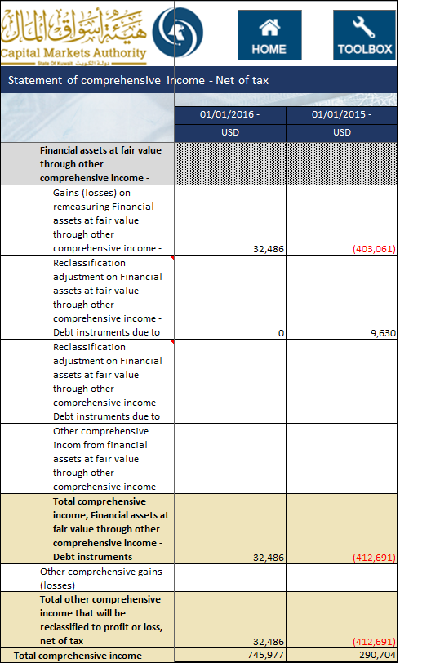

Following is the list of elements that have a negative effect on the total:

* Reclassification adjustment on Financial assets at fair value through other comprehensive income - Debt instruments due to sale
* Reclassification adjustment on Financial assets at fair value through other comprehensive income - Debt instruments due to impairment

## Statement of Cash Flows

Following is the Statement of Cash flow from the Report:

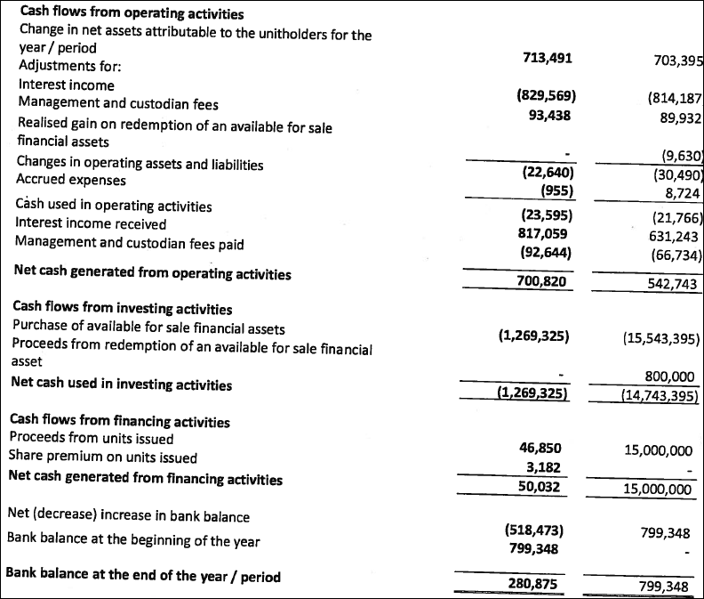

The details of Cash flow statement filled in the iFile template as follows for financing activities;

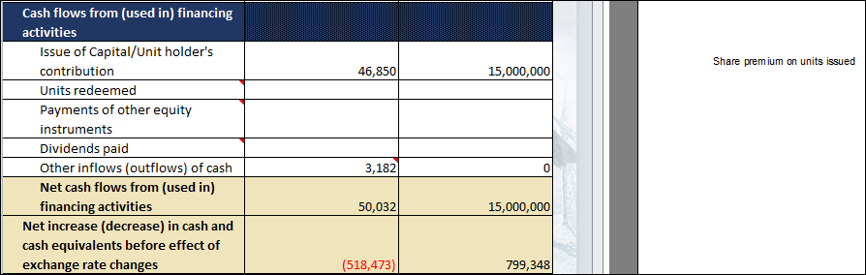

Note: Share premium on units issued is mapped to Concept ‘Other inflows (outflows) of cash’, being the best next tag in CMA ifile tool with a footnote (right side view) for better understanding.

Following is the list of elements that have a negative effect on the total:

* Adjustments for dividend income
* Adjustments for Interest/Finance income
* Adjustments for Management Fees
* Adjustments for Custodian Fees
* Adjustments for Share of results of associates
* Purchase of investment properties
* Purchase of Financial assets at fair value through profit or loss
* Purchase of Financial assets carried at amortized cost
* Acquisition of Investments in associates
* Purchase of financial assets at fair value through other comprehensive income
* Purchase of other long-term assets
* Units redeemed
* Payments of other equity instruments
* Dividends paid

## Statement of Changes in Equity

Following is the Statement of Changes in Equity from the Report:

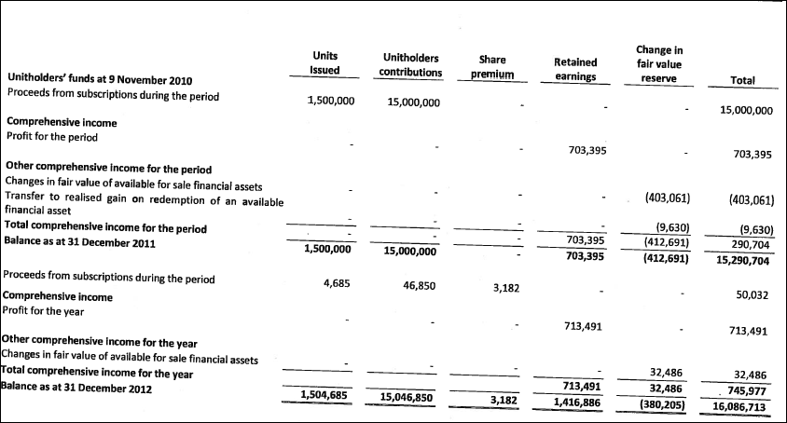

The details of Statement of Changes in Equity filled in the iFile template as follows:

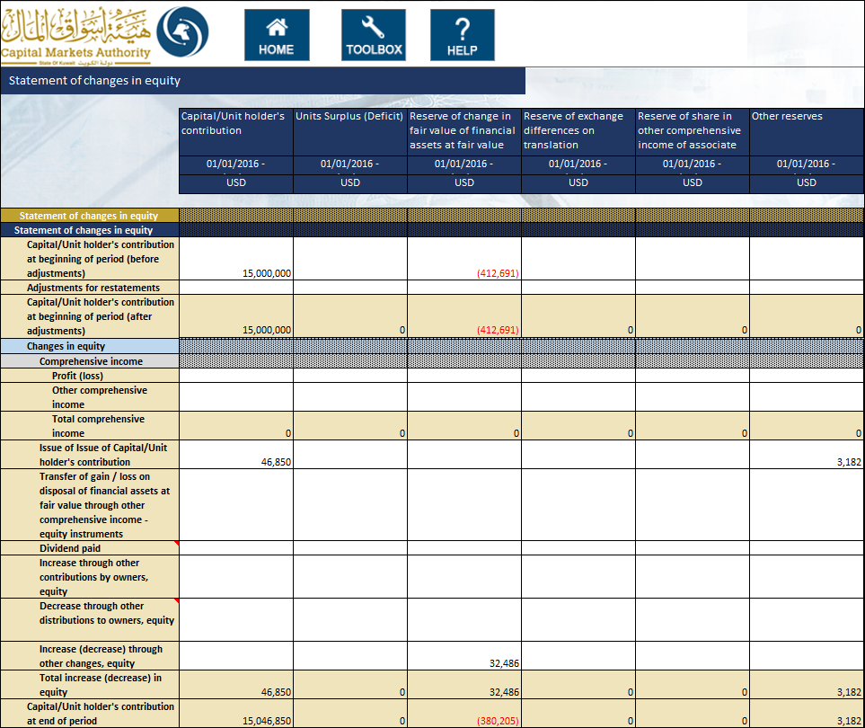

*Note: Share premium reserve is mapped to other reserves column.*

When the value for ‘Preparation format’ in Filing information selected is “Standalone” then Total equity attributable to the parent company and Non-Controlling interest’s column will be disabled.

The information input in this template will have to match that inputted as part of the information inputted in the Balance Sheet.

* The value reported for ‘Capital/Unit holder's contribution’ in the Statement of changes in equity template must equal the value for ‘Capital/Unit holder's contribution’ in the Statement of financial position template
* The value reported for ‘Units Surplus (Deficit)’ in the Statement of changes in equity template must equal the value for ‘Units Surplus (Deficit)’ in the Statement of financial position template
* The value reported for ‘Reserve of change in fair value of financial assets at fair value through other comprehensive income’ in the Statement of changes in equity template must equal the value for ‘Reserve of change in fair value of financial assets at fair value through other comprehensive income’ in the Statement of financial position template
* The value reported for ‘Reserve of exchange differences on translation’ in the Statement of changes in equity template must equal the value for ‘Reserve of exchange differences on translation’ in the Statement of financial position template
* The value reported for ‘Reserve of share in other comprehensive income of associate companies’ in the Statement of changes in equity template must equal the value for ‘Reserve of share in other comprehensive income of associate companies’ the Statement of financial position template
* The value reported for ‘Other reserves’ in the Statement of changes in equity template must equal the value for ‘Other reserves’ the Statement of financial position template
* The value reported for ‘Realisation/Equalisation reserve’ in the Statement of changes in equity template must equal the value for ‘Realisation/Equalisation reserve’ the Statement of financial position template
* The value reported for ‘Retained earnings’ in the Statement of changes in equity template must equal the value for ‘Retained earnings’ the Statement of financial position template
* The value reported for ‘Other equity components’ in the Statement of changes in equity template must equal the value for ‘Other equity components’ the Statement of financial position template
* The value reported for ‘Total equity attributable to unit holders of the fund’ in the Statement of changes in equity template must equal the value for ‘Total equity attributable to unit holders of the fund’ the Statement of financial position template (only in case of Consolidated)
* The value reported for ‘Non-controlling interests’ in the Statement of changes in equity template must equal the value for ‘Non-controlling interests’ the Statement of financial position template (only in case of Consolidated)

Following is the list of elements that have a negative effect on the total:

* Dividend paid
* Decrease through other distributions to owners, equity

## Notes to Financial Statements

The notes to financial statements can be added to the CMA iFile as a text block. For example, following is the General information note given in the report:

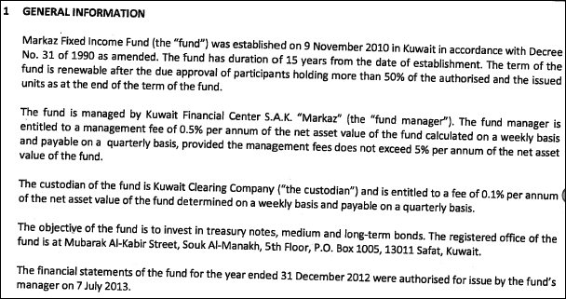

To add this note, the text editor can be opened by double clicking the text-block field for notes as shown below:

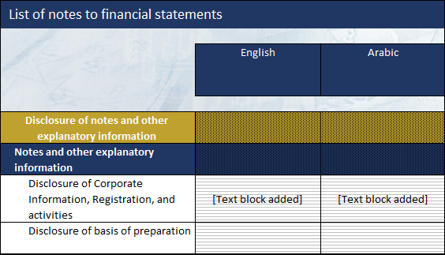

The user can add the disclosure for notes to financial statements and it will be included as a text block in the XBRL output of the CMA iFile. The user can enter the notes in both English and Arabic for the same period. Following is the example of text editor with a note added:

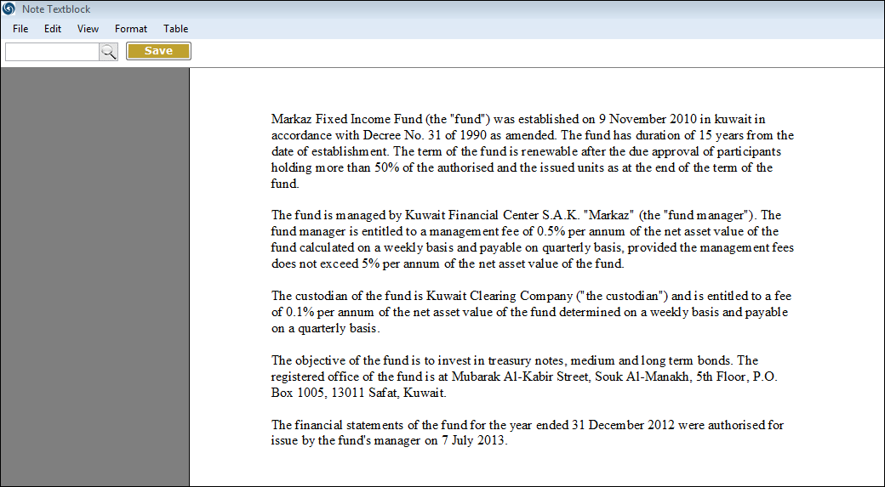

*Kindly note that the text blocks for notes to financial statements in Arabic are mandatory.*

## Fair Value through Profit and Loss Investments

The user can input information pertaining to the companies FVTPL investments, for the local and foreign, listed and unlisted investments. For each of the investments, the user will be required to input the following information:

* Investment Type
* Type of product
* Investment products list
* Name
* Region
* Country
* Number of shares
* Cost per share
* Total Cost
* Market value per share
* Total market value
* Date of last valuation of unquoted shares
* Realized Gains / (Losses)
* Unrealized Gains / (Losses)
* Underlying Currency
* Credit Rating (for debt instruments)

The information input in this template will have to match that inputted as part of the information inputted in the Balance Sheet and Income Statement.

* The sum of the ‘Total Market Value’ in the Fair Value Through Profits and Loss Investments template must equal the ‘Financial Assets at Fair Value through profit or loss’ in the Statement of financial position, current/non-current template
* The sum of the ‘Realized Gains / (Losses)’ in the Fair Value Through Profits and Loss Investments template must equal the ‘Realized gains (losses) on sale of financial assets at fair value through profit and loss’ in the Income Statement, nature of expense template
* The sum of the ‘Unrealized Gains / (Losses)’ in the Fair Value Through Profits and Loss Investments template must equal the ‘Unrealized gains (losses) on sale of financial assets at fair value through profit and loss’ in Income Statement, nature of expense template

## Financial Assets at Fair Value through Other Comprehensive Income

The user can input information pertaining to the companies FAFVOCI investments, for the local and foreign, listed and unlisted investments. For each of the investments, the user will be required to input the following information:

* Investment Type
* Type of product
* Investment products list
* Name
* Region
* Country
* Number of shares
* Cost per share
* Total Cost
* Market value per share
* Total Market Value
* Date of last valuation of unquoted shares
* Realized Gains / (Losses)
* Change in Fair Value during the period
* Impairment loss during the period
* Accumulated Impairment Balance
* Reserve of change in Fair value
* Underlying Currency
* Credit Rating (for debt instruments)

The information input in this template will have to match that inputted as part of the information inputted in the Balance Sheet and Income Statement.

* The sum of the ‘Total Market Value’ in the Financial Asset at Fair Value through Other Comprehensive Income template must equal the sum of ‘Financial asset at fair Value through other comprehensive income, current’ and ‘Financial asset at fair Value through other comprehensive income, non-current’ in the Statement of financial position, current/non-current template
* The sum of the ‘Realized Gains / (Losses)’ in the Financial Asset at Fair Value through Other Comprehensive Income template must equal the ‘Realized gains on sale of financial assets at fair value through other comprehensive income - Debt instruments’ in the Income Statement, Nature of expenses template and Transfer of gain / loss on disposal of financial assets at fair value through other comprehensive income - equity instruments in the Statement of changes in equity template.
* The sum of the ‘Change in Fair Value during the Period’ in the Financial Asset at Fair Value through Other Comprehensive Income template must equal the ‘Net fair value change on financial assets at fair value through other comprehensive income - equity instruments’ and ‘Gains (losses) on re-measuring Financial assets at fair value through other comprehensive income - Debt instruments’ in the Statement of comprehensive income - Net of tax statement template.

## Financial Assets Carried at Amortized Cost

The user can input information pertaining to the companies FACAC investments, for the local and foreign, listed and unlisted investments. For each of the investments, the user will be required to input the following information:

* Investment Type
* Name
* Region
* Country
* Product Type
* Acquisition Date/Start Date
* Underlying Currency
* Carrying amount
* Amortized cost
* FX Translation Change
* Maturity
* Credit Rating
* Fair Value

The information input in this template will have to match that inputted as part of the information inputted in the Balance Sheet and Income Statement.

* The sum of the ‘Carrying amount’ in the Financial Assets Carried at Amortized Cost template must equal the ‘Financial assets carried at amortized cost, current’ and ‘Financial assets carried at amortized cost, non-current’ in the Statement of financial position, current/non-current template.

## Investments in Associates

The user can input information pertaining to the company’s Investment in associates, for the local and foreign investments. For each of the investments, the user will be required to input the following information:

* Name
* Region
* Country
* Listing Status
* Investment Type
* Underlying Currency
* Carrying amount (Ending)
* Carrying amount (Beginning)
* Percentage of ownership
* Dividend received
* Impairment expense / (reversal)
* Share of Results
* Share of Other Comprehensive Income
* FX Translation Change
* Other movement
* Acquisitions/ Disposals/ Redemption
* Fair value (for listed investment based on market price)

The information input in this template will have to match that inputted as part of the information inputted in the Balance Sheet and Income Statement.

* The sum of the ‘Carrying amount (Ending) in the Investment in associates template must equal the ‘Investment in associates’ in the Statement of financial position, current/non-current template

## Investment and Held for Trading Properties

The user can input information pertaining to the company’s Investment and Held for Trading Properties, for the local and foreign investments. For each of the investments, the user will be required to input the following information:

|  |
| --- |
| * Name of Property |
| * Region |
| * Country |
| * Date acquired |
| * Acquisition cost |
| * Name of counter party that sold the property |
| * Is the counter party a related party? (Yes/No) |
| * Accounting Basis |
| * Property Category |
| * Property Type |
| * Underlying Currency |
| * Carrying amount (Ending) |
| * Carrying amount (Beginning) |
| * Additions |
| * Disposals |
| * Name of counter party that purchased the property |
| * Is the counter party a related party? (Yes/No) |
| * Date of disposal |
| * Depreciation expense |
| * Accumulated depreciation |
| * Name of Valuer 1 |
| * Fair value as per Valuer 1 |
| * Date of Valuation 1 |
| * Name of Valuer 2 |
| * Fair value as per Valuer 2 |
| * Date of Valuation 2 |
| * The lesser of the two valuation |
| * Impairment Loss During the Period |
| * Accumulated impairment |
| * FX Translation change |
| * Other Changes |
| * Realized Gains / (Losses) |
| * Unrealized Gains / (Losses) |

The information input in this template will have to match that inputted as part of the information inputted in the Balance Sheet and Income Statement.

* The sum of the ‘Carrying amount (Ending) in the Investment and Held for Trading Properties template must equal the ‘Investment properties’ in the Statement of financial position, current/non-current template.
* The sum of the ‘Carrying amount (Ending) in the Investment and Held for Trading Properties template must equal the ‘Trading properties’ in the Statement of financial position, current/non-current template

## Money Market Products

The user can input information pertaining to the companies Money market product investments., The user will be required to input the following information:

|  |
| --- |
| * Name of Counter Party |
| * Investment Type |
| * Type of money market Investment |
| * Region |
| * Country |
| * Principal Amount |
| * Underlying Currency |
| * Investment Term - From |
| * Investment Term - To |
| * Number of Investment days /liquidation days for Bonds or Sukus |
| * Days till maturity |
| * Liquidity Term for Bonds/Sukuks (T+1 , T+2 , T+3 ..) |
| * Profit Rate |
| * Carrying amount |
| * Percentage on total investment & Cash |
| * Product of Days till maturity and Percentage on total investment & Cash |
| * Profit During the Period |
| * Credit Rating |
| * Name of Rating Agency |