CMA’s XBRL Based Electronic Filing Platform

IFSAH

Instruction Manual for iFile Tool
Version 1.0


Contents
1. Accessing the IFSAH Portal 3
2. Downloading iFile Tool from the IFSAH Portal 3
3. Installing iFile Tool 5
4. Opening the iFile tool 7
5. Introduction Page 8
6. Creating templates 9
7. The Home Button 13
8. The Tool Box Button 13
9. Help documentation 20
10. Generating XBRL document 21
11. Uninstalling the tool 24

Accessing the IFSAH Portal

The Company Super Users (CSUs) and Company Users (CUs) can access the IFSAH portal through any browser, as long as they are connected to the internet. CSUs can then login into the IFSAH portal through the following link
https://ifsah.cma.gov.kw.

Downloading iFile Tool from the IFSAH Portal

Once the CSUs and CUs are logged into the IFSAH portal with valid credentials, they can download the iFile tool installer.
The CSU can download the latest version of the iFile installer by clicking on the ‘Download – Download Installer’ menu option. Here, the CSU will have to input the relevant sector by selecting from the drop down field.
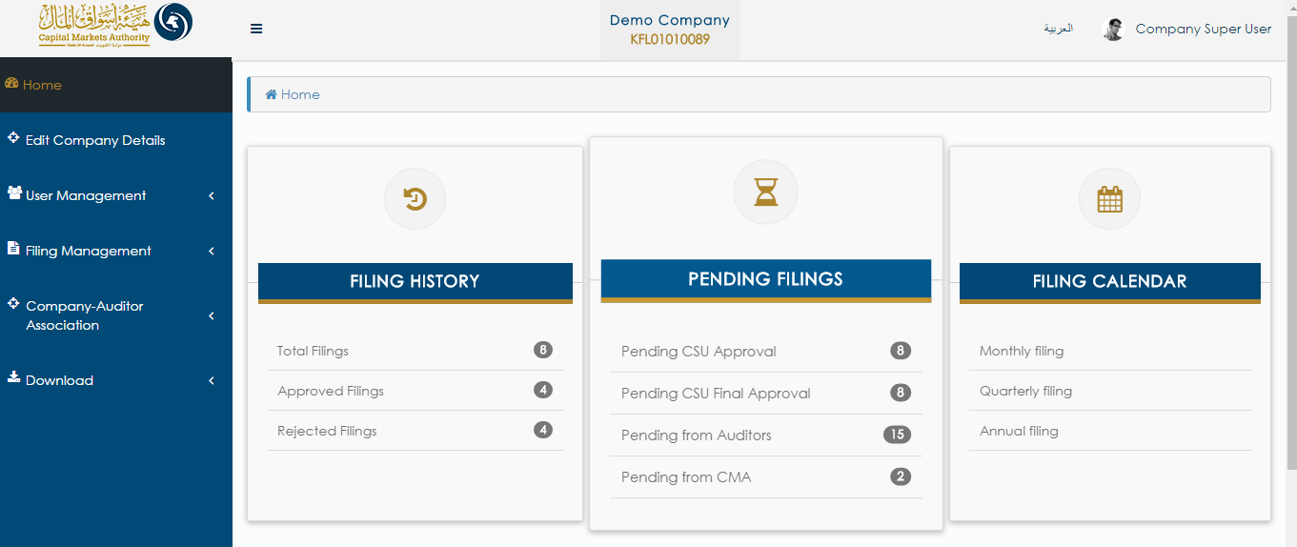

The CU can download the latest version of the iFile installer by clicking on the ‘Download – Download Installer’ menu option. The CU will have to input the relevant sector by selecting from the drop down field.
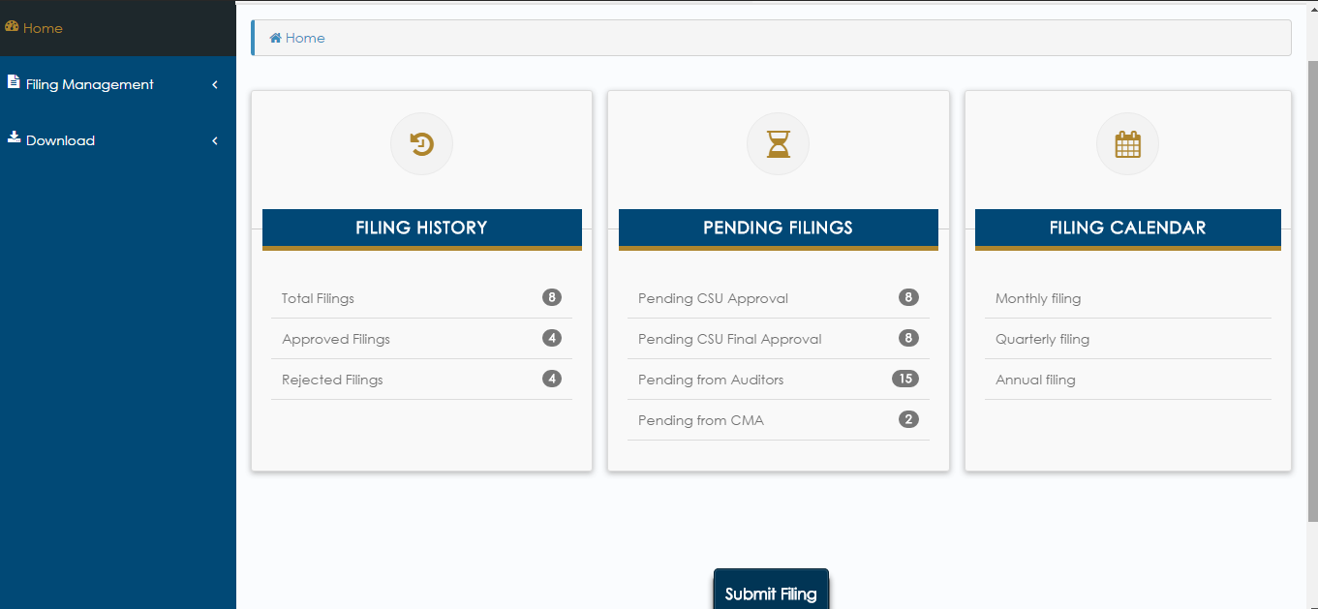

Installing iFile Tool

Once the user downloads the installer from the IFSAH portal, they will need to unzip the zip folder and then follow below steps:
- Open the extracted folder and double click on the application file available.
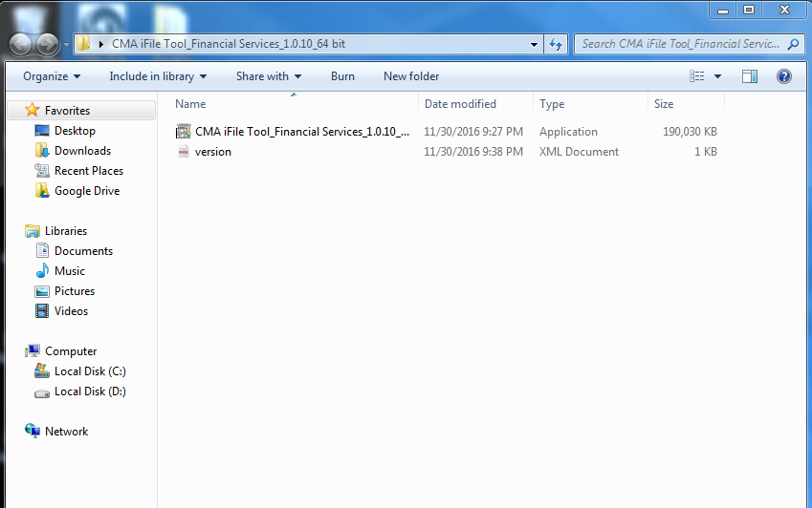

- On double clicking on the application file, the Welcome Screen will pop up. Click on the ‘Next’ button available on the Welcome screen.
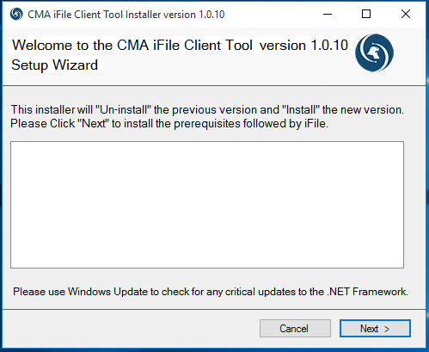

- On clicking ‘Next’, the installation of the iFile tool will be initiated, coupled with the display of the tool installation.
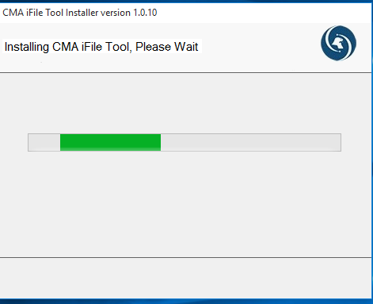

- Click on ‘Close’ button once the installation is completed.
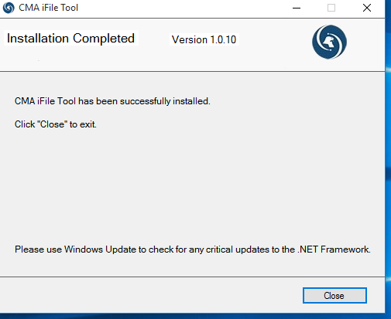

Opening the iFile tool

Once the tool is successfully installed, CMA iFile Tool short-cut icon will be displayed on the desktop. In order to access the iFile tool, the user can double click on the icon displayed below.
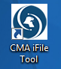

Introduction Page

Once the user double clicks on the short-cut icon, the ‘Introduction’ page will be displayed with a list of instructions to be followed, in order to generate an XBRL instance document. The user can access the tool in both English and Arabic.
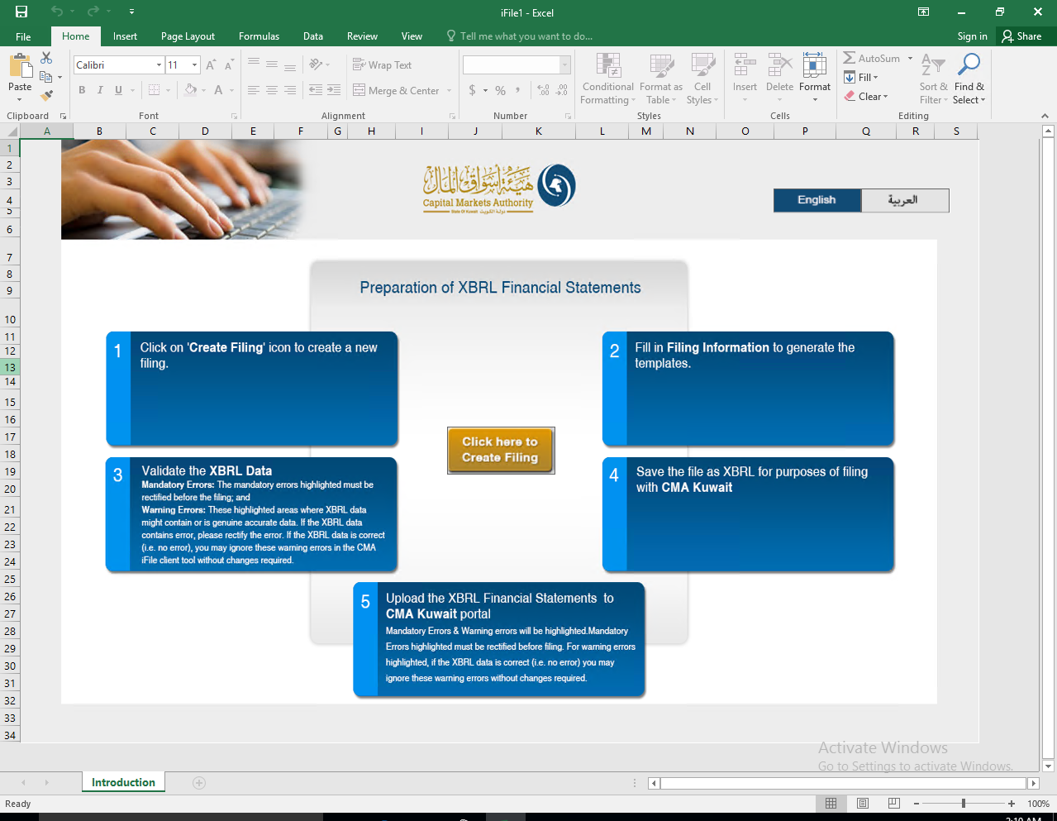

Creating templates

In order to generate templates, the user can click on the ‘Click Here to Create Filing’ button to fill in the filing information required.

On clicking on the ‘Click Here to Create Filing’ button, a pop-up registration page will appear, where in the user will have to input information about the company on behalf of which he/she is performing the filing.
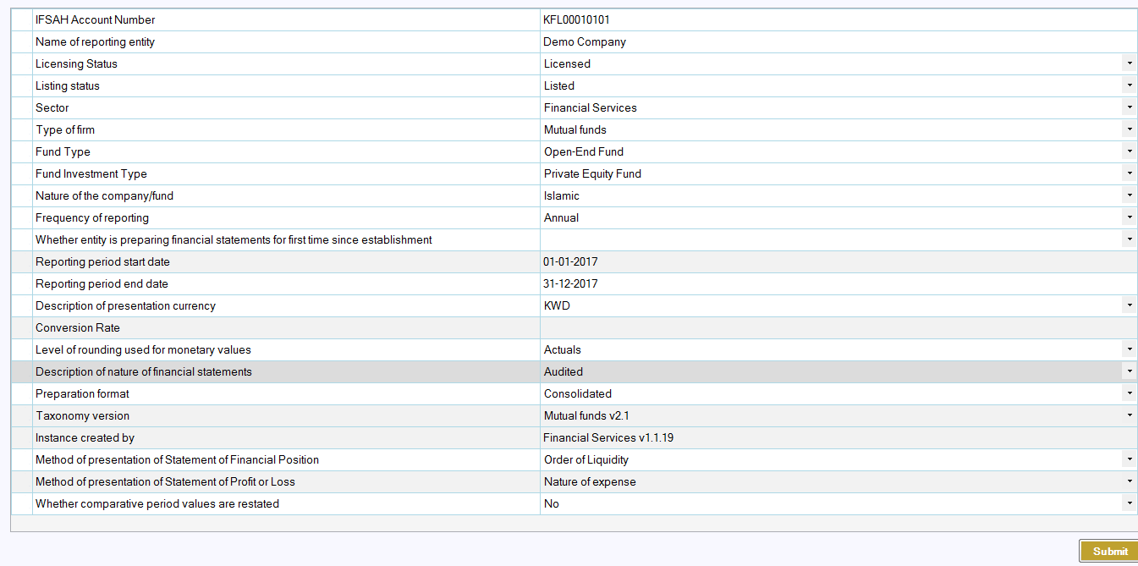
Following is a brief description of the inputs required by the user on this page:
- IFSAH Account Number: It’s a registration number provided when any company has been registered at CMA. The value provided in this field should have a length of 11 characters, with a format of the first three characters as alphabets, followed by eight characters of digits (e.g. KFL00010101)

- Name of reporting entity: Name of the company

- Licensing Status: Based on whether company is licensed by CMA or not, the user can select the appropriate option such as “Licensed” or “Unlicensed”.

- Listing Status: Based on listing status of the company, the user can select the appropriate option, such as “Listed” or “Unlisted”.

- Sector: Based on company’s sector, the user can select the appropriate option from the drop down list.

- Type of Firm: Based on company’s type of firm, the user can select the appropriate option from the drop down list.

- Fund Type: This field is enabled only for ‘Mutual Fund’ type of firm. Based on fund type the company belongs to, the user can select the appropriate option, such as “Open-End Fund” or “Closed-End Fund” or “Exchange Traded Fund”.

- Fund Investment Type: This field is enabled only for ‘Mutual Fund’ type of firm. Based on fund investment type of the company, the user can select the appropriate option, such as “Equity Fund” or “Money Market Fund” or “Private Equity Fund” or “Real Estate Fund” or “Debt Instruments Fund” or “Fund of Funds” or “Any other type approved by the Authority”.

- Nature of Company/Fund: The user will have to select whether company is Islamic or Conventional in nature

- Frequency of reporting: The user can select for which frequency he/she is creating the XBRL instance document, such as ‘Annual’, ‘Monthly’, ‘Quarter 1’, ‘Quarter 2’ or ‘Quarter 3’

- Whether company is preparing financial statements for first time since establishment: The user will have to select option as ‘Yes’ if they are filing to CMA for the first time since their company’s establishment, else the user is to select the option ‘No’

- Reporting period start date: This is a read-only field with value populated based on Reporting period end date entered by the user.

- Reporting period end date: The user has to enter the end of the period for which they are filing to CMA. The date should be end of the month.

Users are requested to kindly note the following while inputting the period end date. For illustrative purposes, let us say that the company’s financial reporting period is from 1st January to 31st December:
  - Annual filing: User is to input the last date of the end of the company’s financial report period, i.e. 31st January
  - Monthly filing: User is to input the last date of the end of the month for which he/she is submitting a filing. If the filer is submitting the report for the month of January, he/she will input 31st January.
  - Quarter 1 filing: User is to input the last day, of the third month, of the company’s financial reporting period, i.e. 31st March.
  - Quarter 2 filing: User is to input the last day, of the sixth month, of the company’s financial reporting period, i.e. 30th June
  - Quarter 3 filing: User is to input the last day, of the ninth month, of the company’s financial reporting period, i.e. 30th September

- Description of presentation currency: The user has to select whether the values reported for this filing are in ‘KWD’ or ‘USD’

- Conversion Rate: This field is enabled only when currency selected is ‘USD’. User can add the conversion rate from USD to KWD for this filing.

- Level of rounding used for monetary values: The user has to select whether the values reported for this filing are in ‘Actuals’ or in ‘Thousands’

- Description of nature of financial statements: This is a read-only field. The value will be displayed based on the frequency of reporting value selected

- Preparation format: The user has to select whether the filing is ‘Standalone’ or ‘Consolidated’

- Taxonomy version: This is a read-only field. The value will be displayed based on ‘Type of firm’ value selected.

- Instance created by: This is a read-only field

- Method of presentation of Statement of Financial Position: The user has to select the option of ‘Current/Non-current’ or ‘Order of liquidity’. For Licensed Investment firms, this is a read-only field, as the default will be ‘Order of liquidity’

- Method of presentation of Statement of Profit or Loss: This is a read-only field with the default value displayed as ‘Nature of expense’

- Whether comparative period values are restated: User has to select whether the comparative period values are restated or not.
The user can submit the filing information details by clicking on the ‘Submit’ button. Based on the details filled in by the user, relevant templates would be generated for the user to fill in their company’s data.
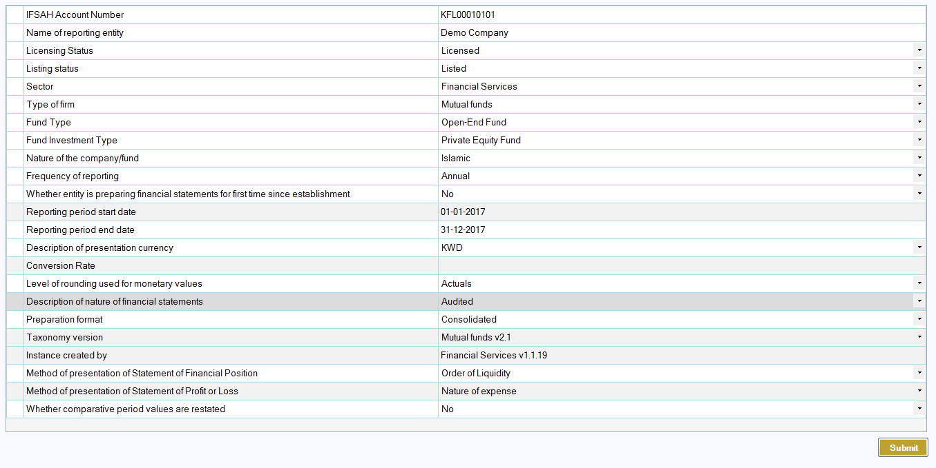

The Home Button

Once the templates are generated, the user will view the following opening tab. On the top of the Excel Tab, the user will have access to three key buttons, the first of which is the ‘Home’ button. By clicking on this button, on any other tab, the user will be redirected to this opening tab, and can view the different tabs that are expected to be filled, as well as view the legend of the color-coding scheme of the input cells.
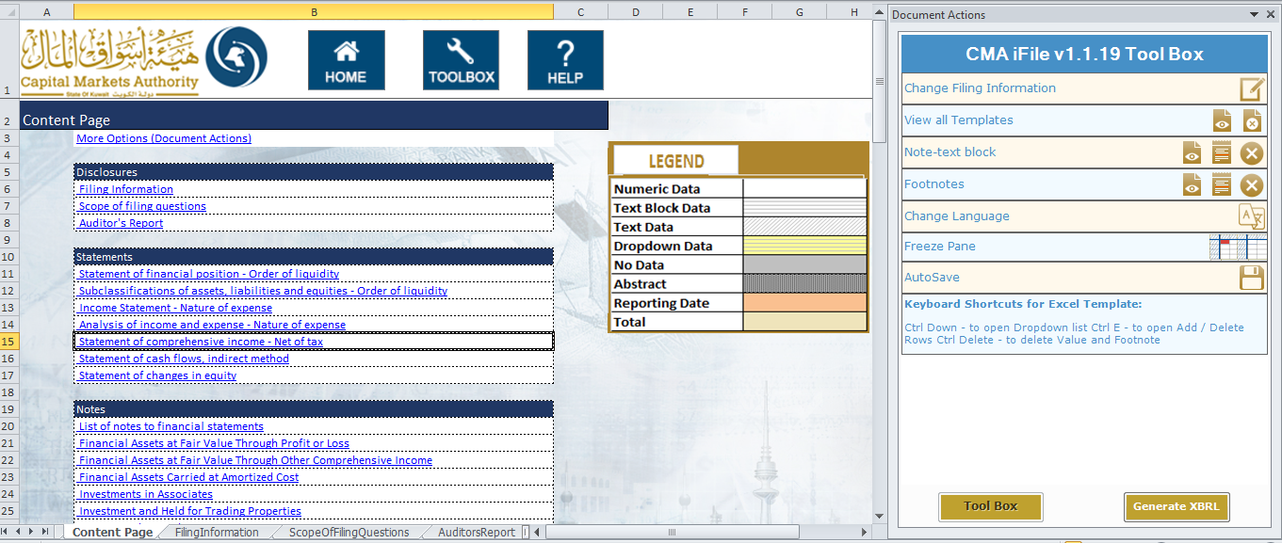

The Tool Box Button

The second button on the top of the Excel tab that the user can click on is the ‘Toolbox’. Another means of accessing the toolbox is by clicking on the bottom left corner on the ‘Document Actions’ pane.

Within the toolbox, the user will have access to different options, which are listed below:

Change Filing Information:
- The user can use the circled button in the ‘Document Actions’ pane to edit the filing information details submitted.
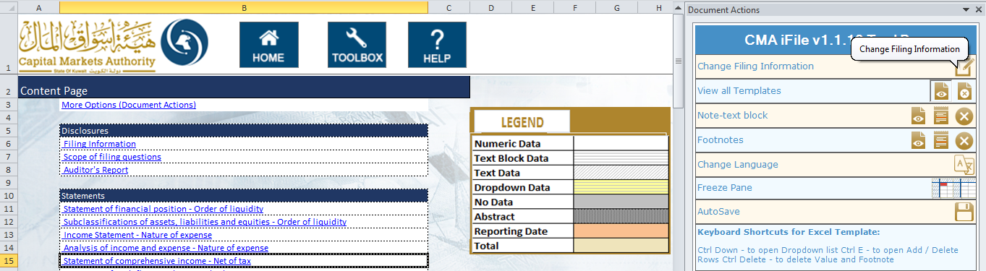

Statements:
- View Statements: The user can view the list of all the templates generated based on the filing information details submitted by clicking on the circled button in the ‘Document Actions’ pane.
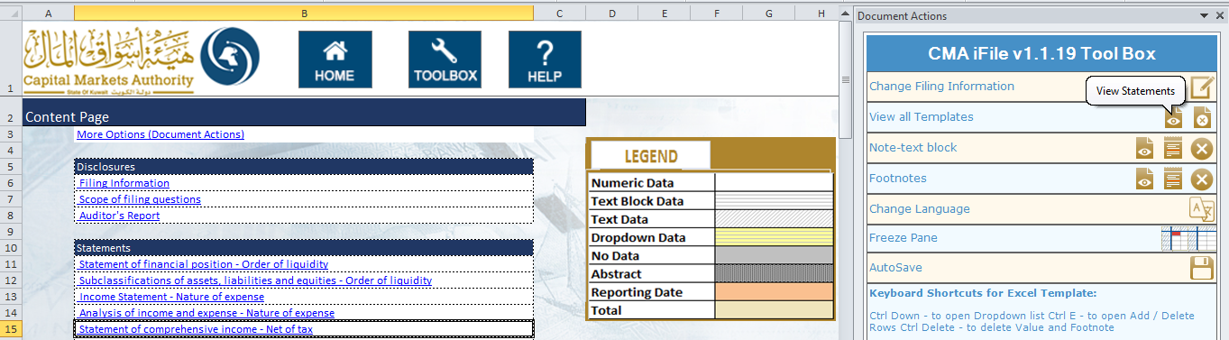

- Clear data: The user can clear all the data entered in any selected statements using this option.
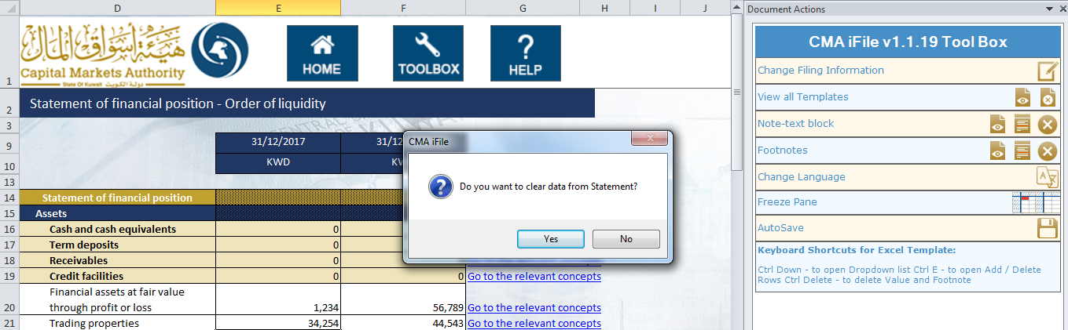

Note-text block:
- Add/View/Edit Notes: For some items, the user will be required to add a note as part of the submission. For this, the user can add/edit/view text block data by either double clicking on the cell, or selecting the option under ‘Note-text block’ from the ‘Document Actions’ pane.
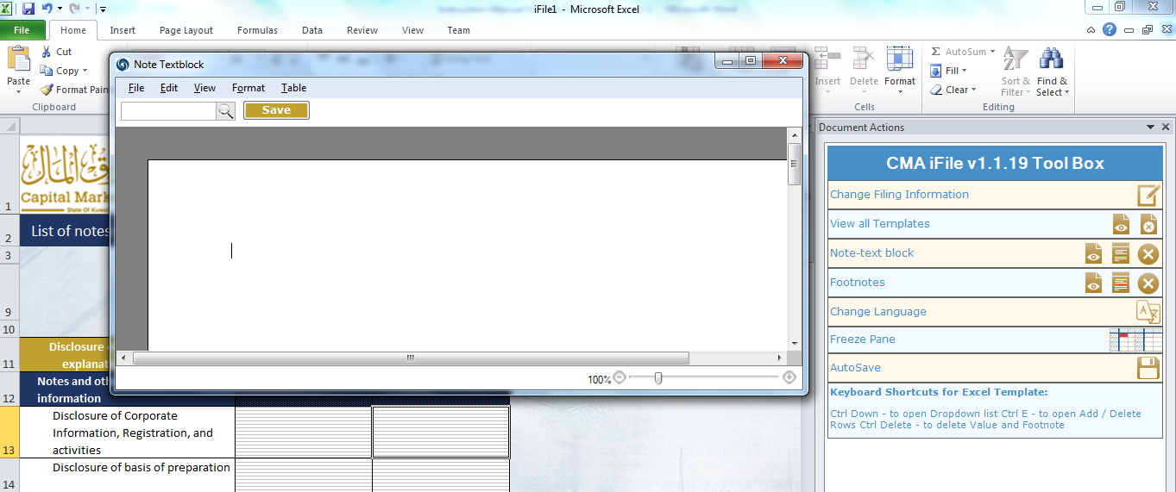

- Delete Notes: The user can also select a text block data field and delete the existing text block data added for that field.
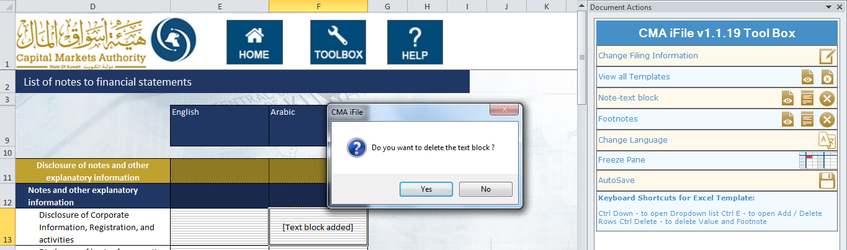

Footnotes:
- Add/View/Edit Footnotes: The user can add/edit/view comments added to any input field by clicking on the circled button in the ‘Document Actions’ pane. However, the user cannot add comments for the fields that are empty.
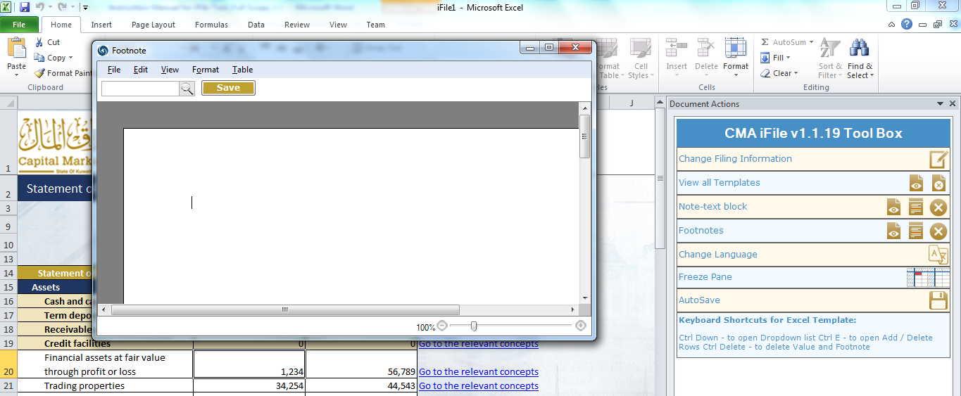

The user can also view the footnotes added by hovering over the cell for which there is a footnote.
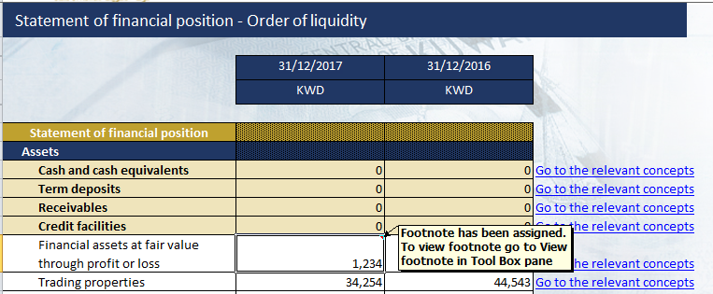

- Delete Selected Notes: The user can delete the footnote already added by selecting that field and then clicking on the circled button in the ‘Document Actions’ pane.
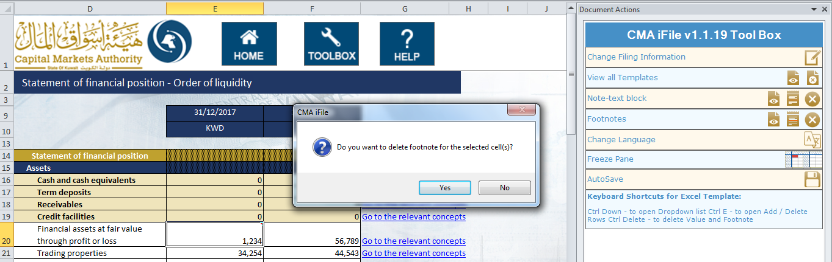

Change Language:
- The user can change the language from English to Arabic or vice-versa by clicking on the circled button in the ‘Document Actions’ pane.
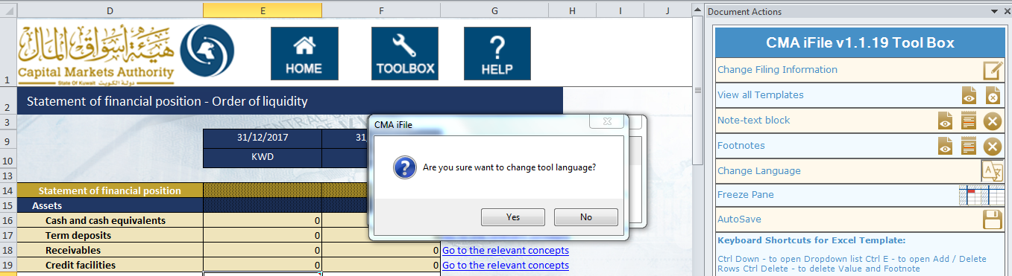

AutoSave:
- The user can configure the time interval for auto-saving the template by clicking on the circled button in the ‘Document Actions’ pane.
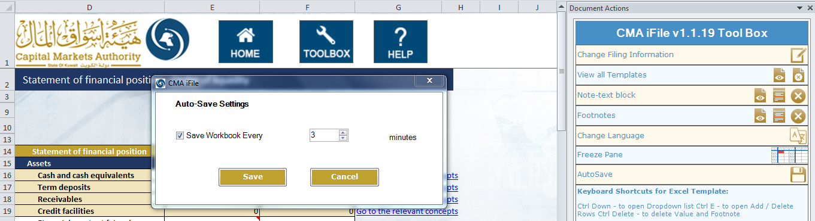

Freeze Pane:
- Freeze Pane: The user can select the circled button in the ‘Document Actions’ pane to freeze the selected pane on the template.
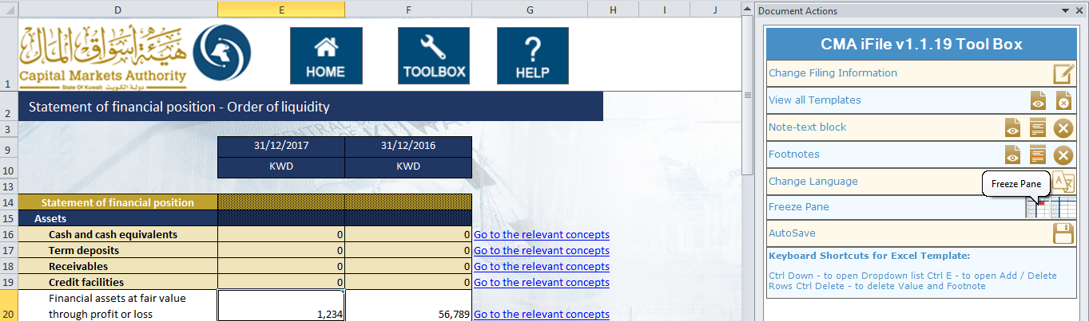

- Unfreeze Pane: The user can unfreeze the freeze pane using the circled button in the ‘Document Actions’ pane.
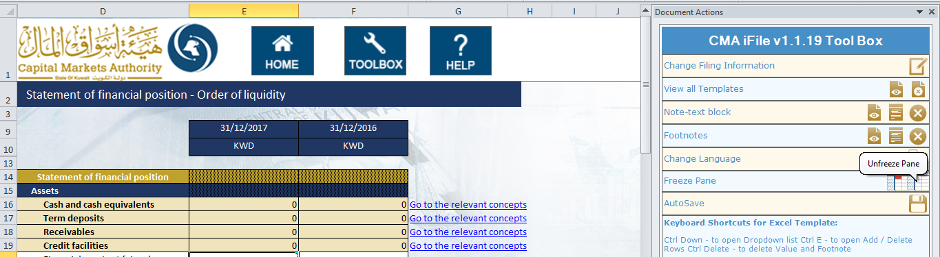

Help documentation

The user can view detailed information for any specific element in the template by double clicking on that element name or by clicking on the ‘Help’ option after select specific element. A window will be displayed in the right side (Document Action pane) with detailed information about the selected element.

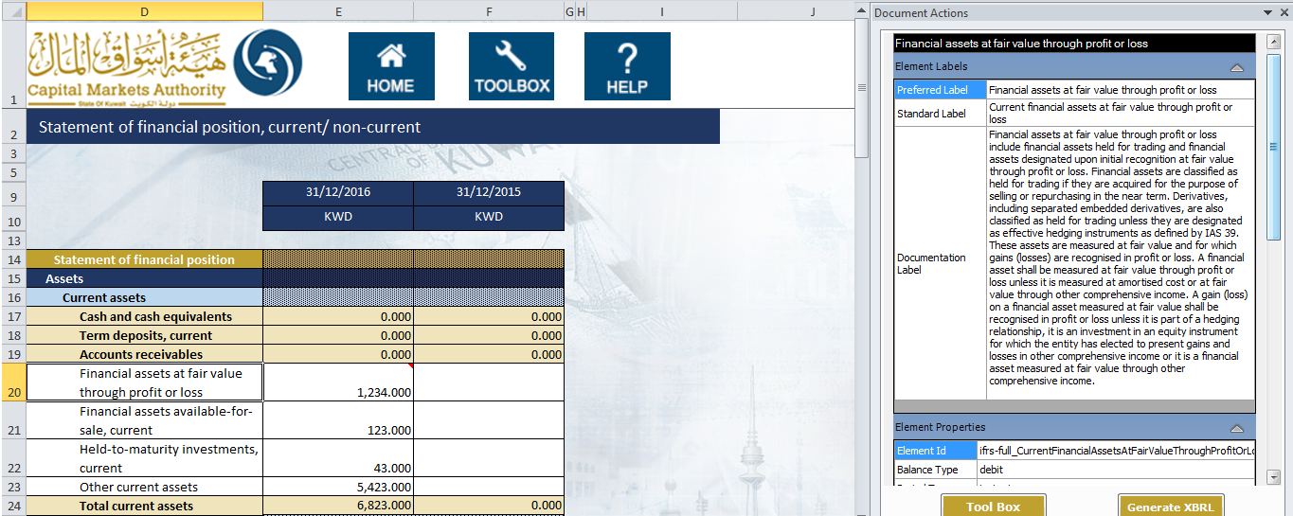

Generating XBRL document

Once the user has filled in all the required data in the templates, he/she can generate the XBRL document for submitting it as a part of filing on the IFSAH portal. The user has to click on the ‘Generate XBRL’ button, after which all the data entered by the user will be validated against the business rules defined by CMA. On clicking on the button, a pop-up box highlighting the time required will appear as shown below.
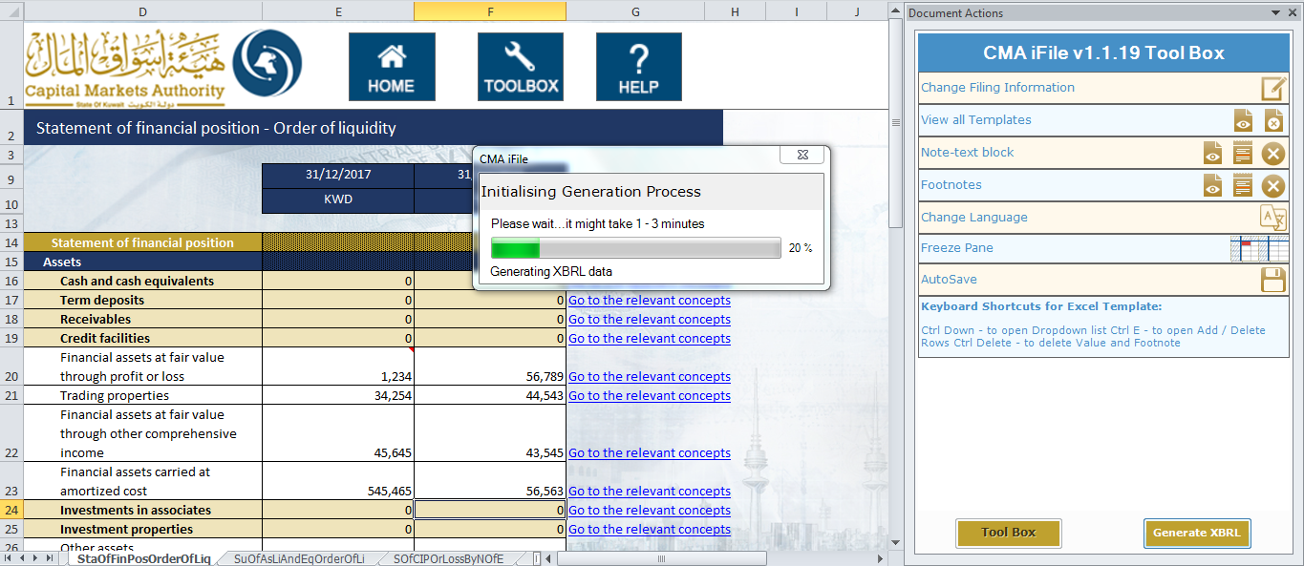

Validation Errors:
If the data entered by user fails the validation run, an error window will be displayed with the details of the errors identified. The user can go through the errors displayed in the validation window and rectify the same.
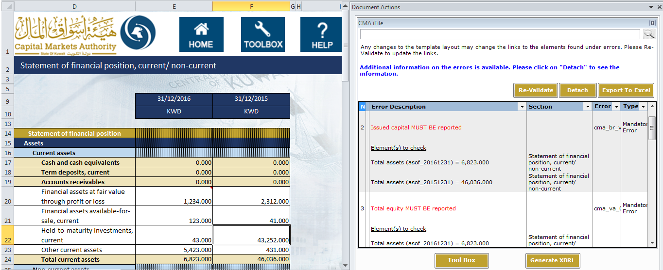

The user can export the validation errors in an excel format using ‘Export to excel’ button on the validation window.

The user can also detach the validation errors as a pop-up using the ‘Detach’ button on the validation window.

The user can re-validate the modified data after rectification using ‘Re-Validate’ button available in the Error window or using ‘Generate XBRL’ option.

Saving XBRL instance document:
If there are no errors in the data, the user will view a pop up window to save the generated XBRL instance document at their desired location.
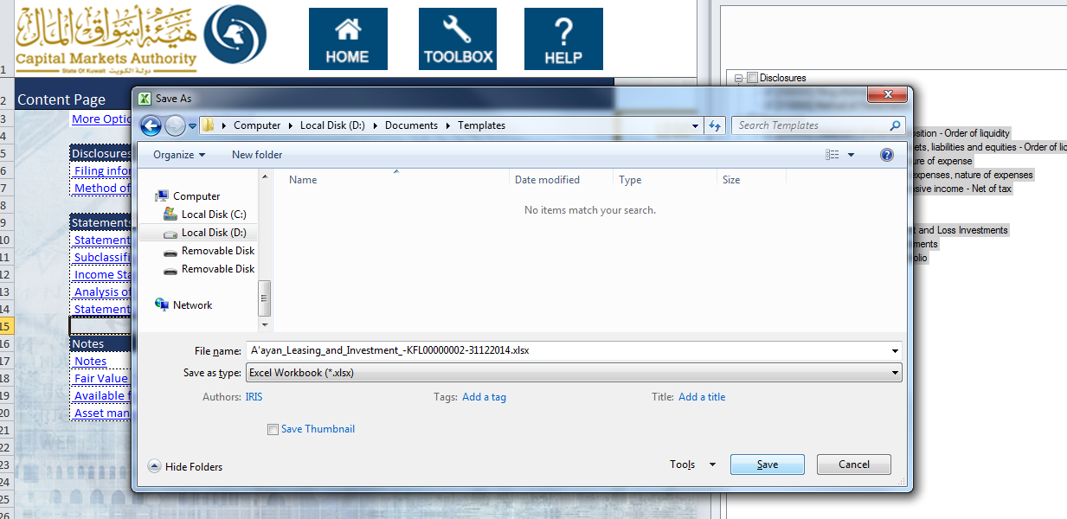

Uninstalling the tool

The user can uninstall the iFile tool from control panel by following the below steps:
- Right click on ‘CMA iFile Tool’ application in control panel.

- Click on ‘Yes’ option in the ‘Confirm Uninstall’ pop up window displayed
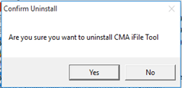

- Click on ‘OK’ option in the uninstallation successful pop up window.
