**CMA’s XBRL Based Electronic Filing Platform**

**IFSAH**

**Instruction Manual for Company Super Users**

Version 1.0



Contents

1. Accessing the IFSAH Portal 3

2. Registration 3

3. Log – In 4

4. Dashboard 4

5. Viewing / Editing the Company’s Details 6

6. Adding Company Users 7

7. Initiating association with an Audit Firm 9

8. Filing calendar 11

9. Following the status of the filing 12

10. Upload filing 13

11. Pending filing 14

12. Viewing history of the filings 18

13. Inquiry module 19

14. Downloading the installer 21

15. Downloading the taxonomy template 22

## Accessing the IFSAH Portal

The Company Super Users (CSUs) can access the IFSAH portal through any browser, as long as they are connected to the internet. CSUs can then login into the IFSAH portal through the following link

<https://ifsah.cma.gov.kw/login/login.>

## Registration

Company Super Users (CSU) can register themselves on portal using the registration link “Super User Registration” available on login page.

Screenshot of login page

On ‘Super User Registration’ page, CSU need to select “Entity” option for ‘Company / Fund /Auditor’ field and fill in required details for registration. Upon submitting the details, request for registration will be sent to CMA for approval. Once approved by CMA an email with the username and a One Time Password (OTP) will be sent to the CSU on the registered email address.

The CSU can also be created by the CMA Admin, after which an email with the username and a One Time Password (OTP) will be sent to the CSU on the registered email address. The CSU can login to the IFSAH portal with the username and OTP. This portal can be accessed in either English or Arabic.

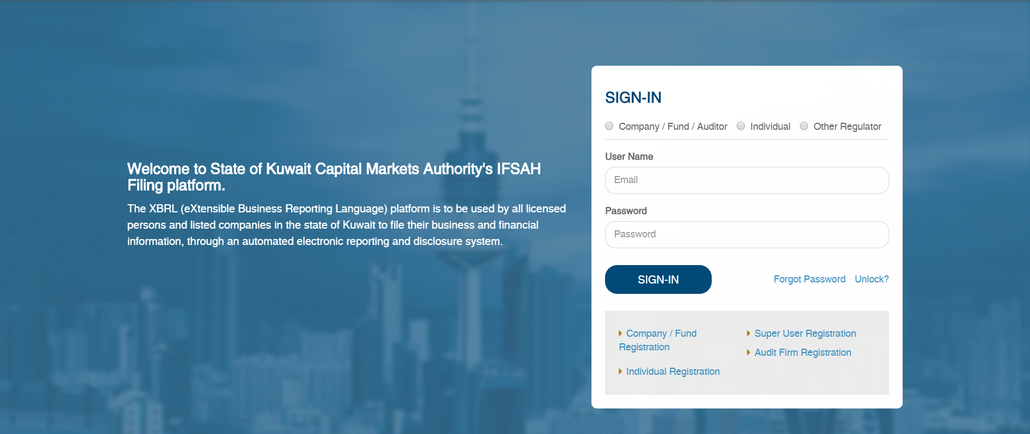

## Log – In

Once the CSU has successfully logged in with the OTP, the CSU will be navigated to the “Change Password” page to set a new password.

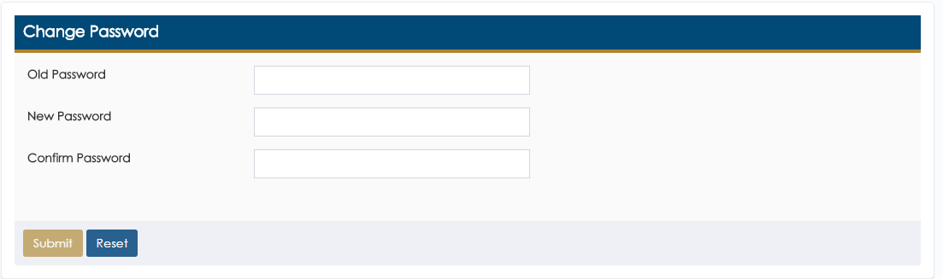

Upon setting the new password, the CSU will be required to login in again with the new password.

## Dashboard

On logging into the portal successfully, the CSU will be navigated to the Dashboard.

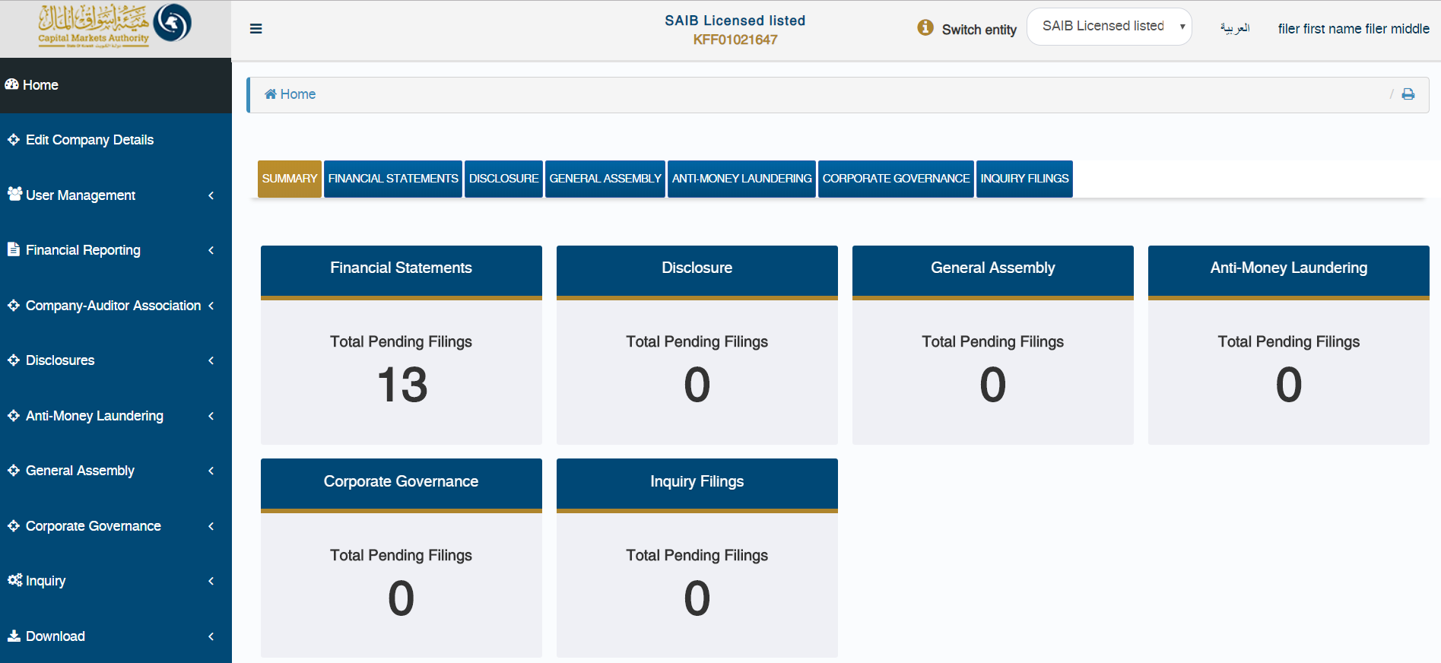

As can be seen on the dashboard, the CSU can navigate between all the domains she/he has access to, including the module on reviewing the inquiry filings.



In addition, if the CSU is a super user for multiple companies, she/he can navigate between the dashboards for these companies by selecting the relevant entity in the ‘Switch entity’ field.



## Viewing / Editing the Company’s Details

The CSU can view & edit company details using ‘Edit Company Details’ menu option, from the Dashboard Page.



By clicking on ‘Edit Company Details’, the CSU will view the page on which he/she can both view, or edit the company details.

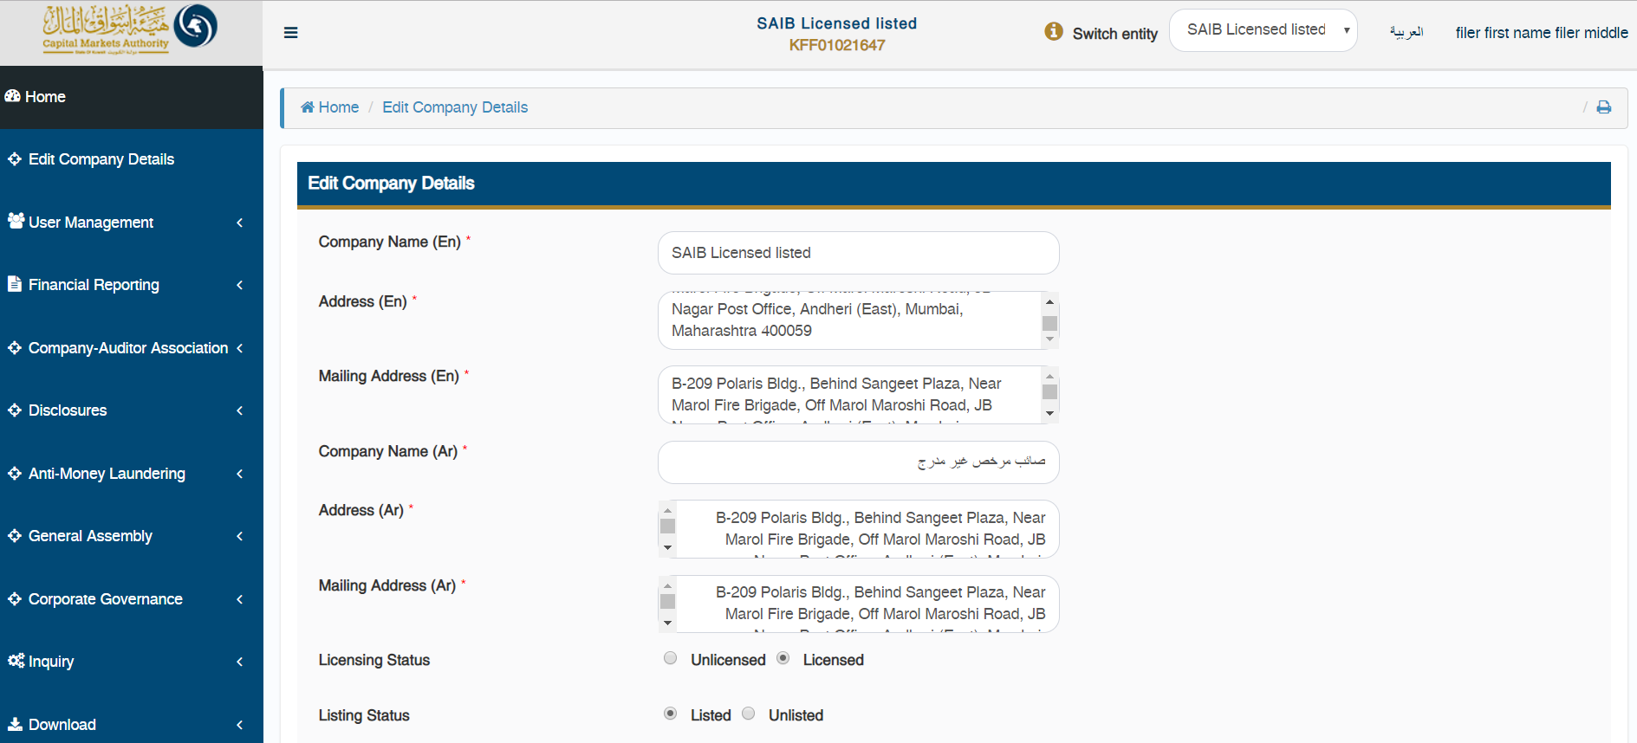

The edited company details will then be sent to CMA for approval, and will be updated only when approved by the CMA Admin.

## Adding Company Users

The CSU can add Company Users (CU) for the Company by clicking on ‘User Management – Add/Edit Company User Details’ menu option.

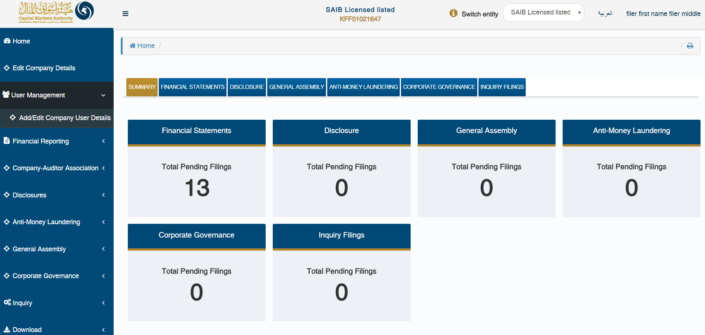

By clicking on the option above, the CSU will be able to view the Company User Details grid with list of all the CUs registered for their company.

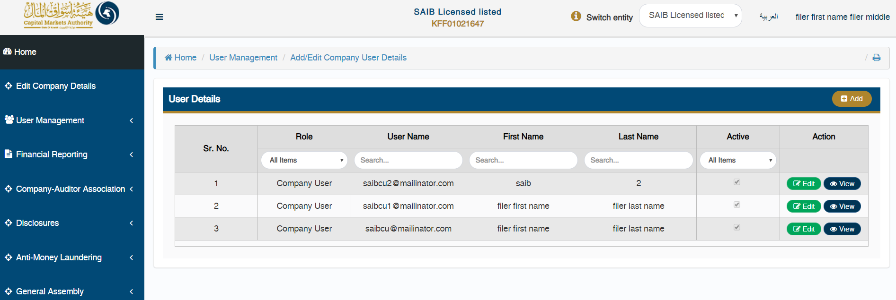

In order to add a new CU for the company, the CSU can click on the ‘Add’ button.



By clicking on the ‘Add’ button, the CSU will be redirected to the ‘Register New User’ page, where he/she will be required to fill out information pertaining to the CU.

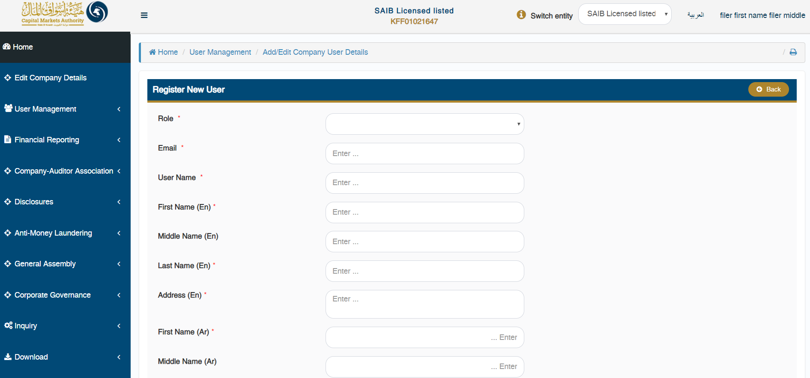

Once the new CU is registered by CSU, an email will be sent to that respective CU on the registered email added with username & OTP in order to login to the IFSAH Portal.

## Initiating association with an Audit Firm

The CSU can initiate an association of his/her company with an Audit Firm who will responsible for auditing their filing. To do so, the CSU can click on ‘Company-Auditor – Initiate Auditor Association’ menu option.

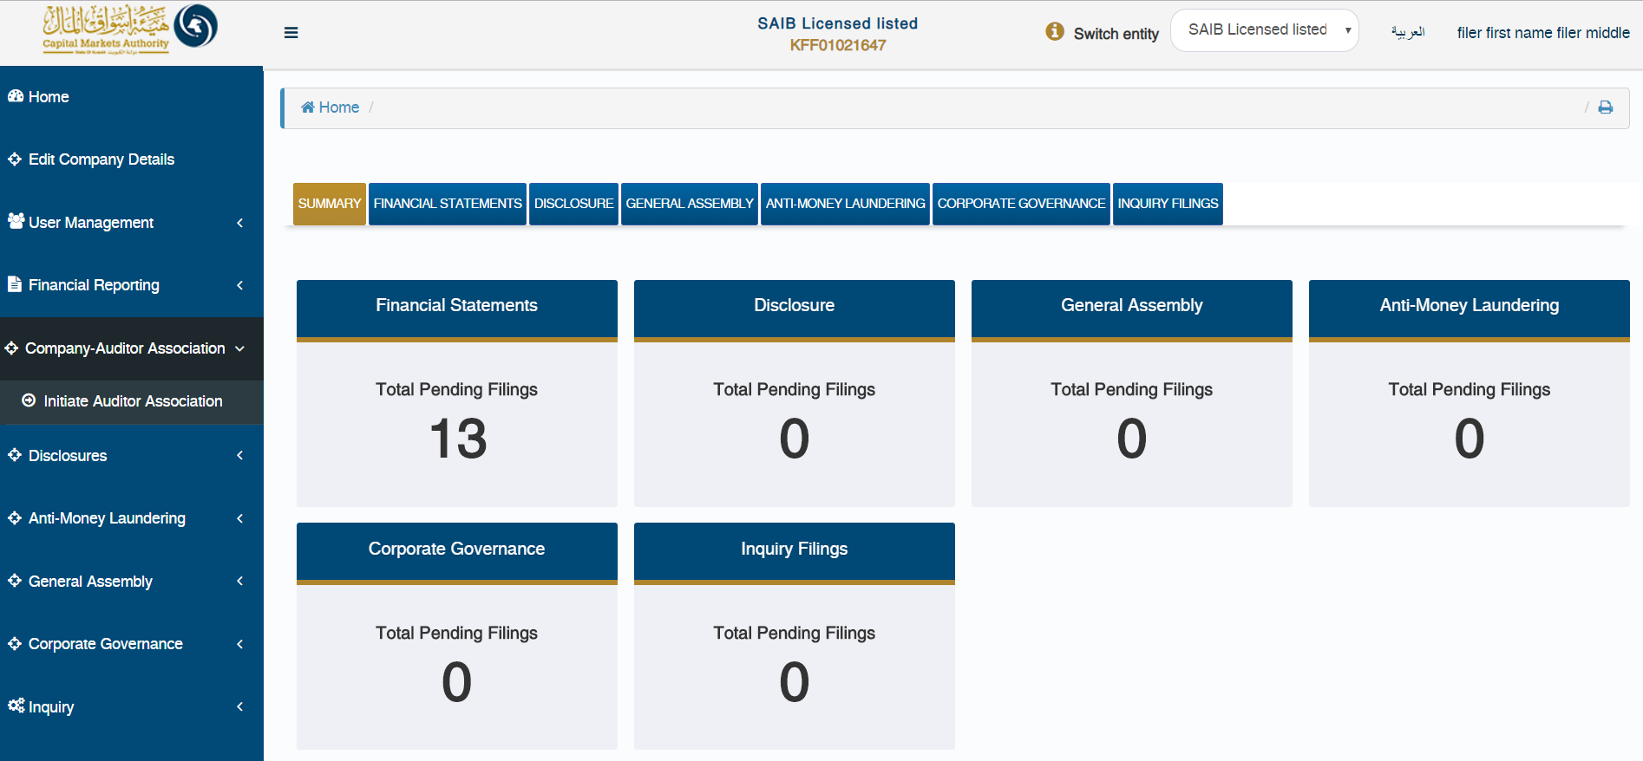

By clicking the ‘Company-Auditor Association’ option from the menu, the CSU will be navigated to the ‘Company Auditor Association’ grid with the list of all existing association details (if any).

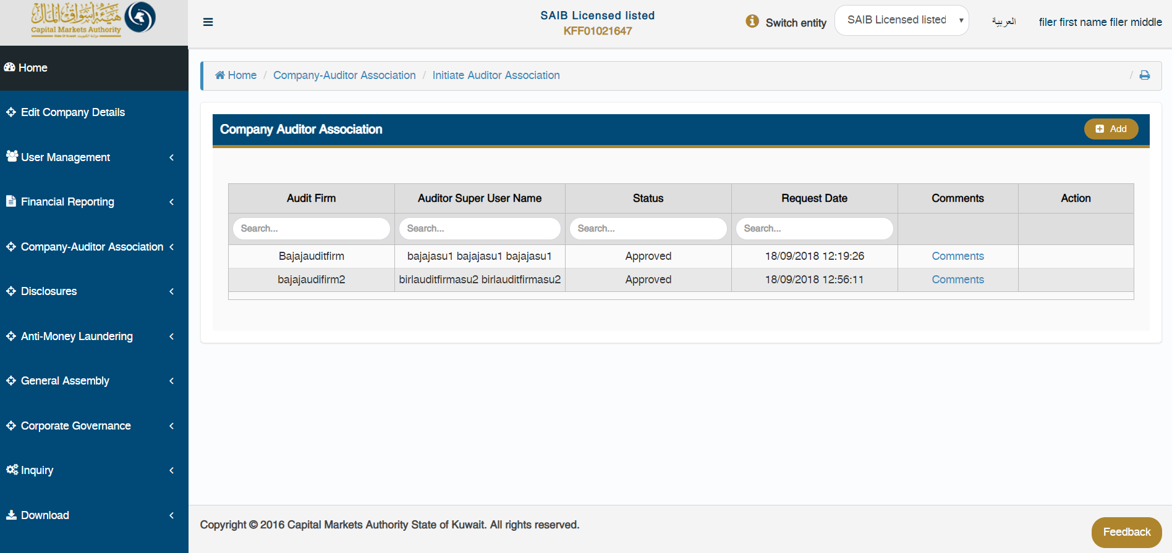

In order to initiate an association with an Auditor firm, the CSU can click on the ‘Add’ button.



By clicking on the ‘Add’ button, the CSU will be required to select the Audit Firm and its respective Auditor Super User (ASU), and submit the data to initiate the association. Once the association is initiated, an email will be sent to the ASU for approval or rejection.

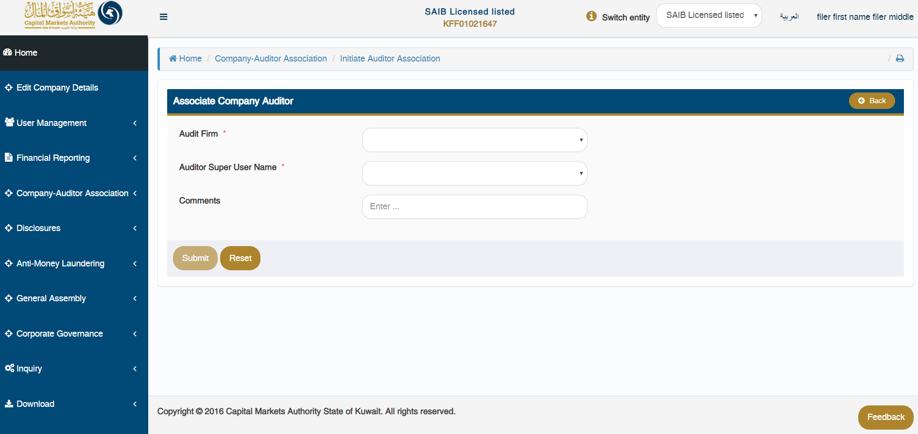

The CSU can view the status of the association initiated in the grid.

## Filing calendar

The CSU can view the filing extension period allowed for specific filing frequency & year by clicking on ‘Financial Statements’ widget on Dashboard or ‘Financial Statement – View Filing Calendar’ menu option.

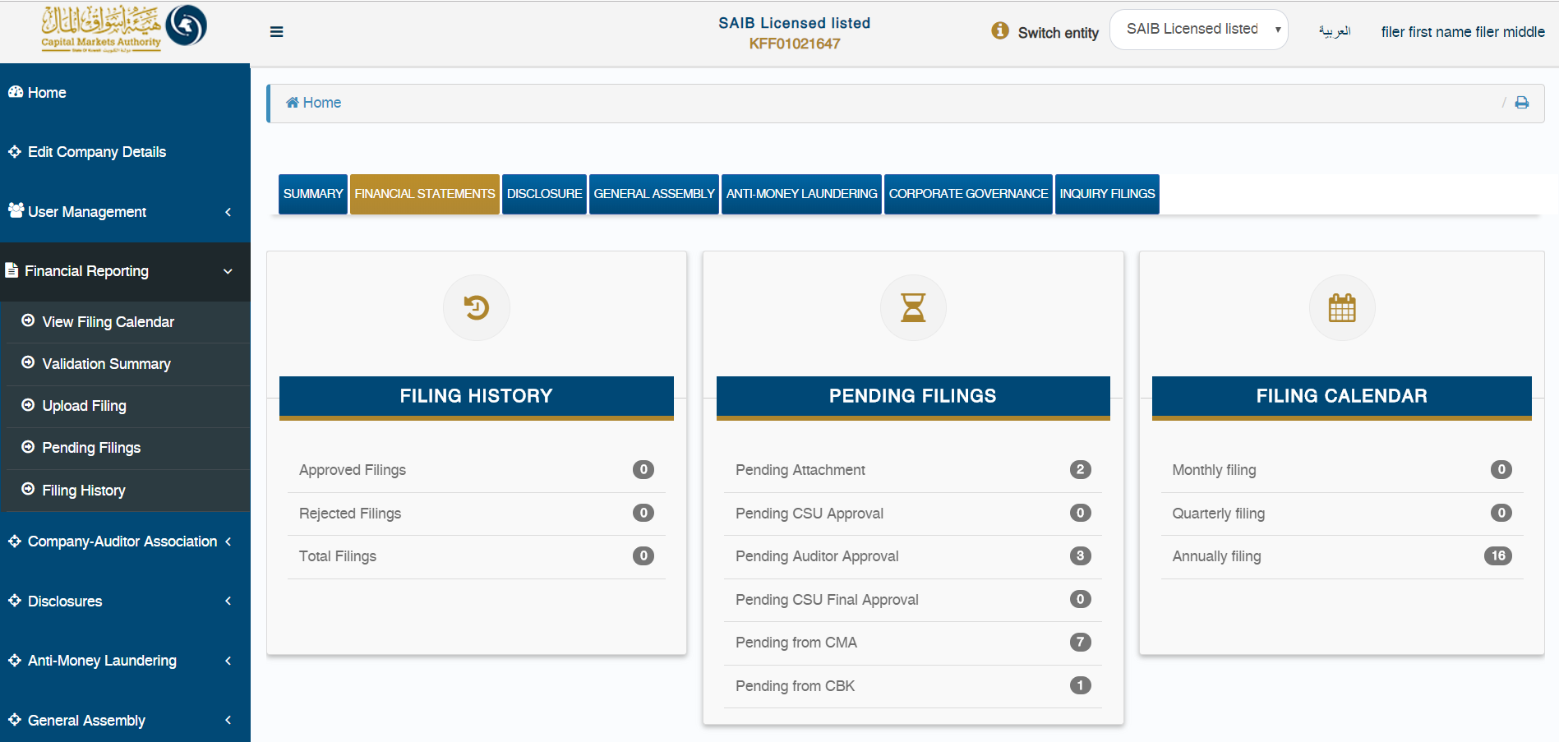

By clicking on either of the above options, the CSU will be redirected to the ‘Filing Calendar Details’ page, where he/she can select the following:

* Filing frequency
* Sector
* Type of Firm
* Financial Year Format
* Year

for which the CSU needs to view the filing period allowed by CMA, in order to upload filing within time. In the event that the CSU/CU uploads a filing after the stated period, the filing will be delayed.

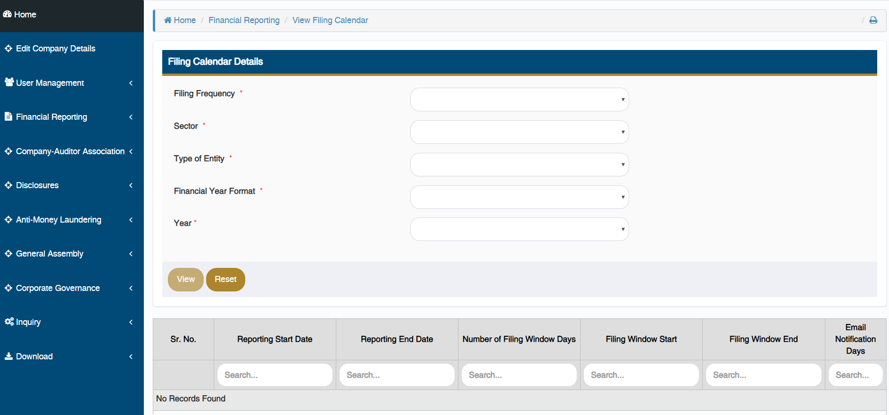

## Upload filing

The CSU can upload the XBRL instance file created from iFile tool on the portal through the ‘Upload XBRL Filing’ page. The CU can navigate to this page from Dashboard by clicking on ‘Submit Filing’ button available at the bottom of the page or using ‘Financial Statements – Upload Filing’ menu option.

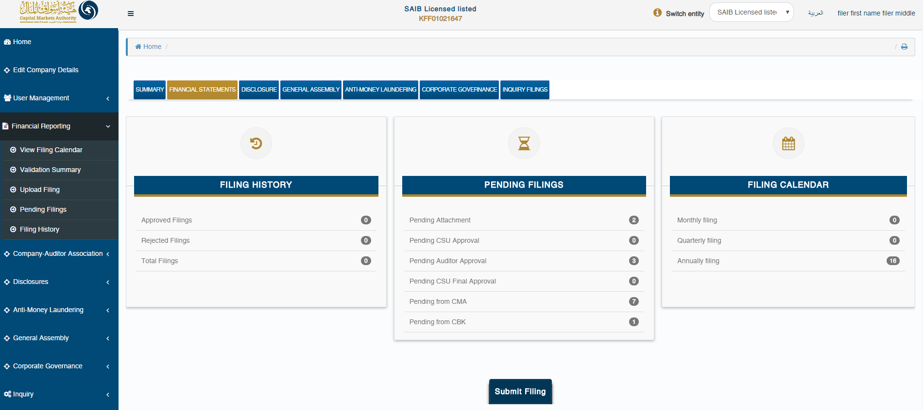

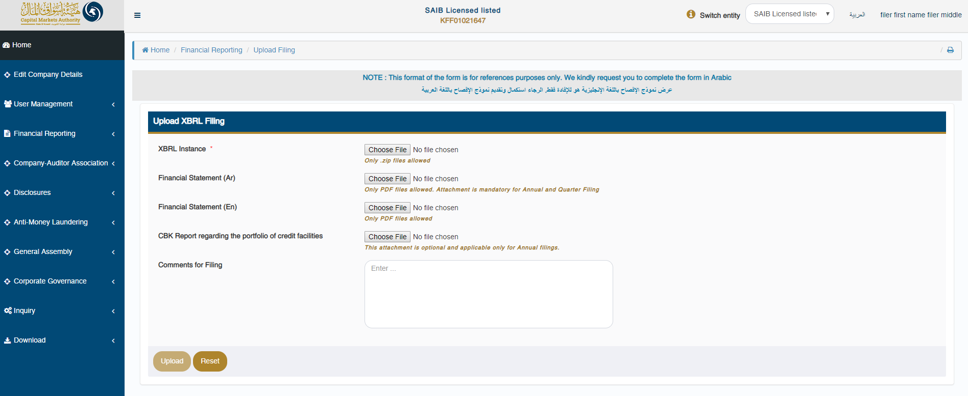

## Following validation status of the filing

Once the XBRL instance file is successfully uploaded on the server, the CSU will be navigated to the ‘Validation Summary’ page, for further validations.



The CSU can check the validation status for that filing on this page. Based on the validation result, the CSU can do either of the following:

* Navigate to ‘Pending Filing’ page if validation is successful or;
* Navigate to ‘Validation Error’ page in case the validation fails by clicking on “View Errors” link available.

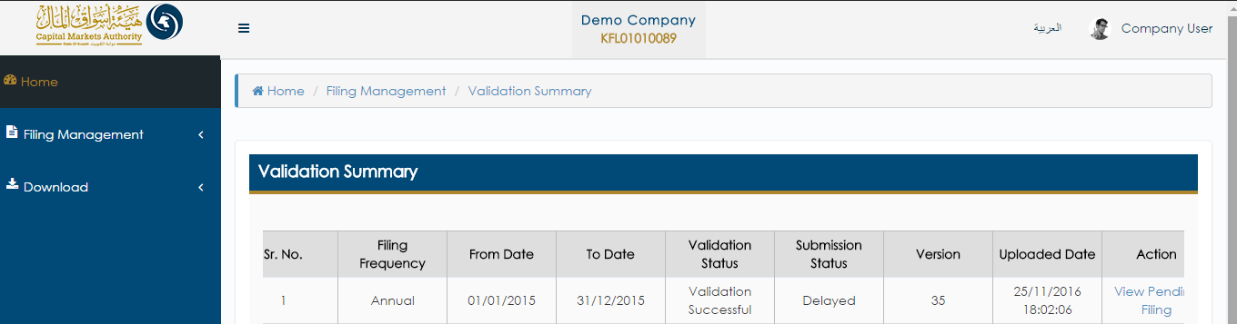

## Pending filing

The CSU can view filings pending his/her approval from by clicking on the ‘(Domain name) – Pending Filings’ menu option, or by selecting either of the tabs on the Dashboard.

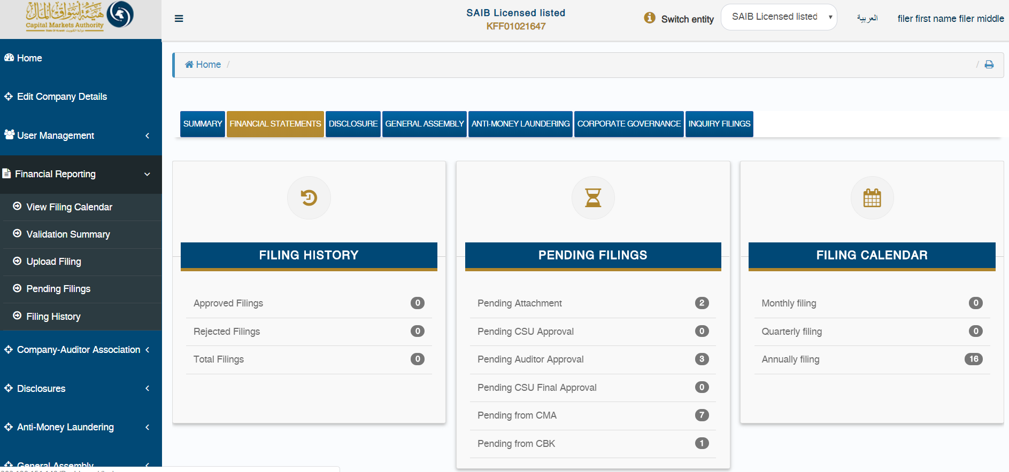

On the ‘Pending Filings’ page, the CSU can view the ‘Filing Status’ & ‘Submission Status’ for any of the filings uploaded for their company. Here, the CSU can also filter records based on various filters.

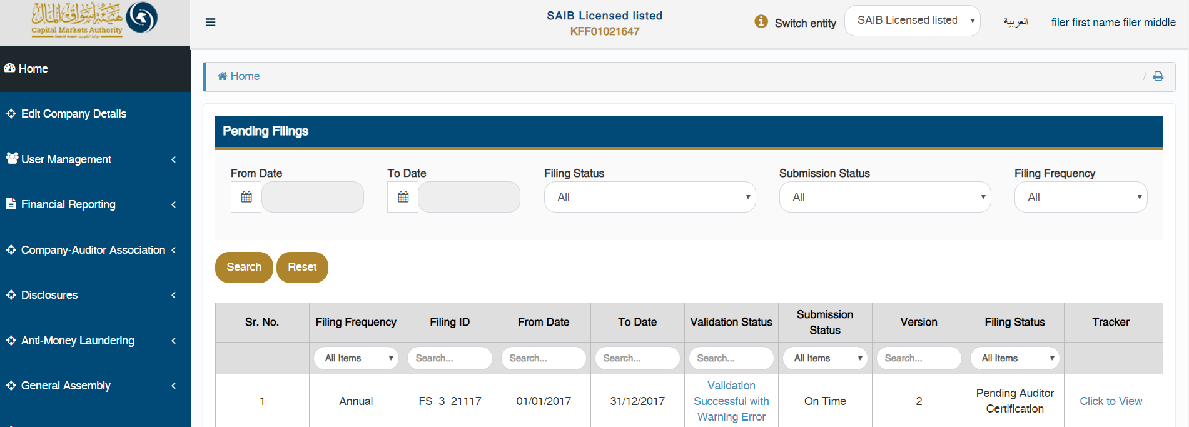

The CSU can view the complete flow of any specific filing by clicking on the ‘Click to View’ link available under ‘View Comments’ column.



The CSU can also hover with the mouse on the number displayed in the tracker, to view who uploaded the filing & when it was uploaded. The CSU can view the comments for each filing status by clicking on ‘?’ icon displayed under each number in the tracker.

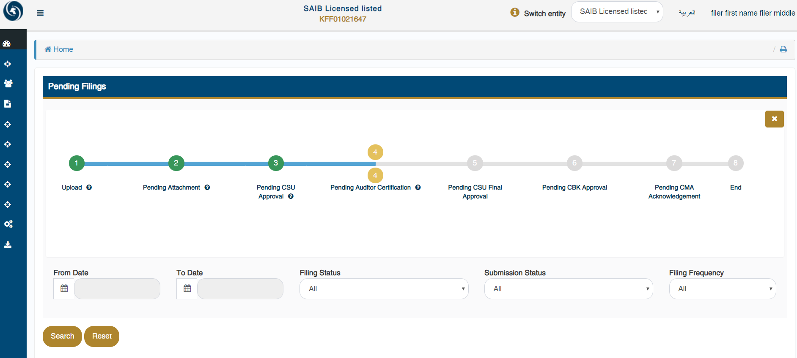

Lastly, the CSU can view/approve/reject the data in the uploaded instance document by clicking on ‘View’ or ‘Approve/Reject’ link available under ‘Action’ column on ‘Pending Filings’ page.

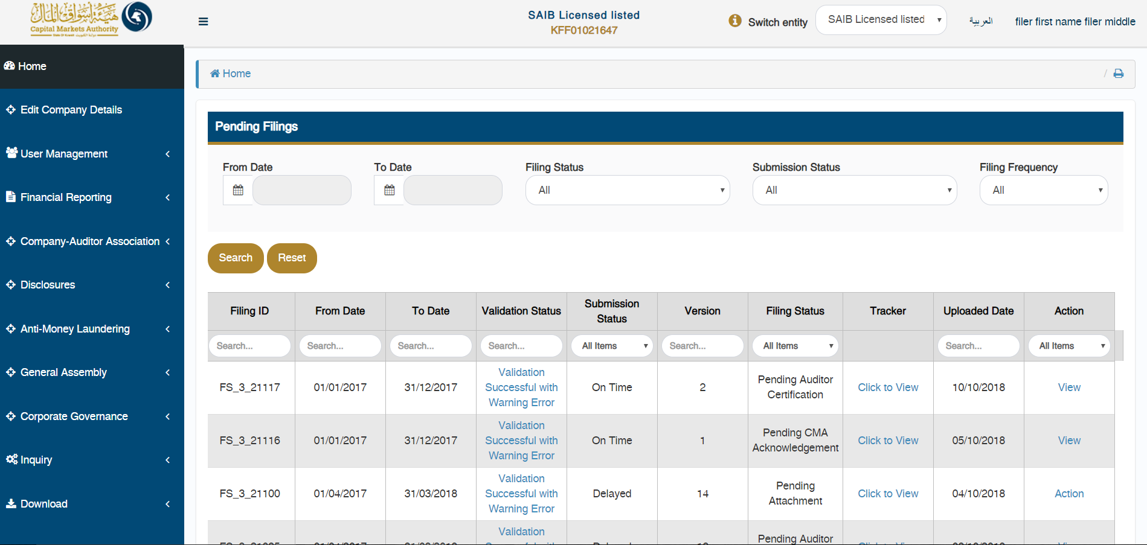

On doing so, the CSU will be able to view all the details of the company, and the filing.

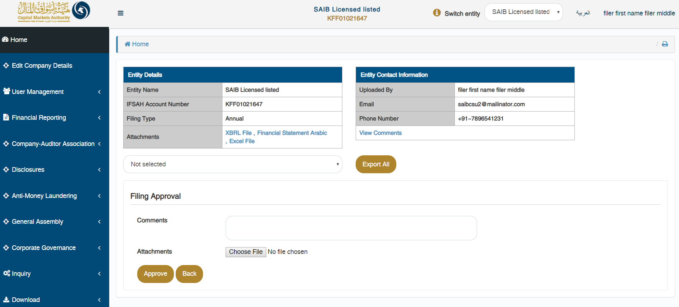

Additionally, the CSU can approve or reject the filing at this stage.



## Viewing history of the filings

The CSU can view the history of all the filings for their company, which have been approved or rejected by clicking on the ‘(Domain name) – Pending Filings’ menu option, or by selecting either of the tabs on the Dashboard.



By clicking on either of the options listed above, the CSU will be able to view the filing history of all submissions.

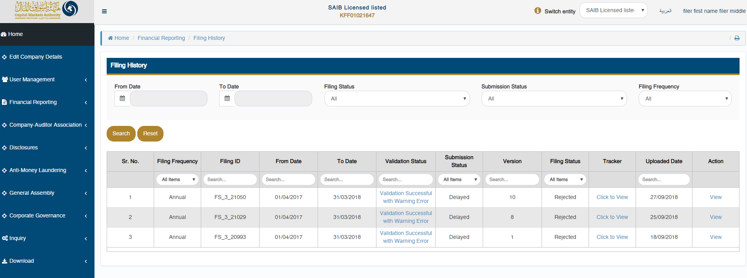

## Inquiry module

The CSU can submit inquiries to the CMA via the inquiry module. This ca be accessed by clicking on ‘Inquiry’ in the menu option. The status of closed inquiries and pending inquiries can be viewed by clicking on the ‘Inquiry filings’ tab on the dashboard.

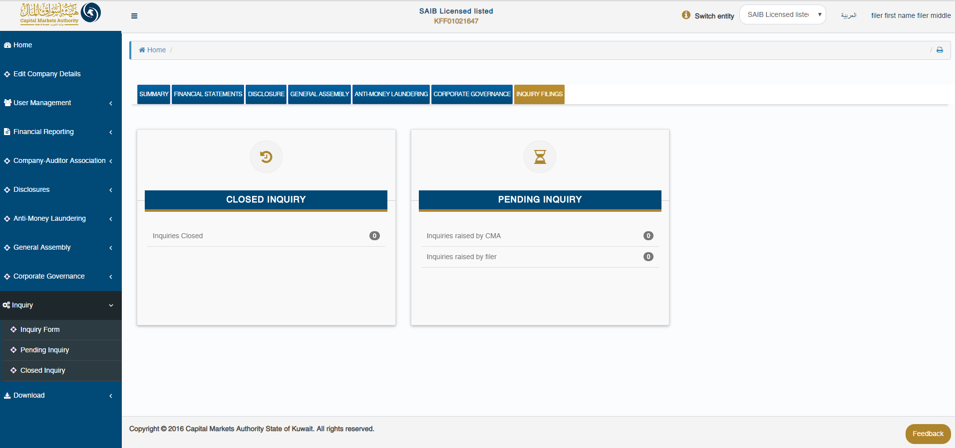

The CSU can access the inquiry form by selecting the ‘Inquiry form’ dropdown under the ‘Inquiry’ option in the menu. Here, the CSU has to select the domain and form name for which the inquiry is being submitted, whilst entering the inquiry in the comment section. The CSU has the option to enter the Filing ID and attachment is relevant and required.

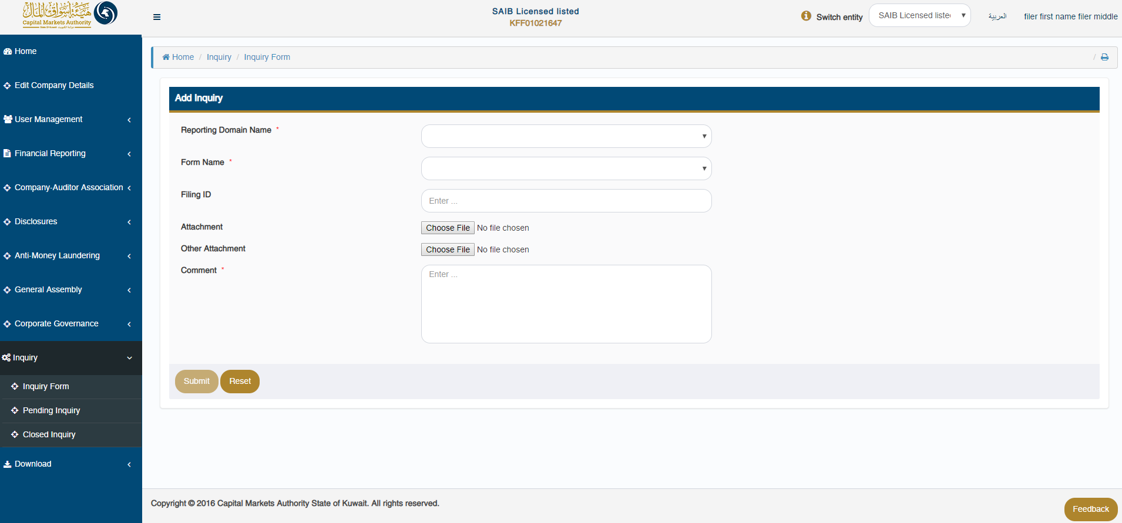

The CSU can review all received/submitted inquiries in a tabular format, while filtering which filing to view based on the following criteria:

* Query Id
* Filing Id
* From Date
* To Date
* Filing Status

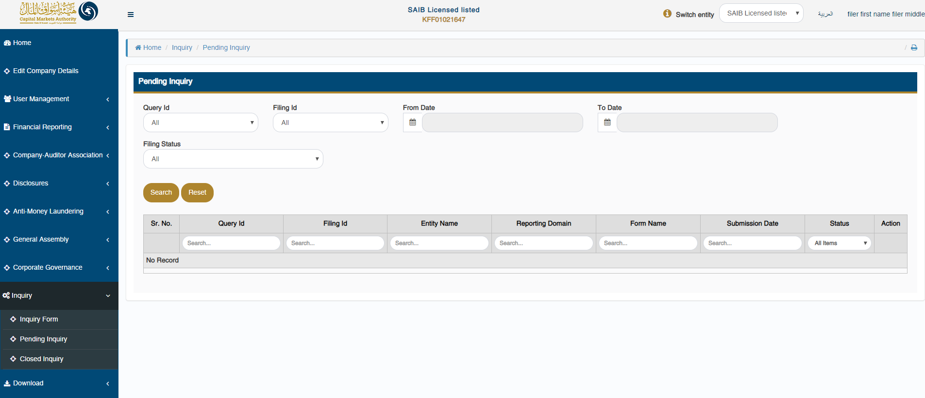

The CSU can review all closed inquiries in a tabular format, while filtering which filing to view based on the following criteria:

* Query Id
* Filing Id
* From Date
* To Date
* Filing Status

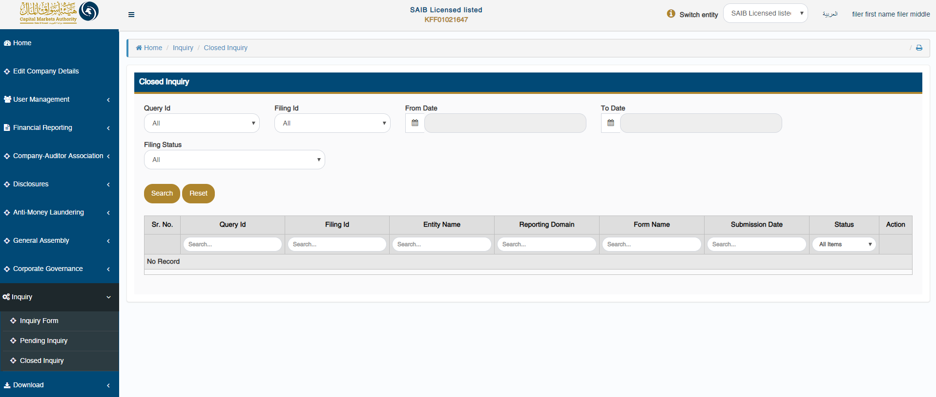

## Downloading the installer

The CSU can download the latest version of the iFile installer by clicking on the ‘Download – Download Installer’ menu option.

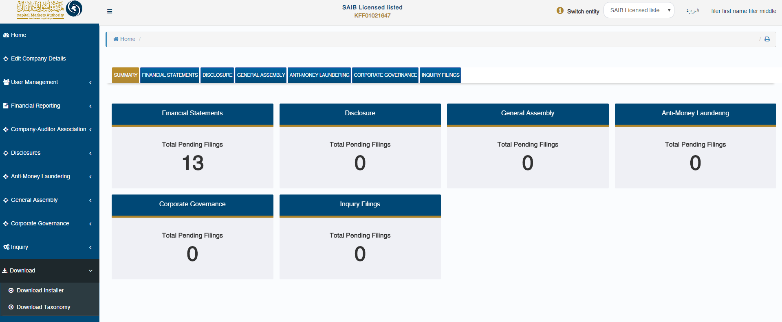

Here, the CSU will have to input the relevant sector by selecting from the drop down field.

Based on their machine’s OS version, the appropriate installer file can be downloaded.

* In order to check the OS version of the machine, the CSU can click on ‘Steps to identify Operating System (OS) Version’
* In order to view the prerequisites required to install the iFile installer, the CSU can click on ‘Pre-requisite for installing the iFile tool’

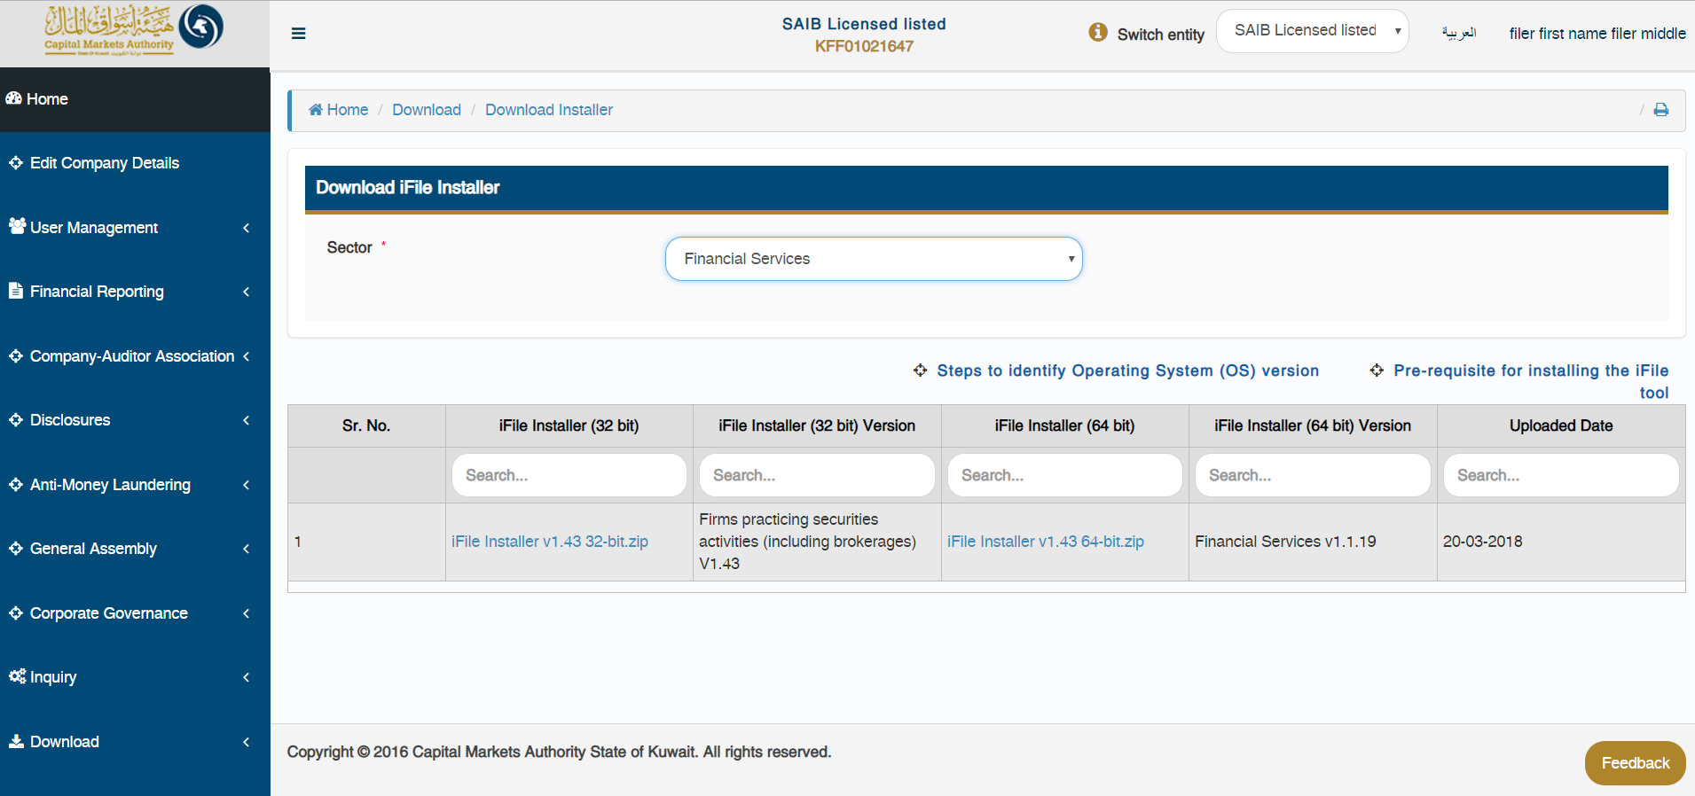

## Downloading the taxonomy template

In order to download the relevant taxonomy templates, the CSU can click on ‘Download – Download Taxonomy’ menu option.



Here, the CSU can select the ‘Sector’ & the ‘Type of Firm’ for which taxonomy file needs to be downloaded.

