**CMA’s XBRL Based Electronic Filing Platform**

**IFSAH**

**Case Study for Brokerage Firms**

Version 1.0



Contents

1. Creating a filing 3

2. Filing information 4

3. Statement of financial position 5

4. Income Statement 10

5. Statement of Comprehensive Income 16

6. Statement of Cash Flows 18

7. Statement of Changes in Equity 22

8. Notes to Financial Statements 25

9. Fair Value through Profit and Loss Investments 26

10. Financial Assets at Fair Value through Other Comprehensive Income 28

11. Financial Assets Carried at Amortized Cost 29

12. Investments in Associates 29

13. Borrowed Funds 30

## Creating a filing

On opening the iFile Tool, the filer can click on the ‘Click here to Create Filing’ button.

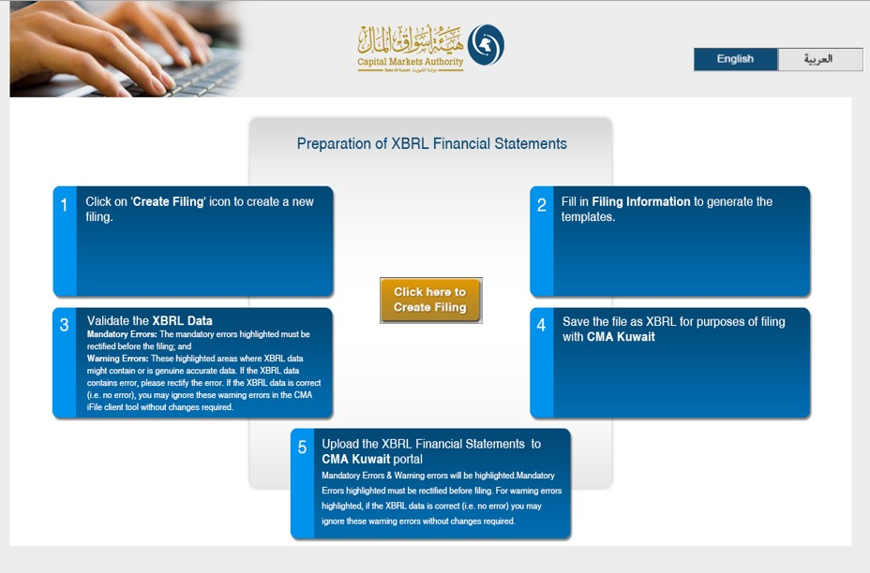

## Filing information

By clicking on the ‘Click here to Create Filing’ button, the user will be redirected to the CMA iFile pop-up, where he/she will be required to input information about the reporting entity.

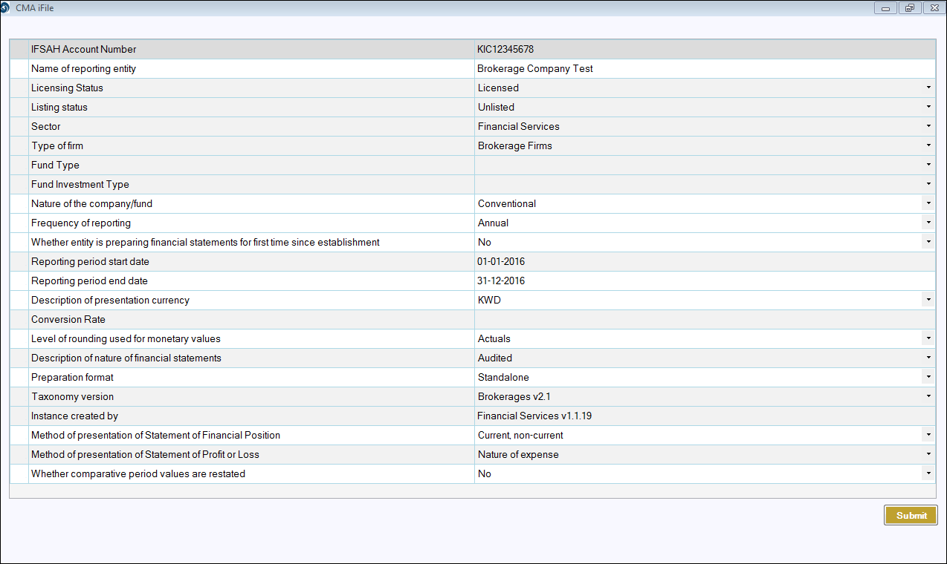

Based on the ‘Method of presentation of Statement of Financial Position’, the filing templates will be generated. In this case, the filer has input current, non-current.



## Statement of financial position

Following is a snapshot of the company’s Statement of Final Position, from the company’s annual report.

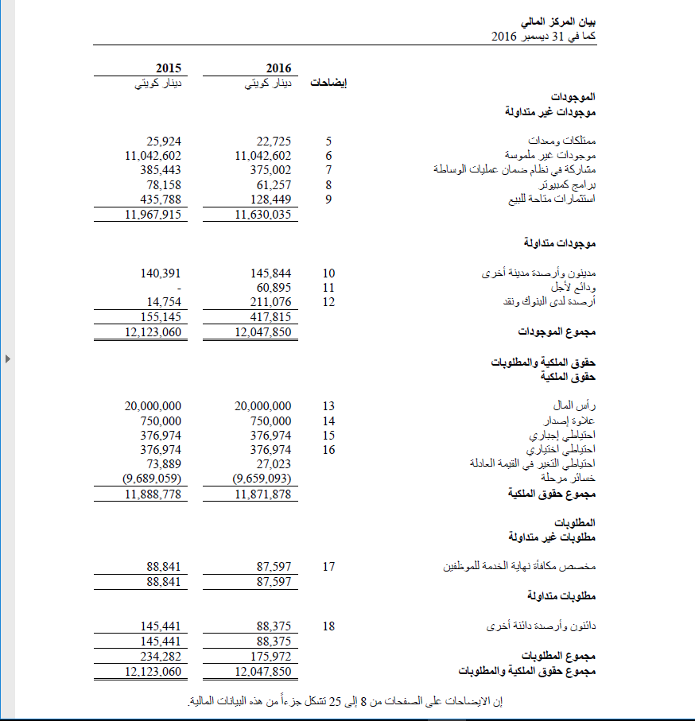

The iFile tool contains two statements for the Statement of Financial Position:

* Statement of financial position, the main statement.
* Subclassifications of assets, liabilities and equity, the sub classification statement.

Some of the concepts in the main statement will be linked to the sub classification statement.

For example, the value of reserves in the main statement is linked to the subclassification.

Following is the extract of the subclassification of reserves as filled in iFile based on the data available in report extract shown above:

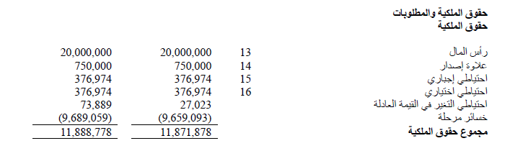

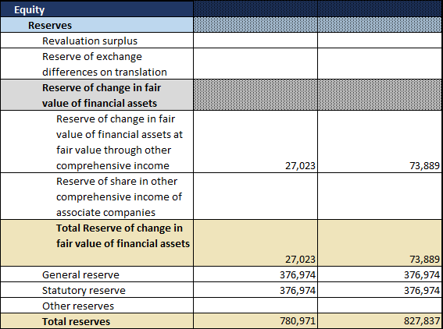

On entering the remaining values, the Statement of Financial Position will be shown in CMA iFile as follows:

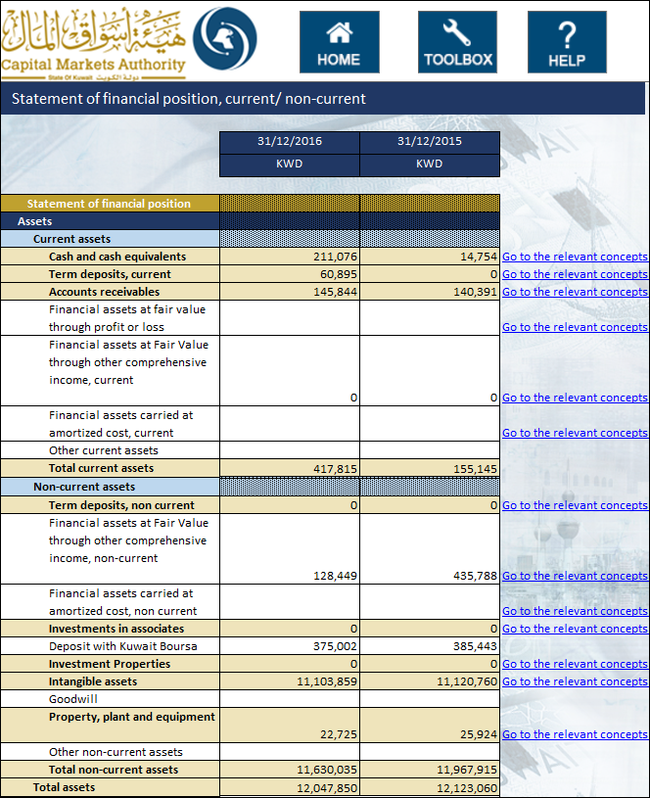

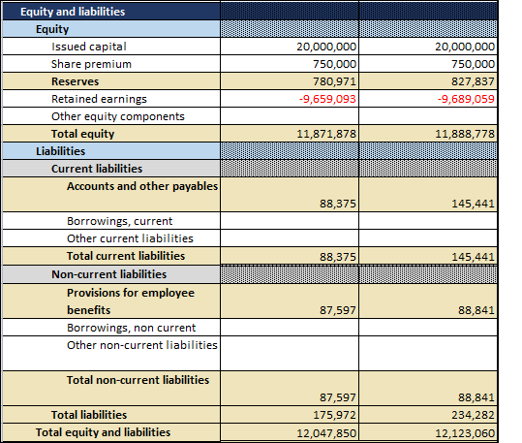

Some of the concepts in the main statement will be linked to the sub classification statement.

The Values in the concepts highlighted in light brown are automatically updated in the main statement when the value is entered in the sub classification statement, except the Totals. By the side of the concepts, linking have been done as ‘*Go to the relevant concepts*’. When the user clicks at ‘Go to the relevant concepts’ the user is directed to the statement from where the values has been derived and vice-versa.

List is as follows:-

* Cash and cash equivalents
* Term deposits, current
* Accounts receivable
* Term deposits, non-current
* Investment in associates
* Investment Properties
* Intangible assets
* Property, plant and equipment
* Reserves
* Accounts and other payables
* Provision for employee benefits

Addition to above, some concepts are linked to the non-standard statements those are as follows:

* Financial assets at fair value through profit or loss
* Financial assets at fair value through other comprehensive income, current
* Financial assets carried at amortized cost, current
* Financial assets at fair value through other comprehensive income, non-current
* Financial assets carried at amortized cost, non-current
* Borrowings, non-current
* Financial assets at fair value through other comprehensive income
* Financial assets carried at amortized cost
* Borrowings

Following is the list of business concepts for which mandatory inputs are required. In the event that the company does not have any inputs, the user can input ‘0’, and the same will be displayed in the final filing document.

* Total assets
* Total equity
* Total liabilities
* Cash and cash equivalents
* Issued capital
* Retained earnings

Additionally, for the following concepts, when the user enters a positive value in the CMA iFile, that value will be deducted from the total, and vice-versa. For example, if the user enters a positive value for ‘Provisions on term deposits’, the value will be deducted from the total concept ‘Total term deposits’.

Following is the list of elements that have a negative effect on the total:

* Provisions on term deposits
* Provisions on trade and other receivables
* Provisions on term deposits, current
* Provisions accounts receivables (current)
* Provisions on term deposits, non-current

## Income Statement

Following is the Statement of Income from the Report:

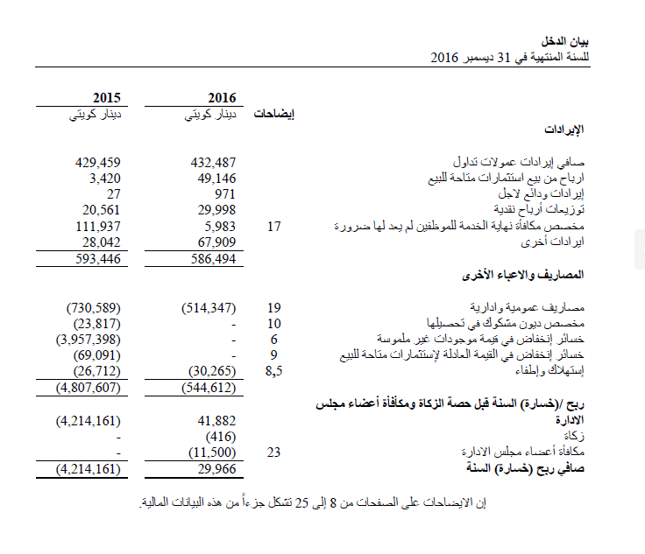The iFile tool contains two statements for the Statement of Comprehensive Income:

* Income statement, the main statement
* Analysis of income and expenses, the analysis statement.Some of the concepts in the main statement will be linked to the subclassification statement. For example, the detail for income from fees and commissions is linked to the sub classification.

Following is the extract of the details from fees and commissions:

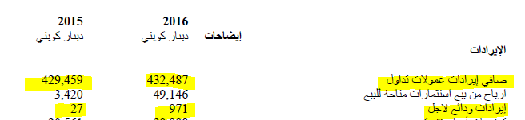

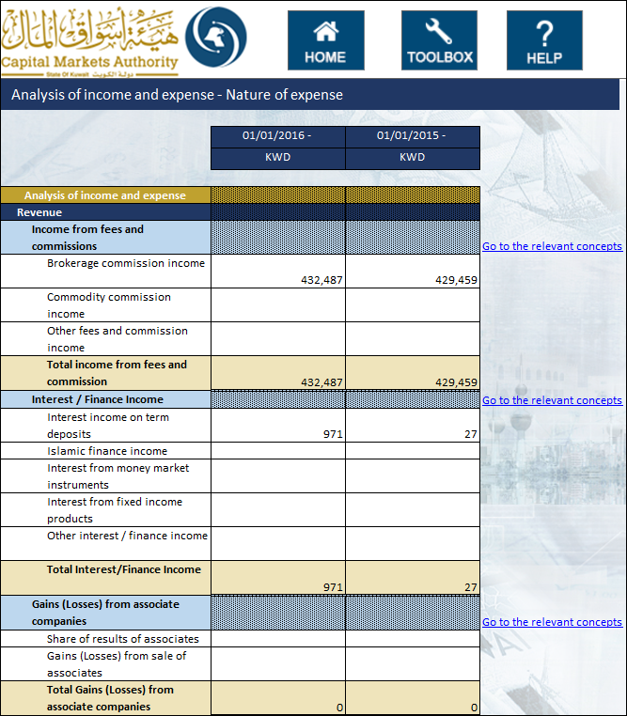

The User can input the values for all other concepts directly in the main statement where reporting in ‘Analysis of income and expenses’ is not required. After entering all values, the Income statement shown in iFile will display the following:

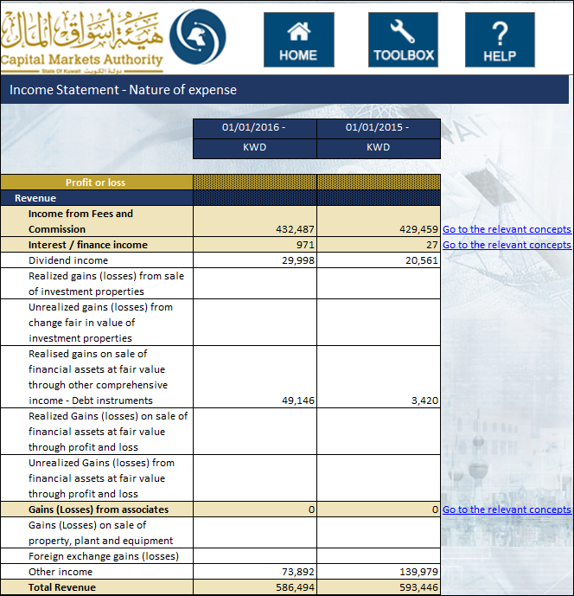

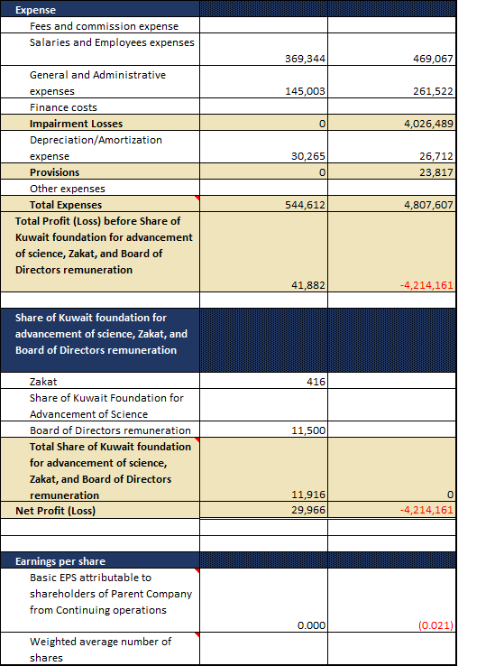

*Kindly note that in the iFile tool, the earnings per share are shown in Kuwaiti Dinar (KWD). As the company has reported earnings per share in fils, the same has been converted in KWD and entered in iFile as shown above.*

The Values in the concepts highlighted in light brown are automatically updated in the main statement when the value is entered in the Analysis statement, except the totals. By the side of the concepts, linking have been done as ‘*Go to the relevant concepts*’. When the user clicks at ‘Go to the relevant concepts’ the user is directed to the statement from where the values has been derived and vice-versa.

List is as follows:-

* Income from Fees and Commission
* Interest / finance income
* Gains (Losses) from associates
* Impairment Losses

Following is the list of elements that have a negative effect on the total:

* Total expenses
* Total Share of Kuwait foundation for advancement of science, Zakat, and Board of Directors remuneration

Following is the list of business concepts for which mandatory inputs are required. In the event that the company does not have any inputs, the user can input ‘0’, and the same will be displayed in the final filing document.

* Total revenue
* Total expenses
* Net profit (loss)
* Total comprehensive income

## Statement of Comprehensive Income

Following is the Statement of Comprehensive Income from the Report:

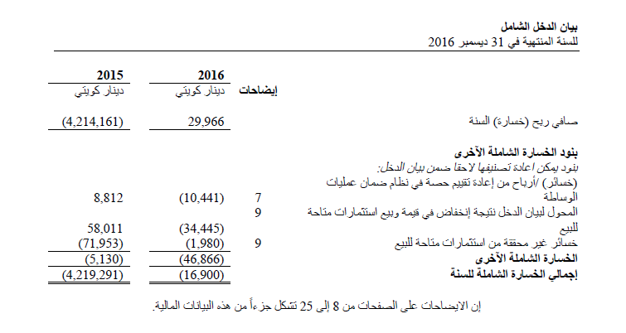

The details in iFile are as follows:

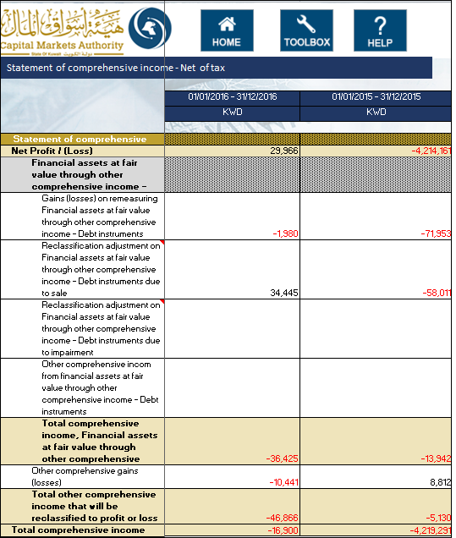

Following is the list of elements that have a negative effect on the total:

* Reclassification adjustments on exchange differences on translation
* Reclassification adjustment on Financial assets at fair value through other comprehensive income - Debt instruments due to sale
* Reclassification adjustment on Financial assets at fair value through other comprehensive income - Debt instruments due to impairment

## Statement of Cash Flows

Following is the Statement of Cash flow from the Report:

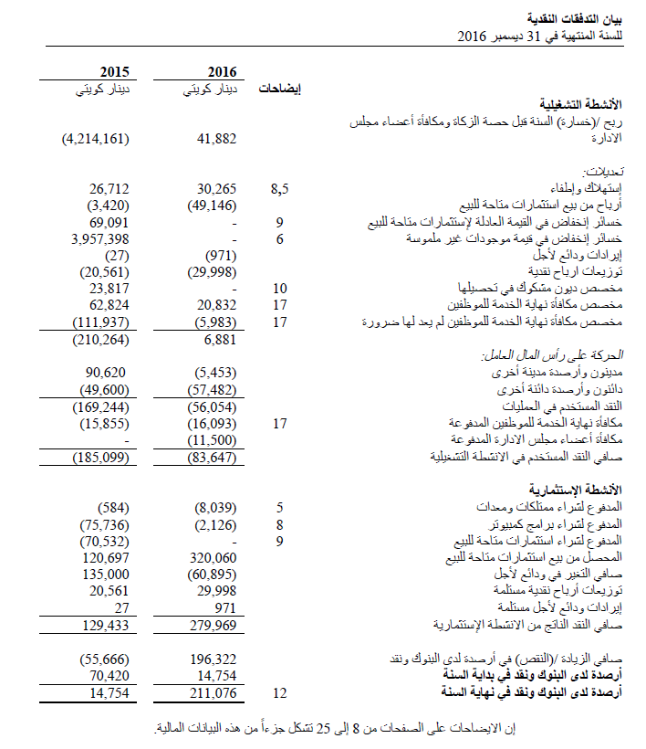

The details in iFile are as follows:

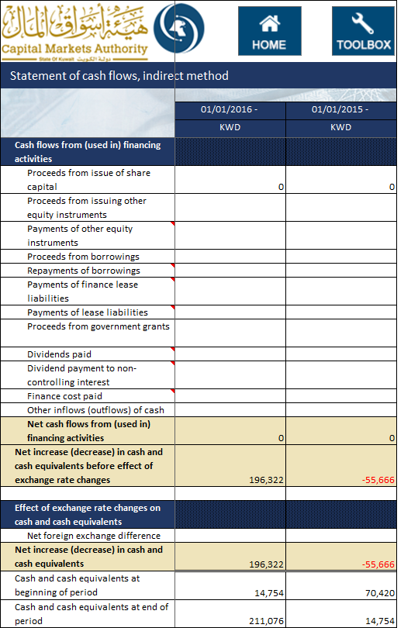

Following is the list of elements that have a negative effect on the total:

* Adjustments for dividend income
* Adjustments for Interest / finance income
* Adjustments for Share of results of associates
* Payment for employee end of term benefits
* Purchase of property, plant and equipment
* Purchase of intangible assets
* Purchase of investment properties
* Purchase of Financial assets at fair value through profit or loss
* Purchase of Financial assets carried at amortized cost
* Acquisition of Investments in associates
* Purchase of financial assets at fair value through other comprehensive income
* Purchase of other long-term assets
* Payments of other equity instruments
* Repayments of borrowings
* Payments of finance lease liabilities
* Payments of lease liabilities
* Dividends paid
* Dividend payment to non-controlling interest
* Finance cost paid

## Statement of Changes in Equity

Following is the Statement of Changes in Equity from the Report:

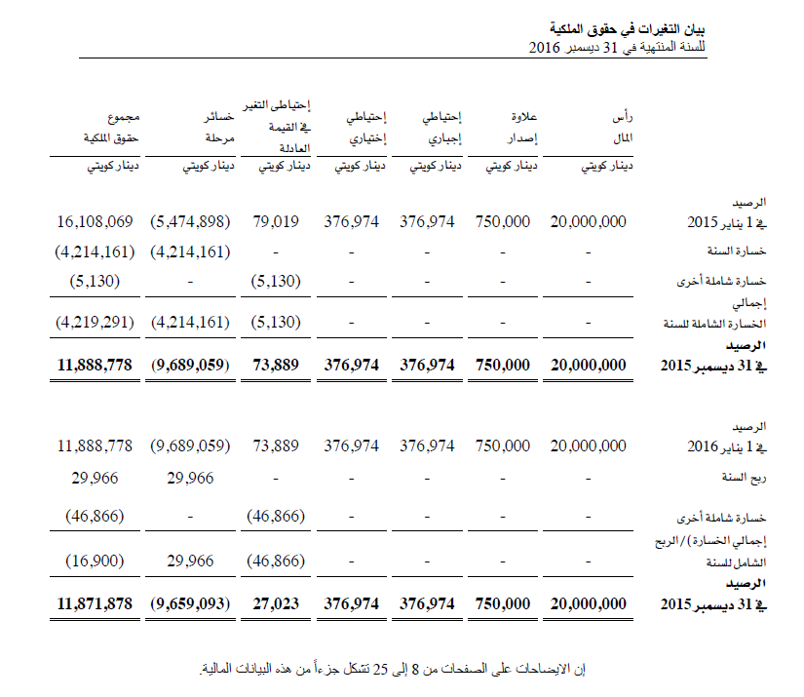

The details in iFile are as follows:

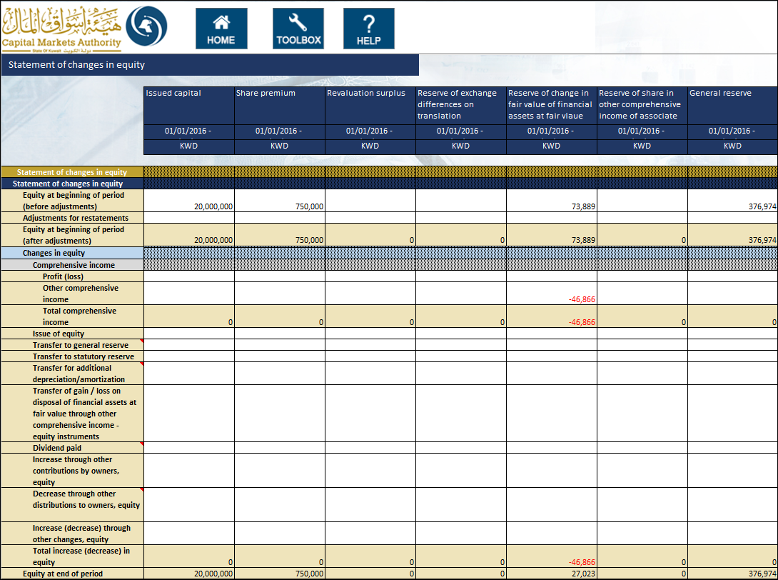

When the value for ‘Preparation format’ in Filing information selected is “Standalone” then Total equity attributable to the parent company and Non-Controlling interests column will be disabled.

The information input in this template will have to match that inputted as part of the information inputted in the Balance Sheet.

* The value reported for ‘Issued capital’ in the Statement of changes in equity template must equal the value for ‘Issued capital’ in the Statement of financial position template
* The value reported for ‘Share premium’ in the Statement of changes in equity template must equal the value for ‘Share premium’ in the Statement of financial position template
* The value reported for ‘Revaluation surplus’ in the Statement of changes in equity template must equal the value for ‘Revaluation surplus’ in the Statement of financial position template
* The value reported for ‘Reserve of exchange differences on translation’ in the Statement of changes in equity template must equal the value for ‘Reserve of exchange differences on translation’ in the Statement of financial position template
* The value reported for ‘Reserve of change in fair value of financial assets at fair value through other comprehensive income’ in the Statement of changes in equity template must equal the value for ‘Reserve of change in fair value of financial assets at fair value through other comprehensive income’ in the Statement of financial position template
* The value reported for ‘Reserve of share in other comprehensive income of associate companies’ in the Statement of changes in equity template must equal the value for ‘Reserve of share in other comprehensive income of associate companies’ the Statement of financial position template
* The value reported for ‘General reserve’ in the Statement of changes in equity template must equal the value for ‘General reserve’ the Statement of financial position template
* The value reported for ‘Statutory reserve’ in the Statement of changes in equity template must equal the value for ‘Statutory reserve’ the Statement of financial position template
* The value reported for ‘Other reserves’ in the Statement of changes in equity template must equal the value for ‘Other reserves’ the Statement of financial position template
* The value reported for ‘Retained earnings (accumulated Losses)’ in the Statement of changes in equity template must equal the value for ‘Retained earnings (accumulated Losses)’ the Statement of financial position template
* The value reported for ‘Other equity components’ in the Statement of changes in equity template must equal the value for ‘Other equity components’ the Statement of financial position template
* The value reported for ‘Equity attributable to owners of parent’ in the Statement of changes in equity template must equal the value for ‘Equity attributable to owners of parent’ the Statement of financial position template (only in case of Consolidated)
* The value reported for ‘Non-controlling interests’ in the Statement of changes in equity template must equal the value for ‘Non-controlling interests’ the Statement of financial position template (only in case of Consolidated)

Following is the list of elements that have a negative effect on the total:

* Transfer to general reserve
* Transfer for additional depreciation/amortization
* Dividend paid
* Decrease through other distributions to owners, equity

## Notes to Financial Statements

The notes to financial statements can be added to CMA iFile as text block. For example, following is the Related Party note documented in the Annual Report:

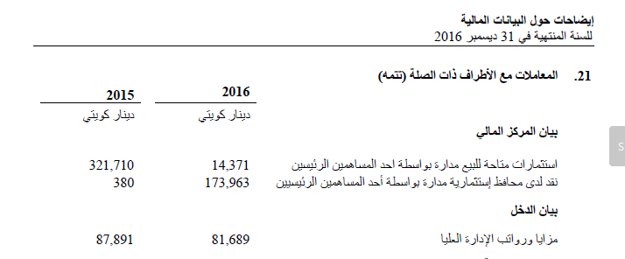

To add this note, the text editor can be opened by double clicking the text-block field for notes as shown below:

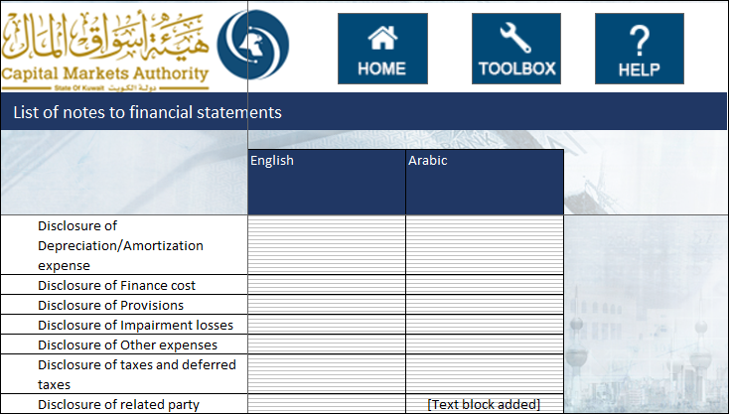

The user can add the disclosure for notes to financial statements and it will be included as a text block in the XBRL output of the CMA iFile. The user can enter the notes in both English and Arabic for the same period. Following is the example of text editor with a note added:

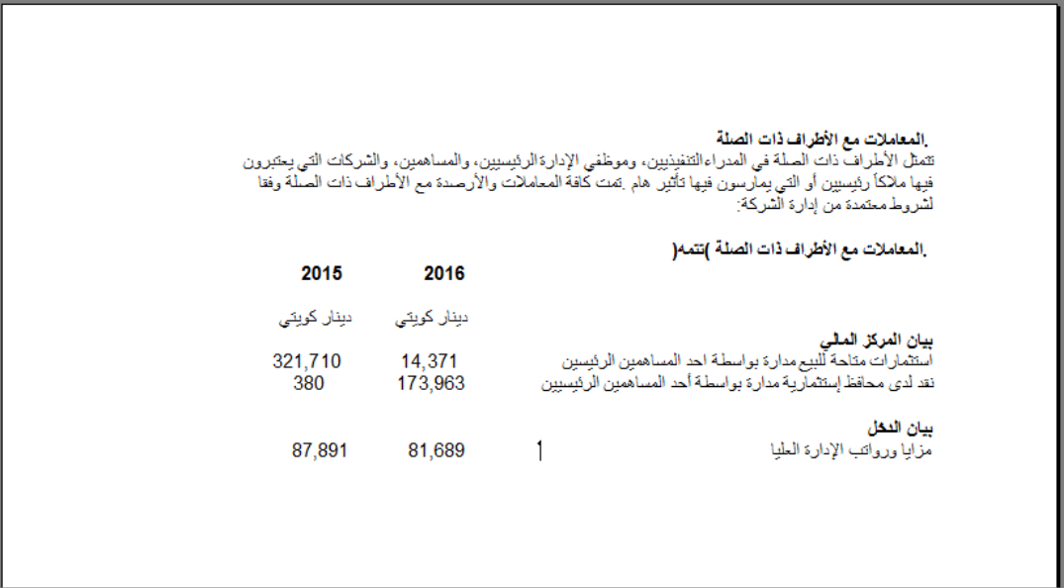*Kindly note that the text blocks for notes to financial statements in Arabic are mandatory.*

## Fair Value through Profit and Loss Investments

The user can input information pertaining to the companies FVTPL investments, for the local and foreign, listed and unlisted investments. For each of the investments, the user will be required to input the following information:

* Investment Type
* Type of product
* Investment products list
* Name
* Region
* Country
* Number of shares
* Cost per share
* Total Cost
* Market value per share
* Total market value
* Date of last valuation of unquoted shares
* Realized Gains / (Losses)
* Unrealized Gains / (Losses)
* Underlying Currency
* Credit Rating (for debt instruments)

The information input in this template will have to match that inputted as part of the information inputted in the Balance Sheet and Income Statement.

* The sum of the ‘Total Market Value’ in the Fair Value Through Profits and Loss Investments template must equal the ‘Financial Assets at Fair Value through profit or loss’ in the Statement of financial position, current/non-current template
* The sum of the ‘Realized Gains / (Losses)’ in the Fair Value Through Profits and Loss Investments template must equal the ‘Realized gains (losses) on sale of financial assets at fair value through profit and loss’ in the Income Statement, nature of expense template
* The sum of the ‘Unrealized Gains / (Losses)’ in the Fair Value Through Profits and Loss Investments template must equal the ‘Unrealized gains (losses) on sale of financial assets at fair value through profit and loss’ in Income Statement, nature of expense template

## Financial Assets at Fair Value through Other Comprehensive Income

The user can input information pertaining to the companies FAFVOCI investments, for the local and foreign, listed and unlisted investments. For each of the investments, the user will be required to input the following information:

* Investment Type
* Type of product
* Investment products list
* Name
* Region
* Country
* Number of shares
* Cost per share
* Total Cost
* Market value per share
* Total Market Value
* Date of last valuation of unquoted shares
* Realized Gains / (Losses)
* Change in Fair Value during the period
* Impairment loss during the period
* Accumulated Impairment Balance
* Reserve of change in Fair value
* Underlying Currency
* Credit Rating (for debt instruments)

The information input in this template will have to match that inputted as part of the information inputted in the Balance Sheet and Income Statement.

* The sum of the ‘Total Market Value’ in the Financial Asset at Fair Value through Other Comprehensive Income template must equal the sum of ‘Financial asset at fair Value through other comprehensive income, current’ and ‘Financial asset at fair Value through other comprehensive income, non-current’ in the Statement of financial position, current/non-current template
* The sum of the ‘Realized Gains / (Losses)’ in the Financial Asset at Fair Value through Other Comprehensive Income template must equal the ‘Realized gains on sale of financial assets at fair value through other comprehensive income - Debt instruments’ in the Income Statement, Nature of expenses template and Transfer of gain / loss on disposal of financial assets at fair value through other comprehensive income - equity instruments in the Statement of changes in equity template.
* The sum of the ‘Change in Fair Value during the Period’ in the Financial Asset at Fair Value through Other Comprehensive Income template must equal the ‘Net fair value change on financial assets at fair value through other comprehensive income - equity instruments’ and ‘Gains (losses) on re-measuring Financial assets at fair value through other comprehensive income - Debt instruments’ in the Statement of comprehensive income - Net of tax statement template.

## Financial Assets Carried at Amortized Cost

The user can input information pertaining to the companies FACAC investments, for the local and foreign, listed and unlisted investments. For each of the investments, the user will be required to input the following information:

* Investment Type
* Name
* Region
* Country
* Product Type
* Acquisition Date/Start Date
* Underlying Currency
* Carrying amount
* Amortized cost
* FX Translation Change
* Maturity
* Credit Rating
* Fair Value

The information input in this template will have to match that inputted as part of the information inputted in the Balance Sheet and Income Statement.

* The sum of the ‘Carrying amount’ in the Financial Assets Carried at Amortized Cost template must equal the ‘Financial assets carried at amortized cost, current’ and ‘Financial assets carried at amortized cost, non-current’ in the Statement of financial position, current/non-current template.

## Investments in Associates

The user can input information pertaining to the company’s Investment in associates, for the local and foreign investments. For each of the investments, the user will be required to input the following information:

* Name
* Region
* Country
* Listing Status
* Investment Type
* Underlying Currency
* Carrying amount (Ending)
* Carrying amount (Beginning)
* Percentage of ownership
* Dividend received
* Impairment expense / (reversal)
* Share of Results
* Share of Other Comprehensive Income
* FX Translation Change
* Other movement
* Acquisitions/ Disposals/ Redemption
* Fair value (for listed investment based on market price)

The information input in this template will have to match that inputted as part of the information inputted in the Balance Sheet and Income Statement.

* The sum of the ‘Carrying amount (Ending) in the Investment in associates template must equal the ‘Investment in associates’ in the Statement of financial position, current/non-current template

## Borrowed Funds

The user can input information pertaining to the company’s borrowed funds. The user will be required to input the following information:

* Name of Bank / Financial Institution
* Region
* Country
* Underlying Currency
* Loan Type
* Amount
* Interest Rate
* Status
* Collateral Amount
* Collateral Type
* Due Date
* Payment Frequency
* Are there covenants?
* Purpose

The information input in this template will have to match that inputted as part of the information inputted in the Balance Sheet.

* The sum of the ‘Amount’ in the borrowed fund template must equal the ‘Borrowings’ in the Statement of financial position, order of liquidity template.
* The sum of the ‘Amount’ in the Borrowed fund template must equal the sum of ‘Long term borrowing’ and ‘Short term borrowing’ in the Statement of financial position, current/non-current template