**CMA’s XBRL Based Electronic Filing Platform**

**IFSAH**

**Instruction Manual for Company Users**

Version 1.0



Contents

1. Accessing the IFSAH Portal 3

2. Registration 3

3. Log – In 4

4. Dashboard 4

5. Upload filing 5

6. Pending filing 6

7. Viewing history of the filings 9

8. Inquiry module 10

## Accessing the IFSAH Portal

The Company Users (CUs) can access the IFSAH portal through any browser, as long as they are connected to the internet. CUs can then login into the IFSAH portal through the following link

<https://ifsah.cma.gov.kw.>

## Registration

The CU will be registered by Company Super User (CSU), after which an email with the username and a One Time Password (OTP) will be sent to the CU. The CU can login into the IFSAH portal with the username and the OTP. This portal can be accessed in either English or Arabic.

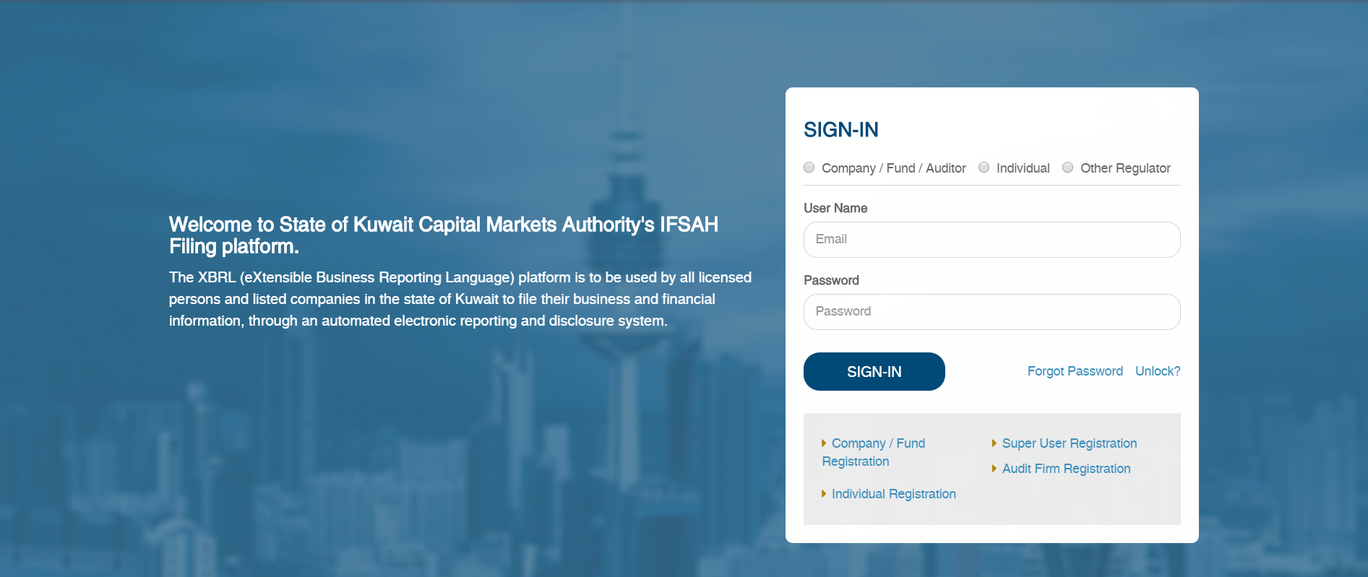

## Log – In

Once the CU has successfully logged in with the OTP, the CU will be navigated to the “Change Password” page to set a new password.

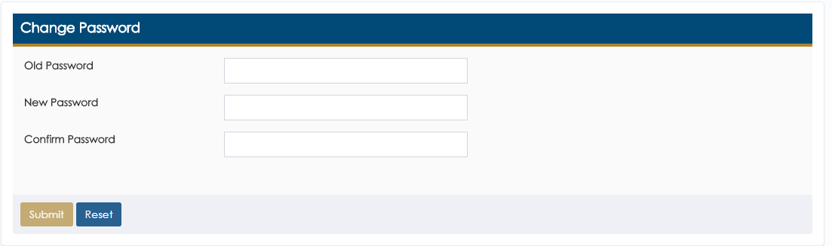

Upon setting the new password, the CU will be required to login in again with the new password.

## Dashboard

On logging into the portal successfully, the CU will be navigated to the Dashboard.

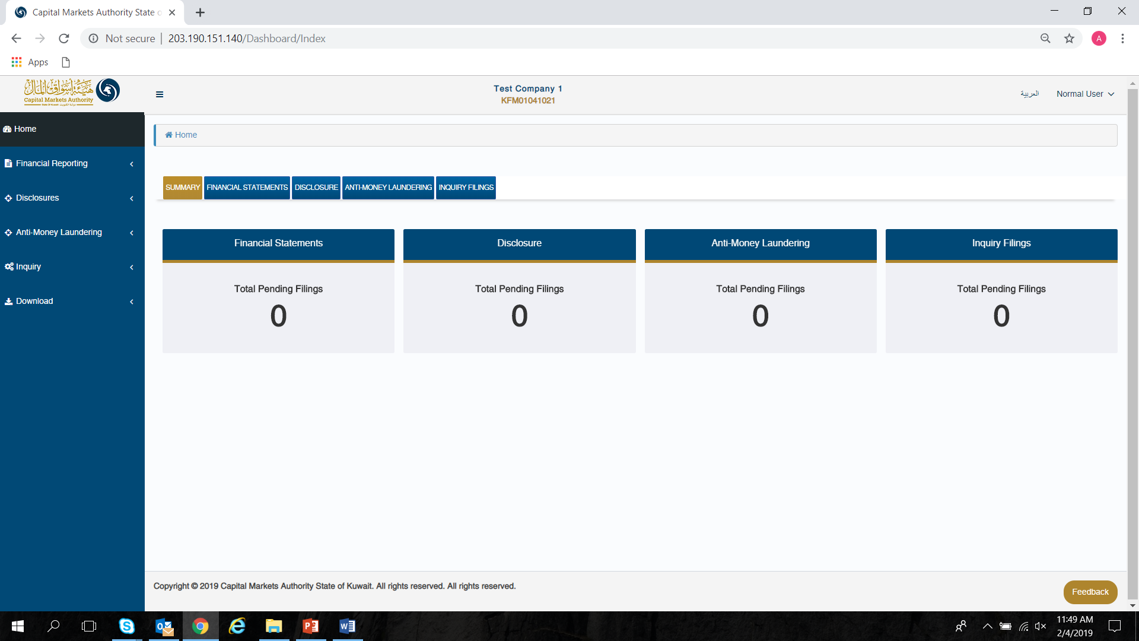

## Upload filing

The CU can submit AML filing through the ‘Anti Money Laundering Form’ page. The CU can navigate to this page using ‘Anti Money Laundering – Anti Money Laundering Form’ menu option.

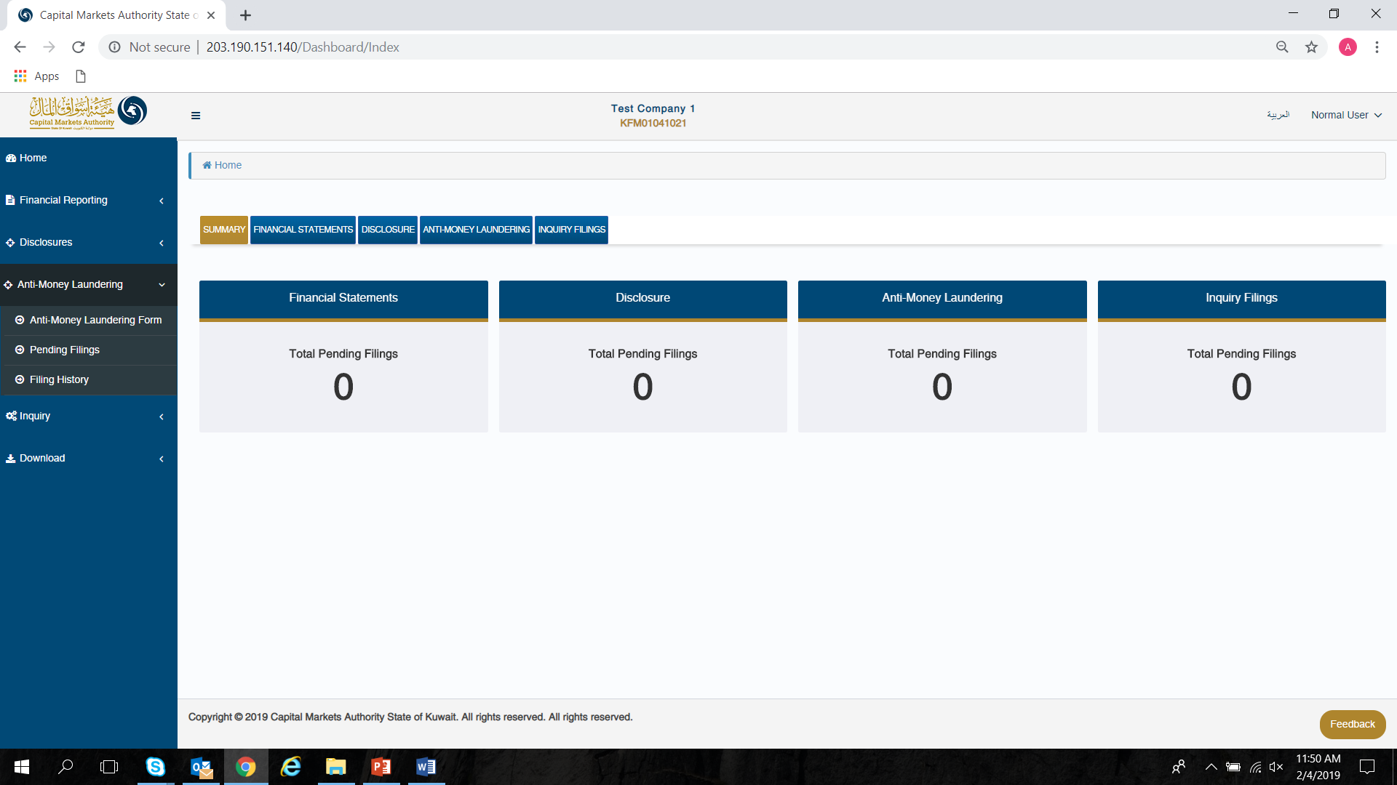

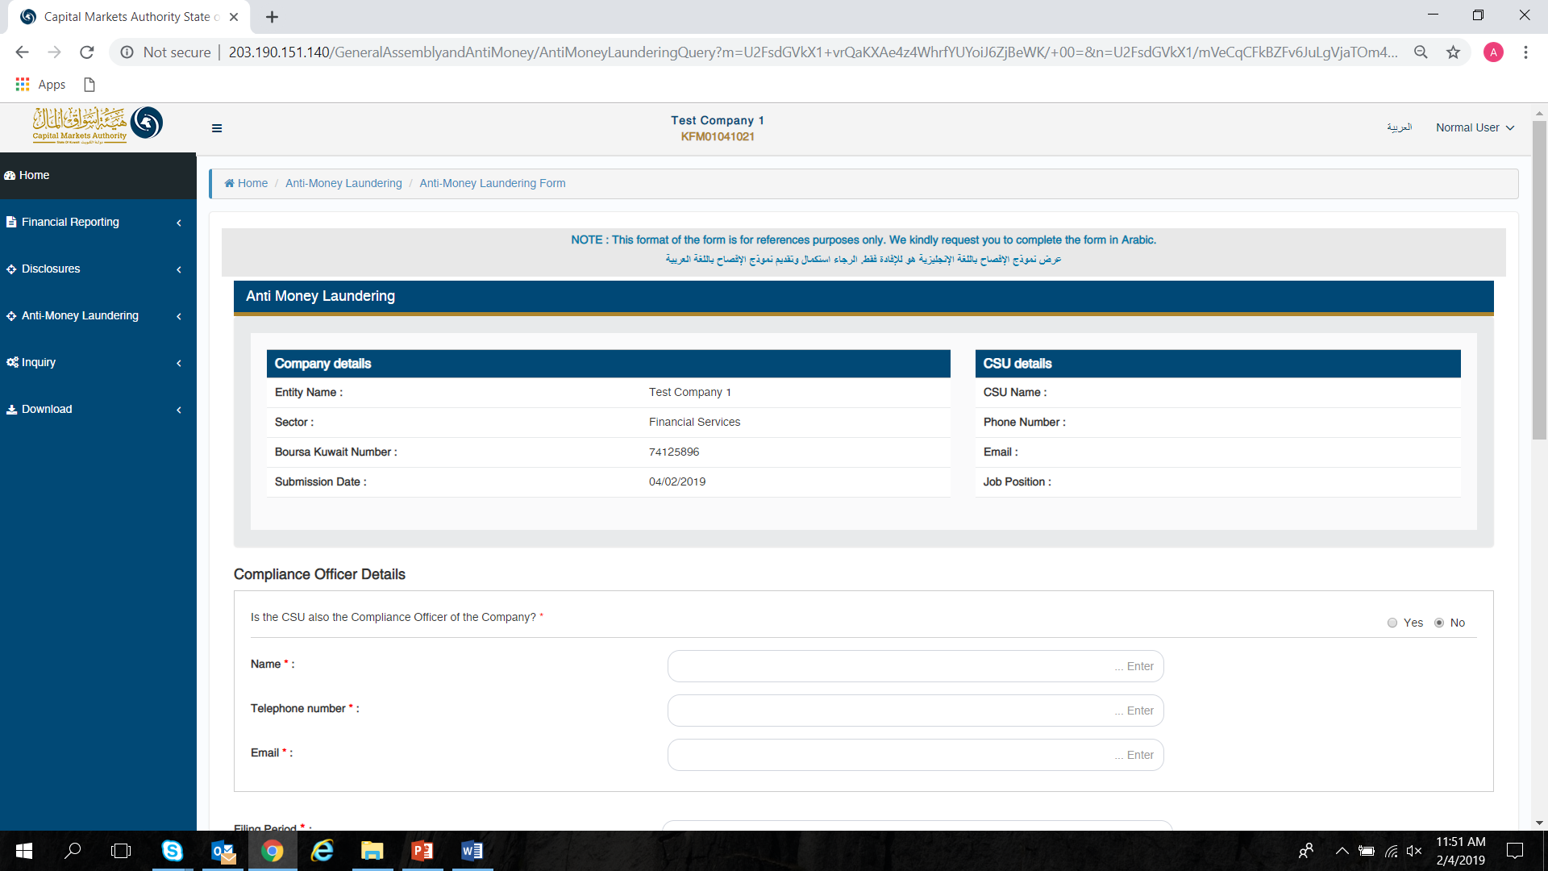

CU can fill in required details in the AML template and either click on ‘Save’ option to save the filled in data for later use or click on ‘Submit’ button to submit data for approval by CSU.

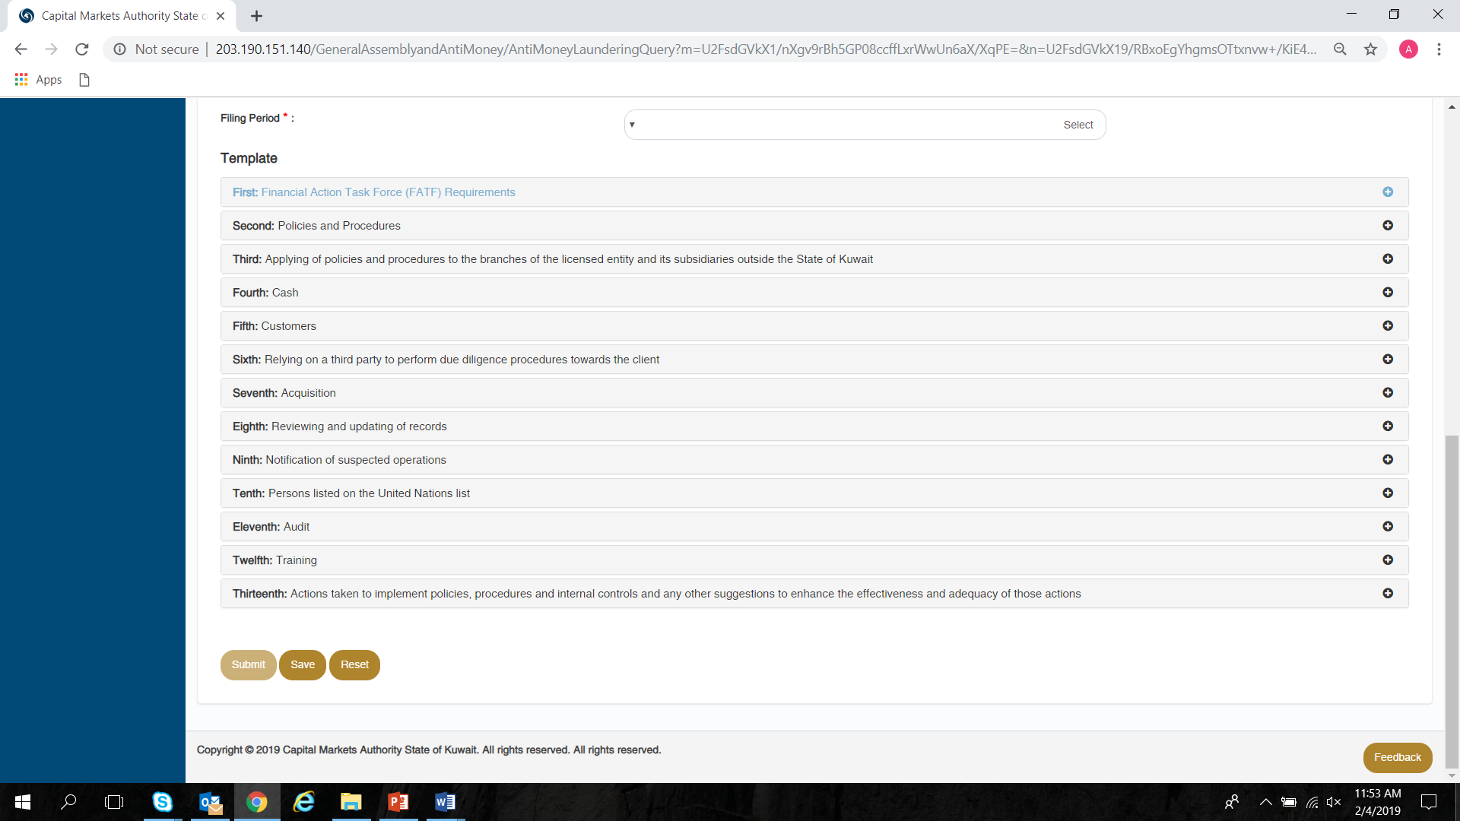

## Pending filing

The CU can view list of filings which he/she had submitted and is yet to be finally acknowledged by CMA by clicking on the ‘Anti Money Laundering – Pending Filings’ menu option, or by selecting either of the tabs on the Dashboard.



On the ‘Pending Filings’ page, the CU can view the ‘Filing Status’ & ‘Submission Status’ for any of the filings submitted for their company. Here, the CU can also filter records based on various filters.

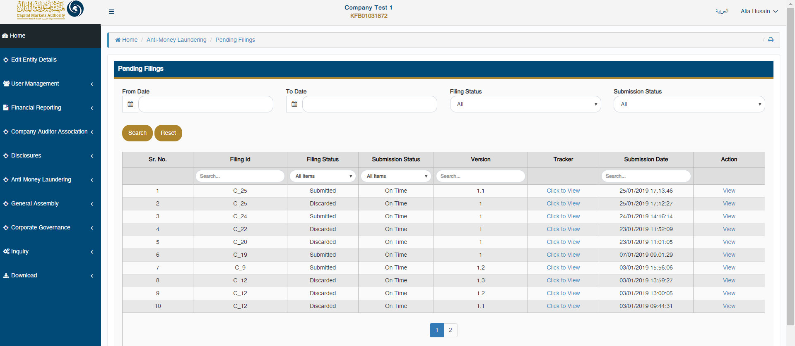

The CU can view the complete flow of any specific filing by clicking on the ‘Click to View’ link available under ‘Tracker’ column.

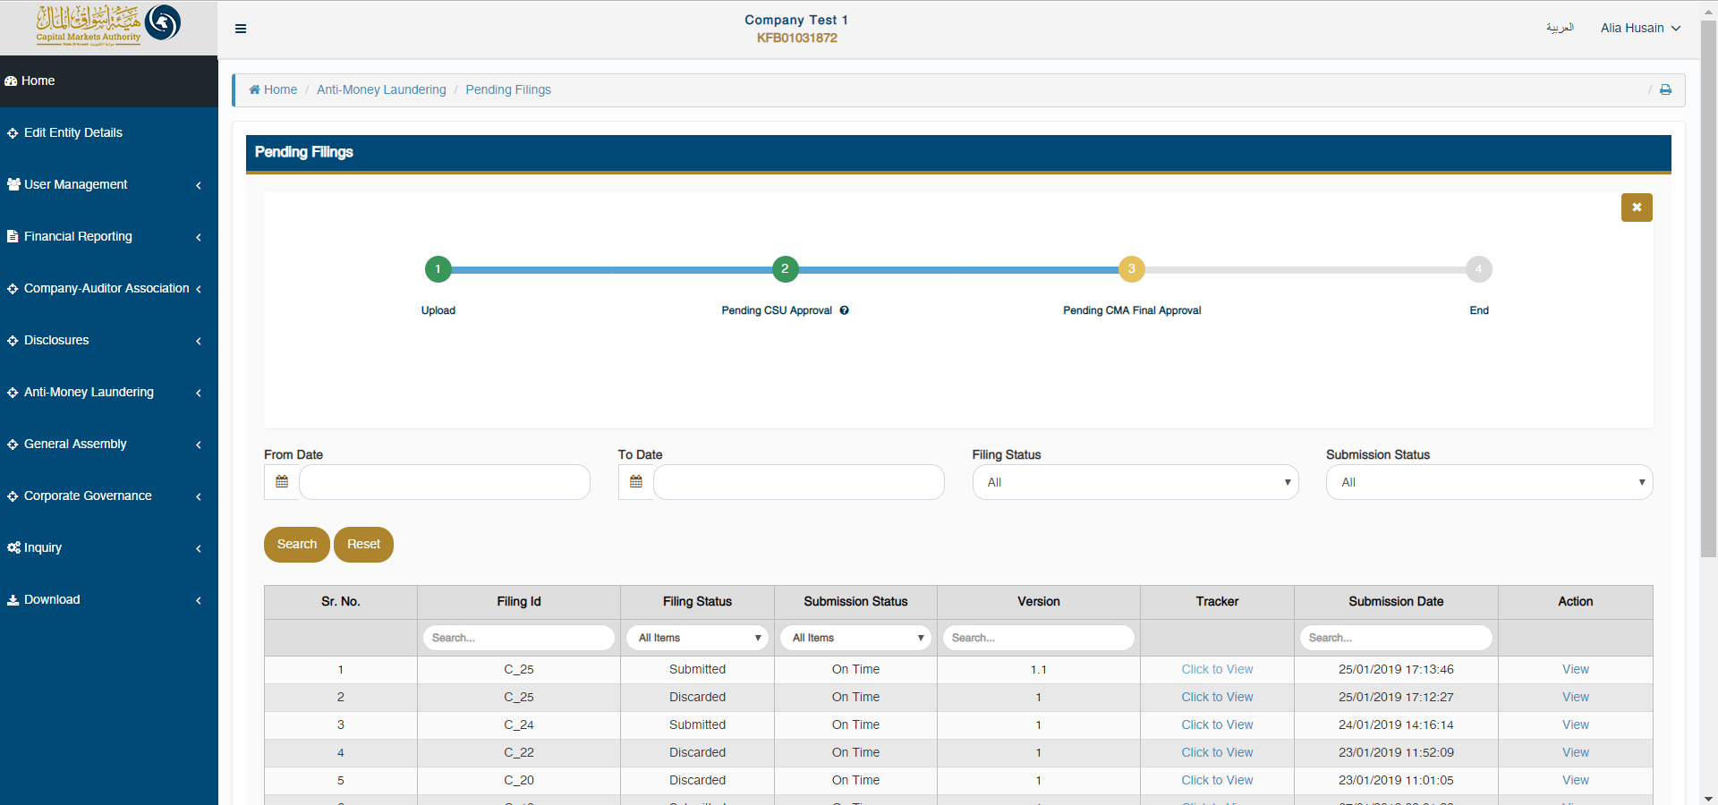

The CU can also hover with the mouse on the number displayed in the tracker, to view who uploaded the filing & when it was uploaded. The CU can view the comments for each filing status by clicking on ‘?’ icon displayed under each number in the tracker.

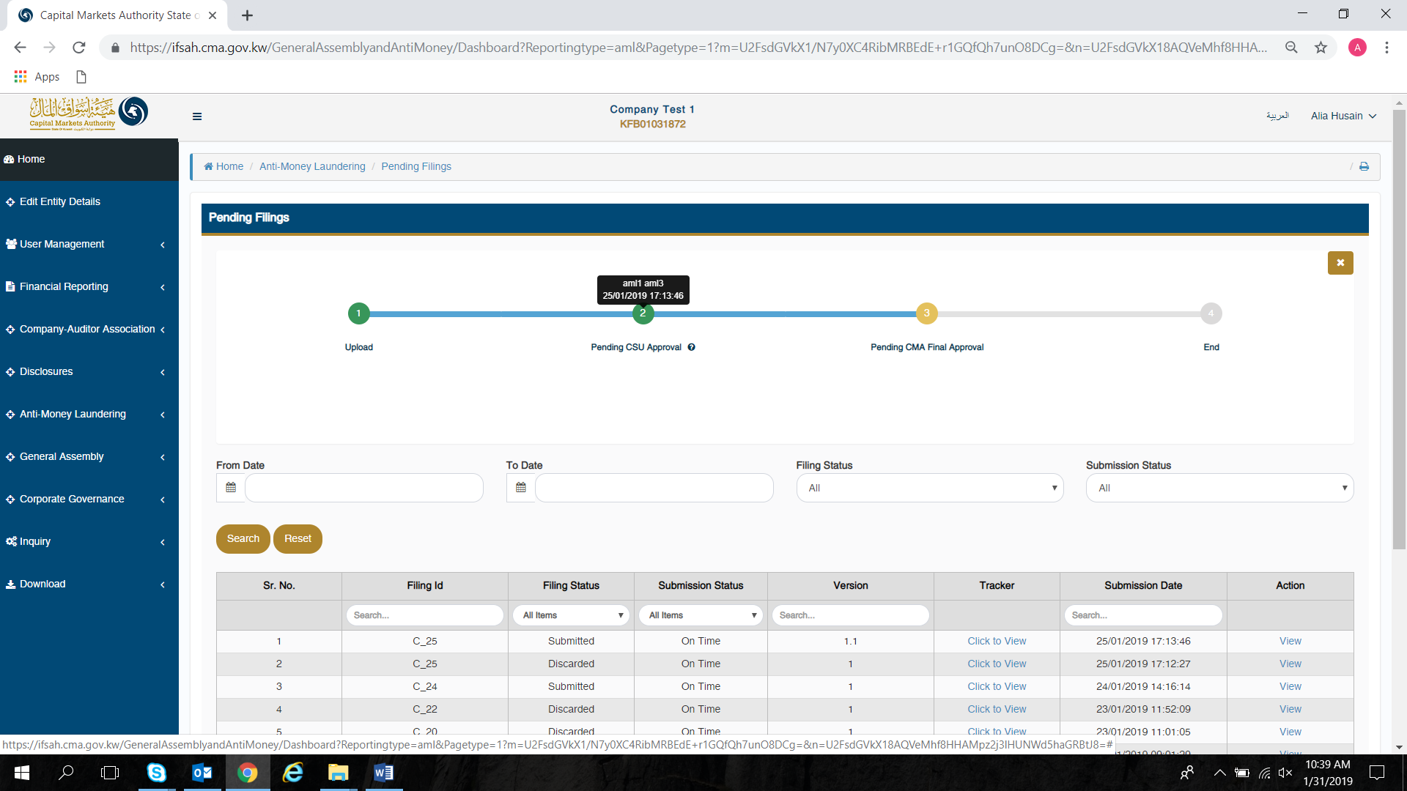

Lastly, the CU can view the data submitted by clicking on ‘View’ link available under ‘Action’ column on ‘Pending Filings’ page.



On doing so, the CU will be able to view all the details of the company, and the filing.

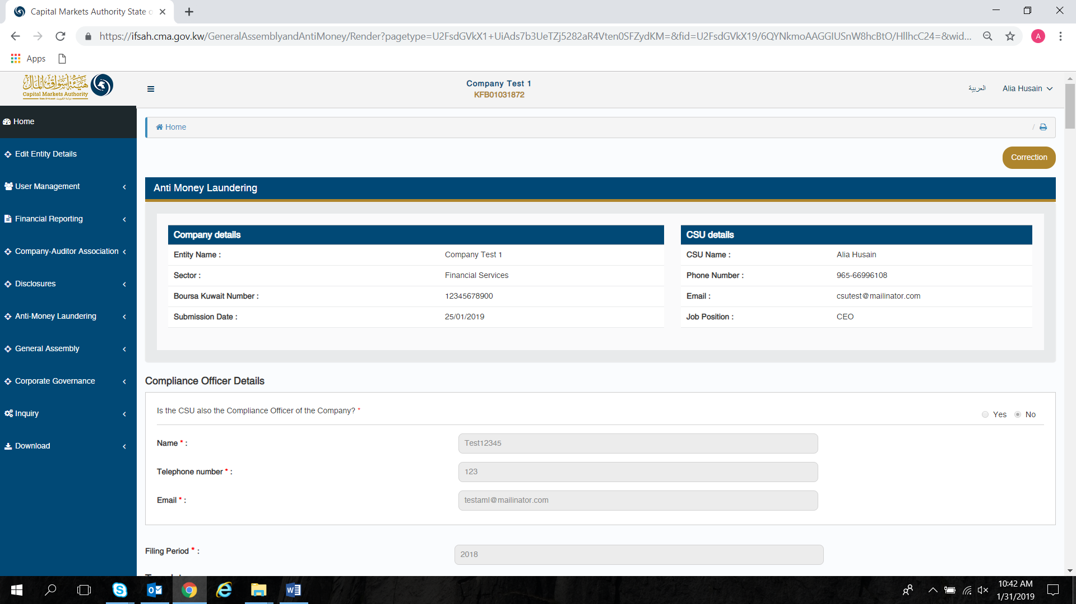

## Viewing history of the filings

The CU can view the history of all the filings for their company (Which he/she has submitted), which have been approved or rejected by clicking on the ‘Anti Money Laundering –Filing History’ menu option, or by selecting either of the tabs on the Dashboard.



By clicking on either of the options listed above, the CU will be able to view the filing history of all submissions done by him/her.

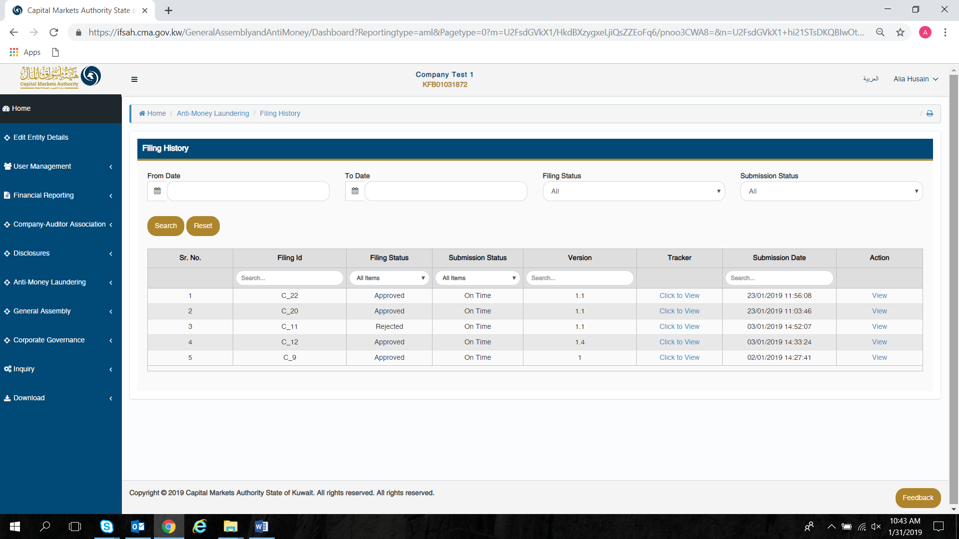

## Inquiry module

The CU can submit inquiries to the CMA via the inquiry module. This can be accessed by clicking on ‘Inquiry’ in the menu option. The status of closed inquiries and pending inquiries can be viewed by clicking on the ‘Inquiry filings’ tab on the dashboard.

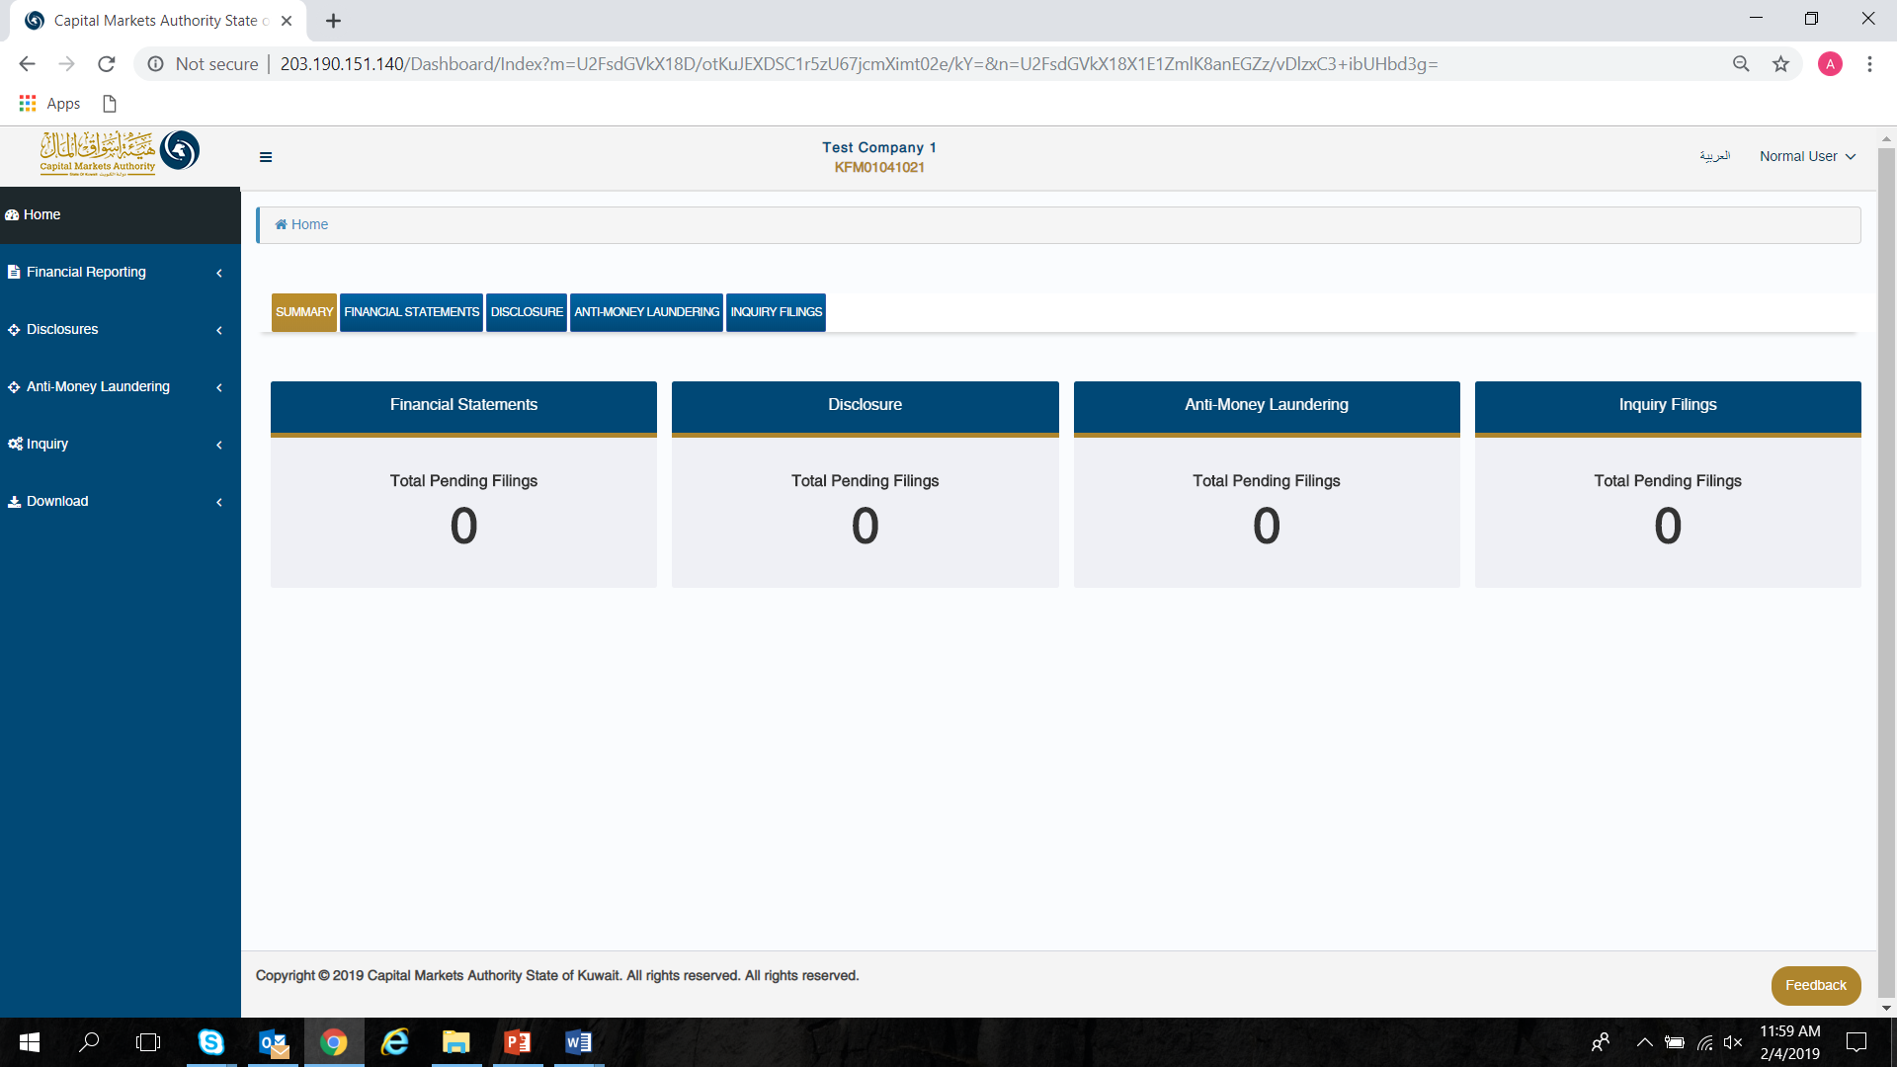

The CU can access the inquiry form by selecting the ‘Inquiry form’ dropdown under the ‘Inquiry’ option in the menu. Here, the CU has to select the domain and form name for which the inquiry is being submitted, whilst entering the inquiry in the comment section. The CU has the option to enter the Filing ID and attachment if relevant and required.

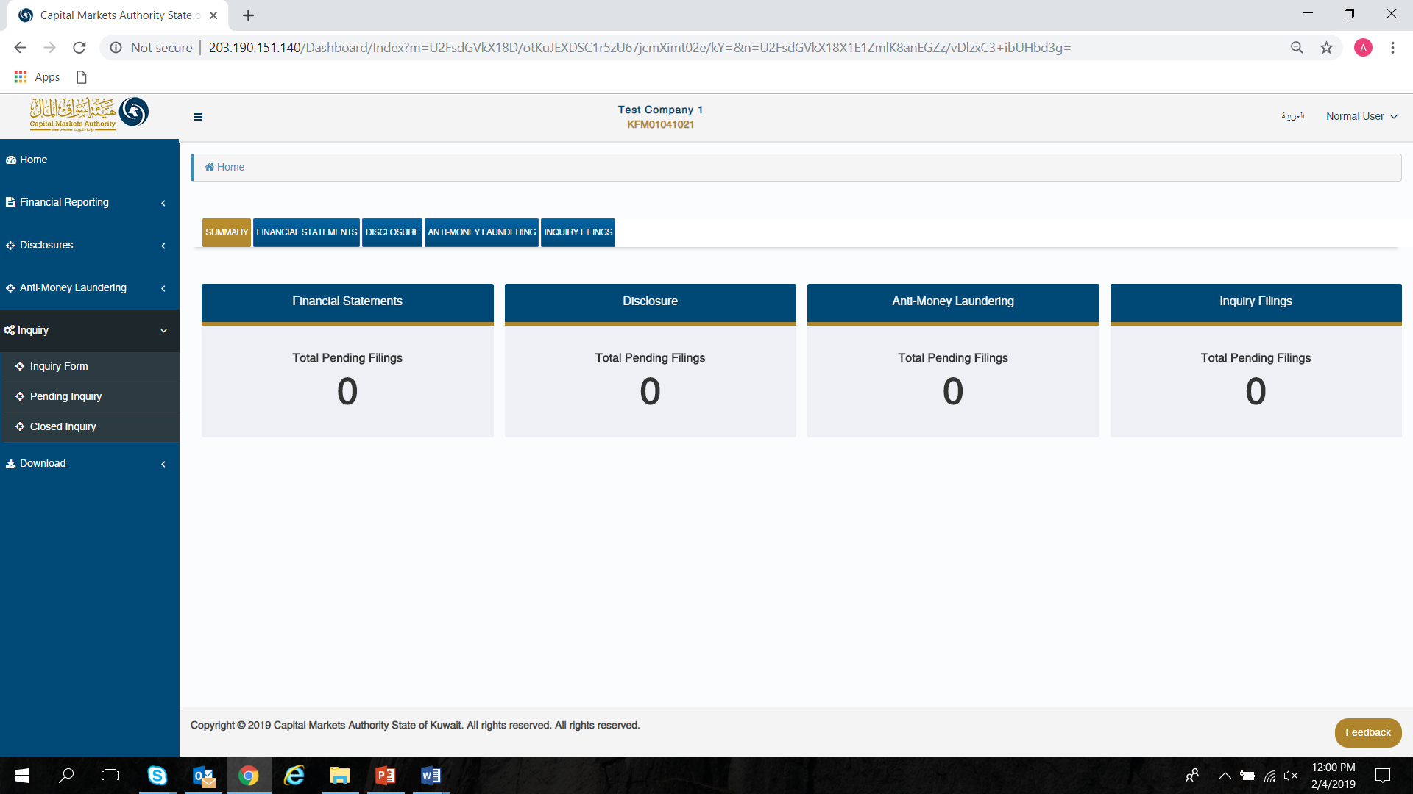

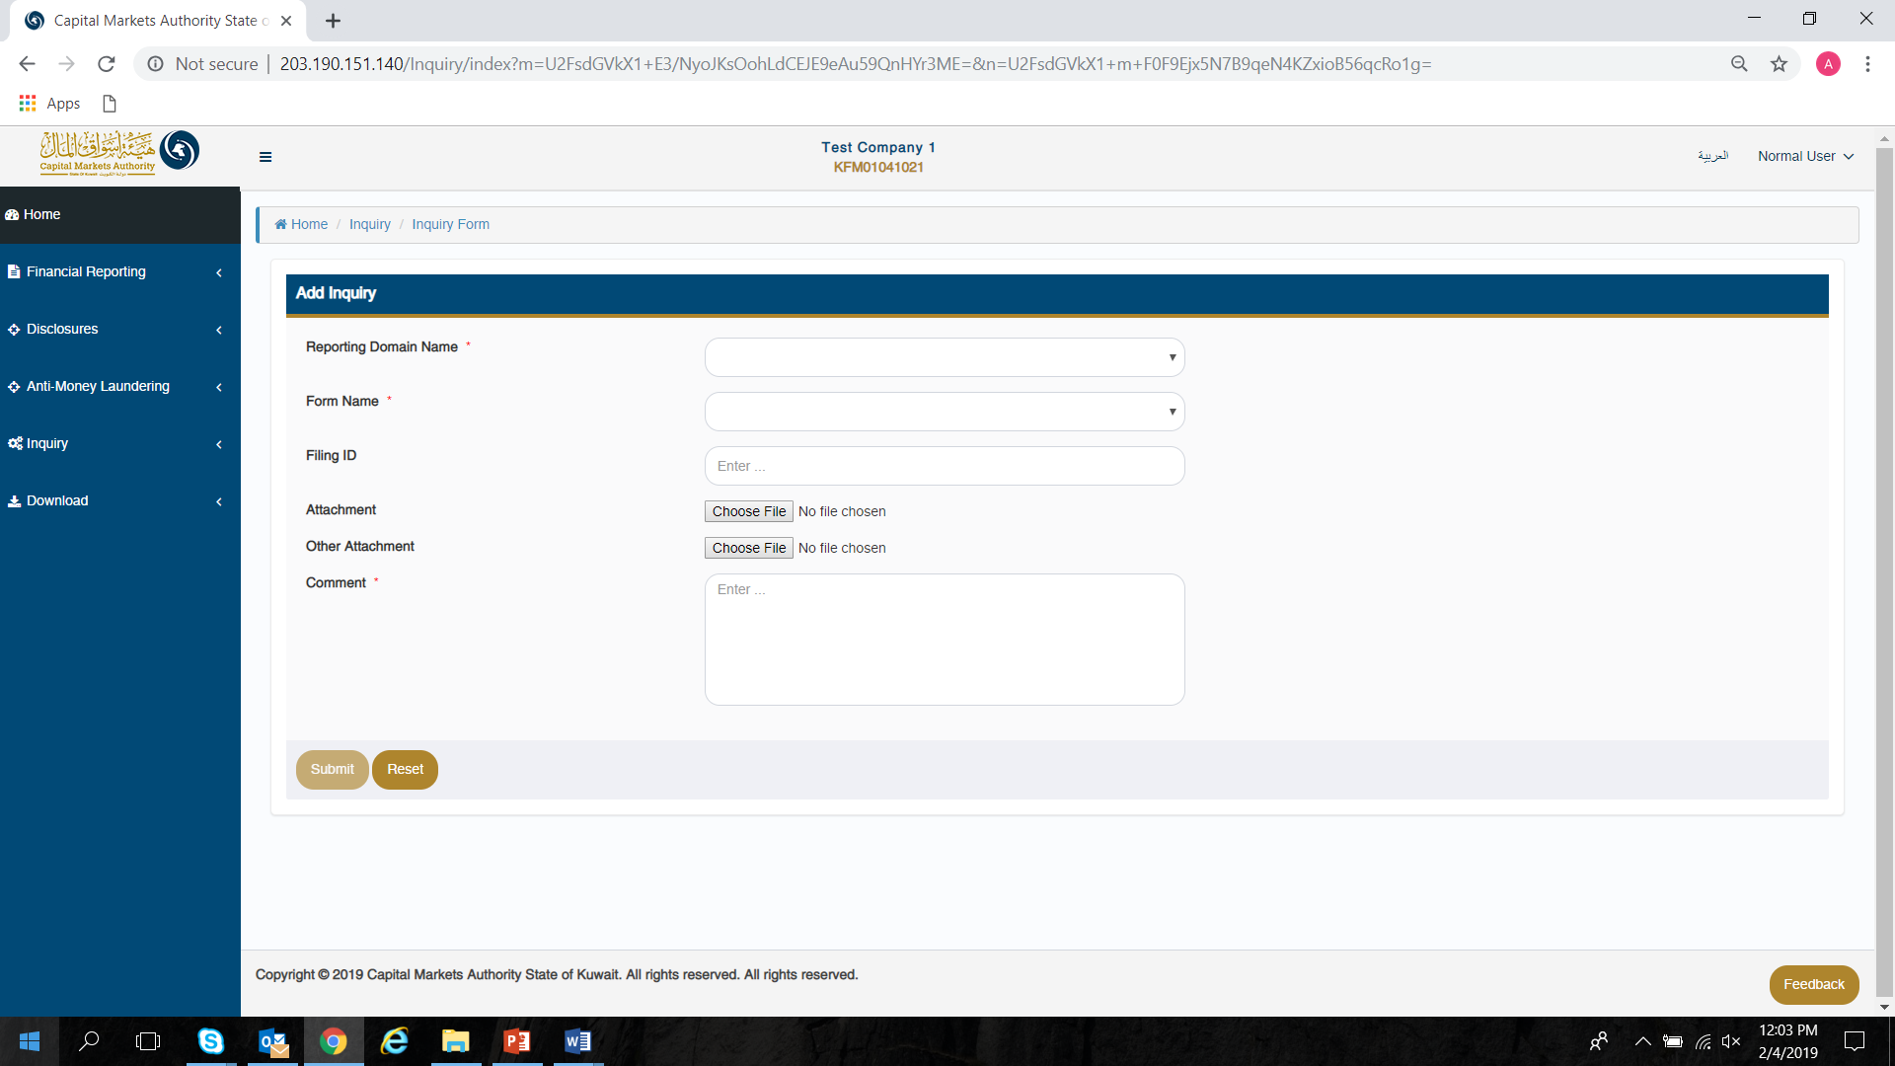

The CU can review all received/submitted inquiries in a tabular format, while filtering which filing to view based on the following criteria:

* Query Id
* Filing Id
* From Date
* To Date
* Filing Status



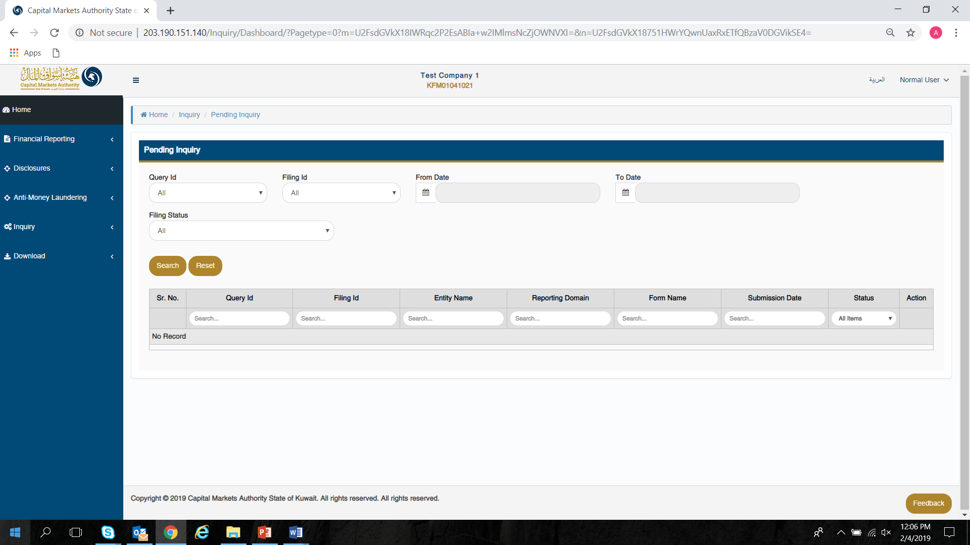

The CU can review all closed inquiries in a tabular format, while filtering which filing to view based on the following criteria:

* Query Id
* Filing Id
* From Date
* To Date
* Filing Status



