**CMA’s XBRL Based Electronic Filing Platform**

**IFSAH**

**Instruction Manual for Company Super Users**

Version 1.0



Contents

1. Accessing the IFSAH Portal 3

2. Registration 3

3. Log – In 4

4. Dashboard 4

5. Viewing / Editing the Company’s Details 6

6. Adding Company Users 7

7. Upload filing 9

8. Pending filing 9

9. Viewing history of the filings 12

10. Inquiry module 13

## Accessing the IFSAH Portal

The Company Super Users (CSUs) can access the IFSAH portal through any browser, as long as they are connected to the internet. CSUs can then login into the IFSAH portal through the following link

<https://ifsah.cma.gov.kw.>

## Registration

Company Super Users (CSU) can register them on portal using the registration link “Super User Registration” available on login page.

On ‘Super User Registration’ page, CSU need to select “Entity” option for ‘Company / Fund /Auditor’ field and fill in required details for registration. Upon submitting the details, request for registration will be sent to CMA for approval. Once approved by CMA an email with the username and a One Time Password (OTP) will be sent to the CSU on the registered email address.

The CSU can also be created by the CMA Admin, after which an email with the username and a One Time Password (OTP) will be sent to the CSU on the registered email address. The CSU can login to the IFSAH portal with the username and OTP. This portal can be accessed in either English or Arabic.

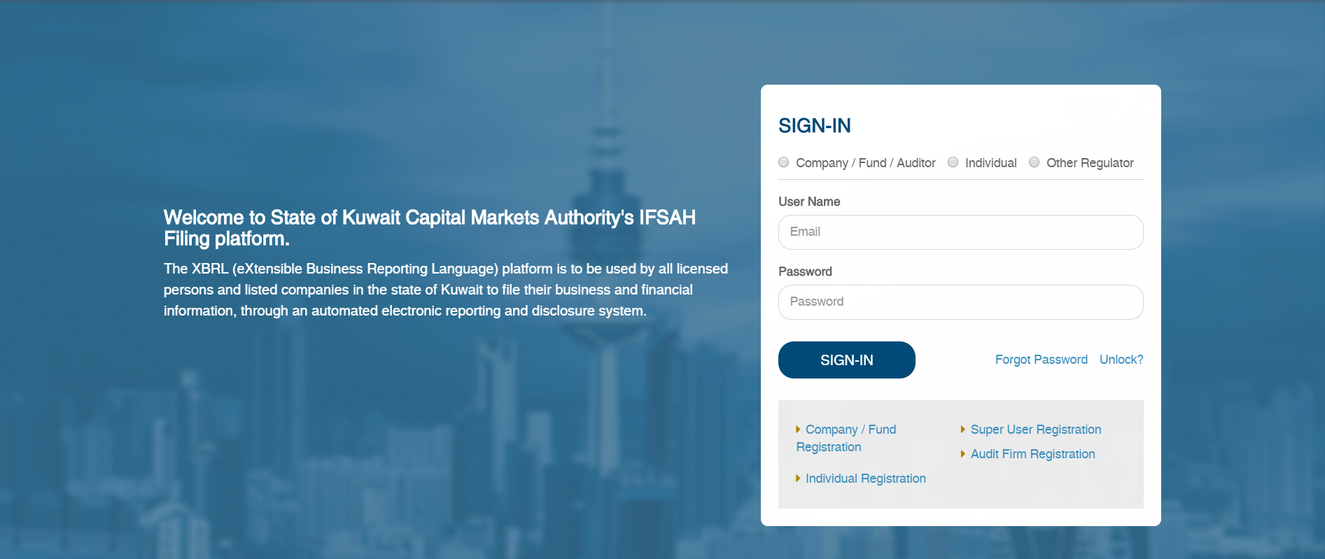

## Log – In

Once the CSU has successfully logged in with the OTP, the CSU will be navigated to the “Change Password” page to set a new password.

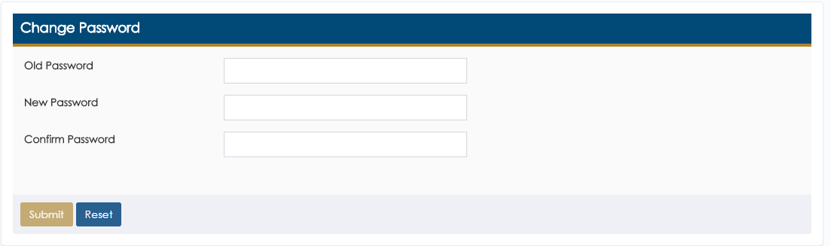

Upon setting the new password, the CSU will be required to login in again with the new password.

## Dashboard

On logging into the portal successfully, the CSU will be navigated to the Dashboard.

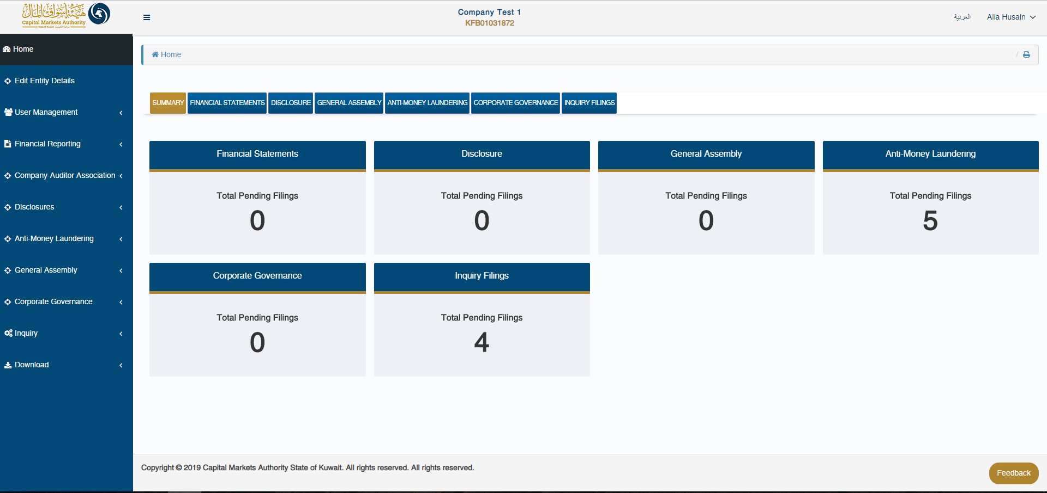

In addition, if the CSU is a super user for multiple companies, she/he can navigate between the dashboards for these companies by selecting the relevant entity in the ‘Switch entity’ field.

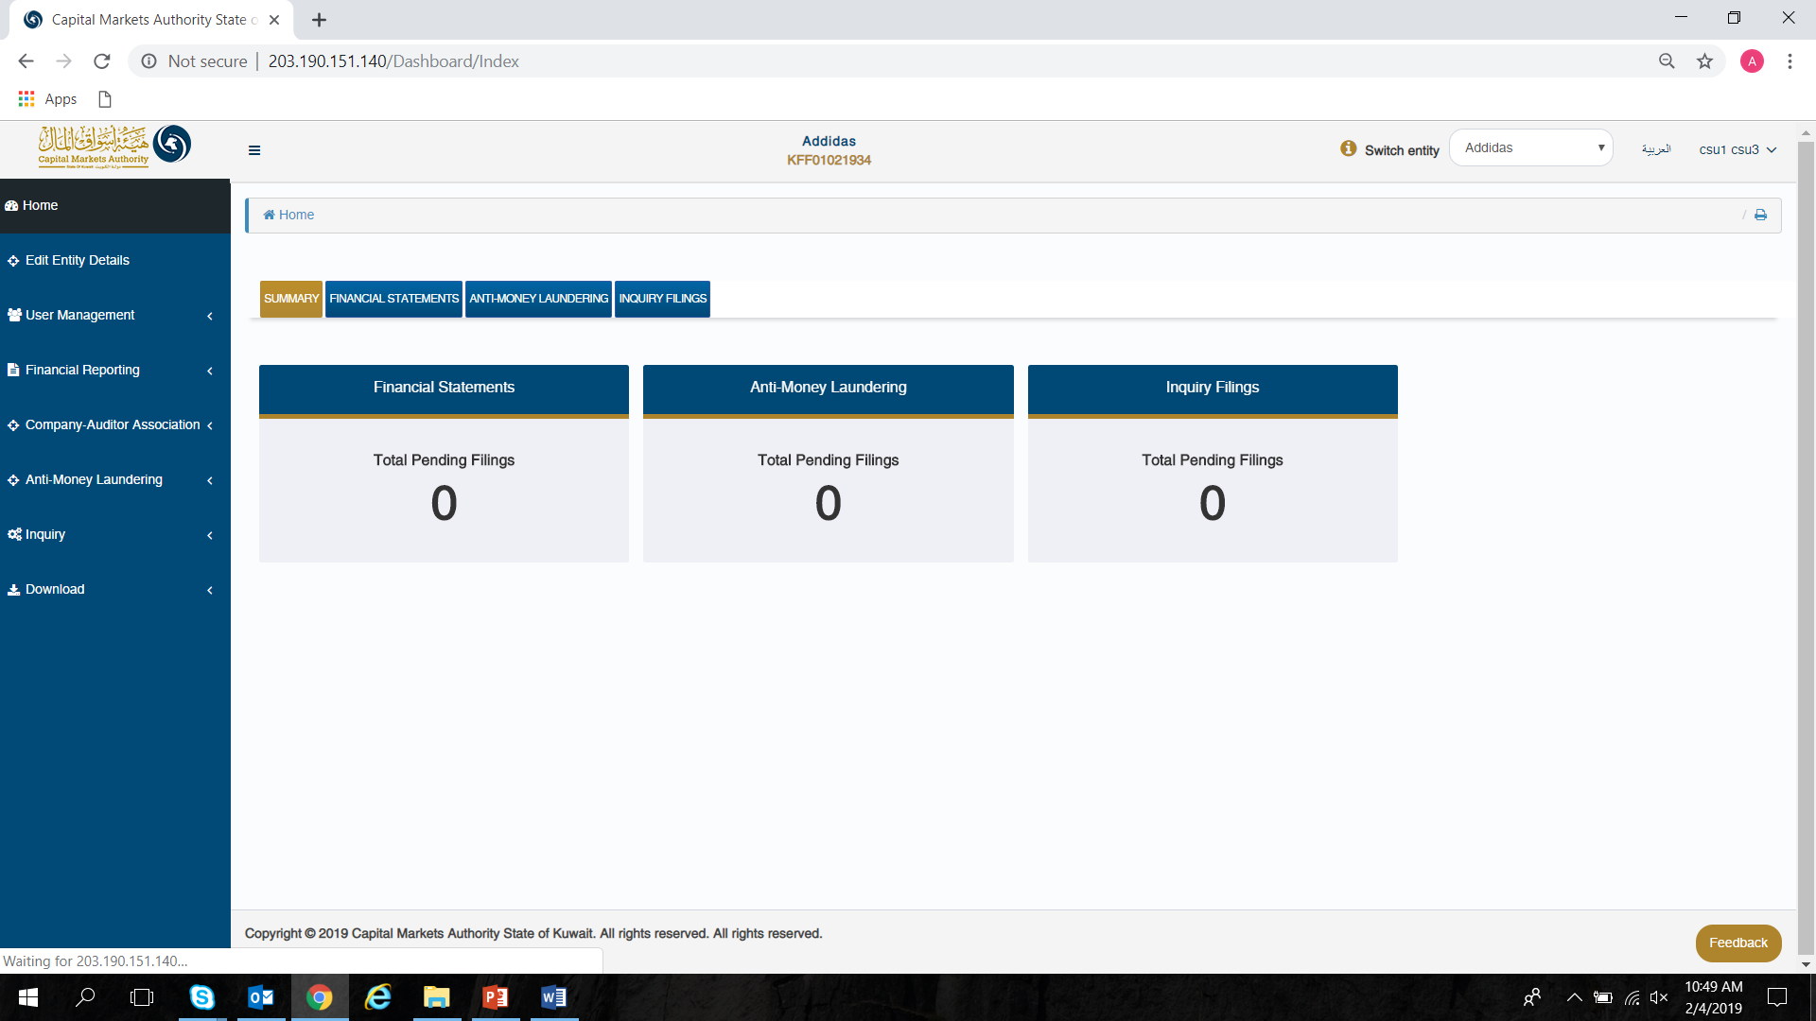

## Viewing / Editing the Company’s Details

The CSU can view & edit company details using ‘Edit Company Details’ menu option, from the Dashboard Page.



By clicking on ‘Edit Company Details’, the CSU will view the page on which he/she can both view, or edit the company details.

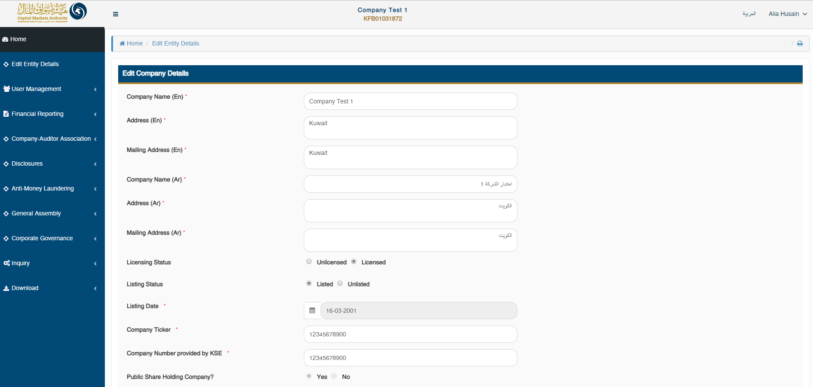

The edited company details will then be sent to CMA for approval, and will be updated only when approved by the CMA Admin.

## Adding Company Users

The CSU can add Company Users (CU) for the Company by clicking on ‘User Management – Add/Edit Company User Details’ menu option.

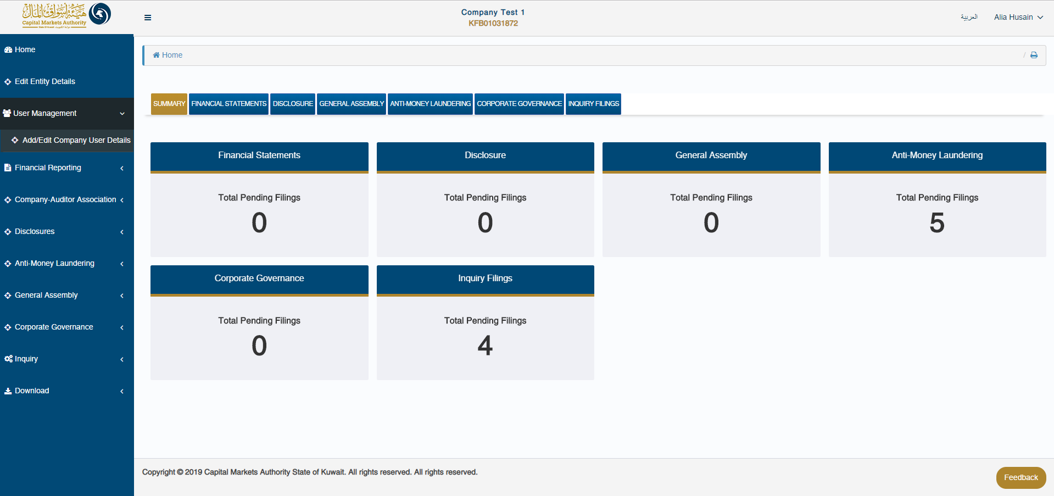

By clicking on the option above, the CSU will be able to view the Company User Details grid with list of all the CUs registered for their company.

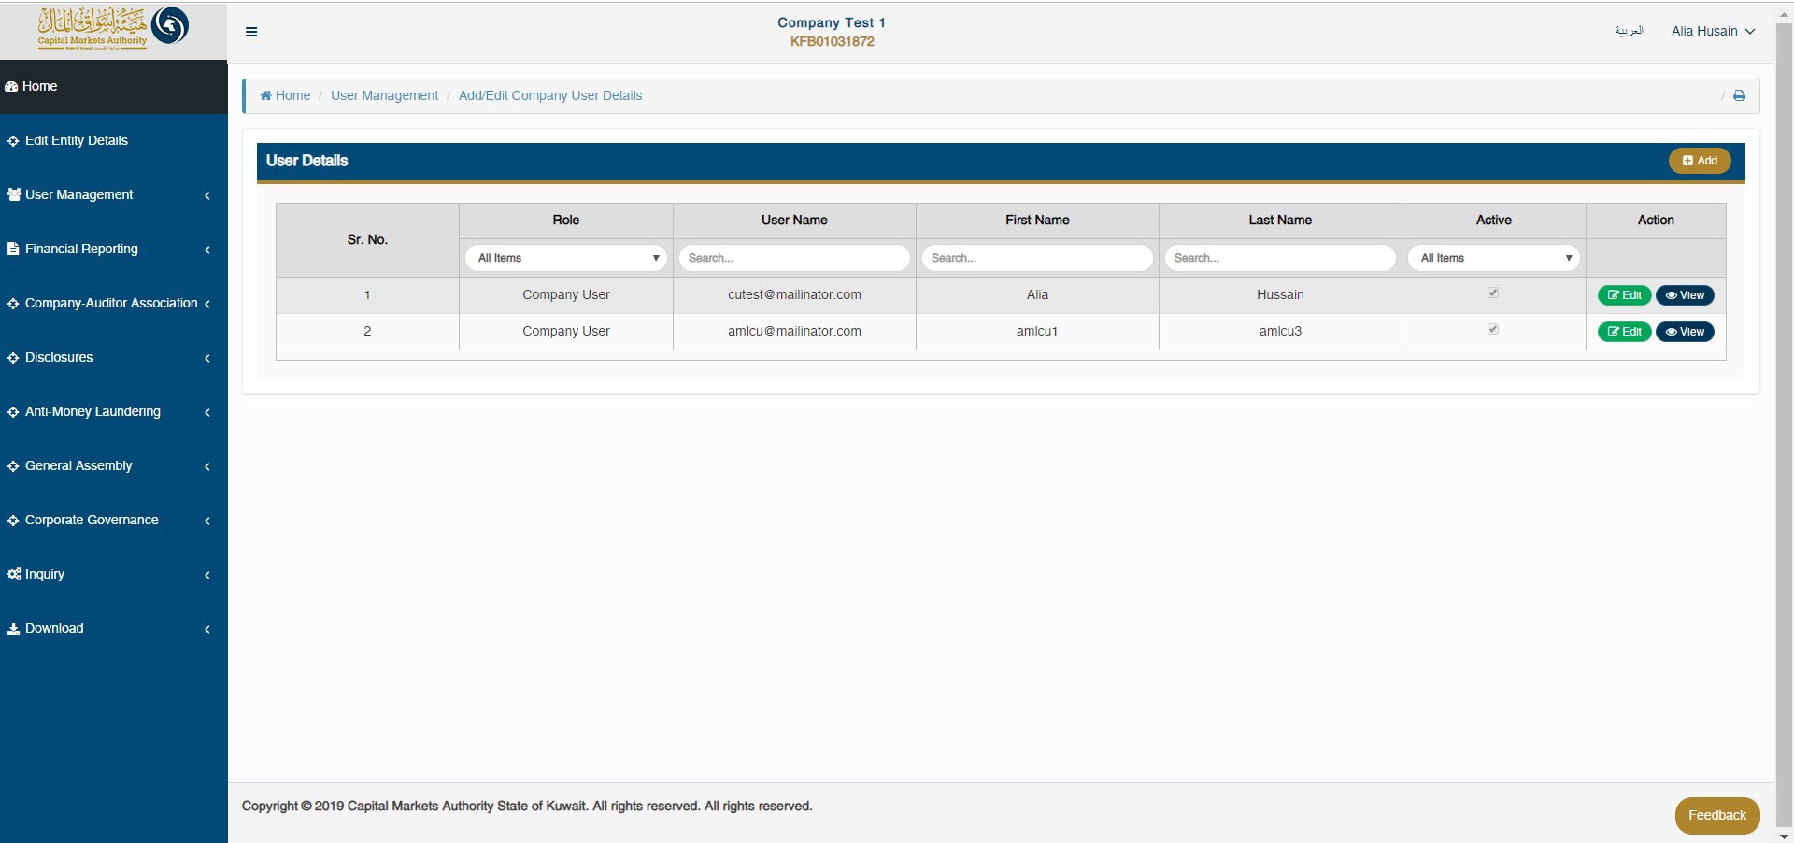

In order to add a new CU for the company, the CSU can click on the ‘Add’ button.



By clicking on the ‘Add’ button, the CSU will be redirected to the ‘Register New User’ page, where he/she will be required to fill out information pertaining to the CU.

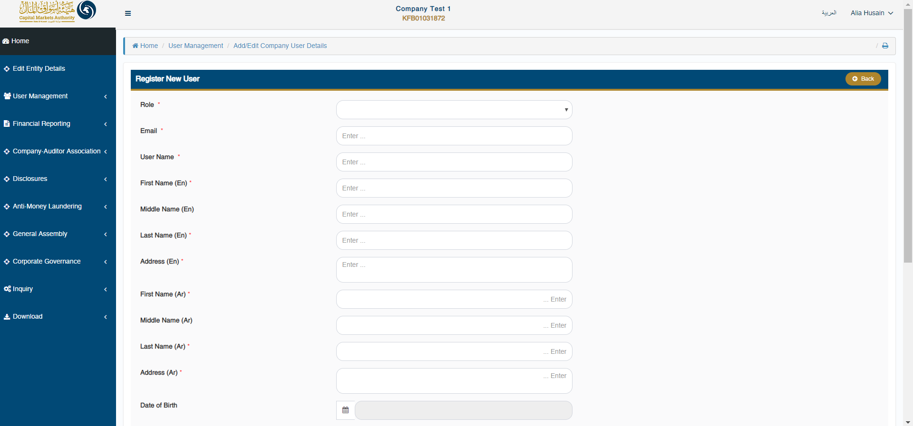

Once the new CU is registered by CSU, an email will be sent to that respective CU on the registered email added with username & OTP in order to login to the IFSAH Portal.

## Upload filing

The CSU can submit AML filing through the ‘Anti Money Laundering Form’ page. The CSU can navigate to this page using ‘Anti Money Laundering – Anti Money Laundering Form’ menu option.

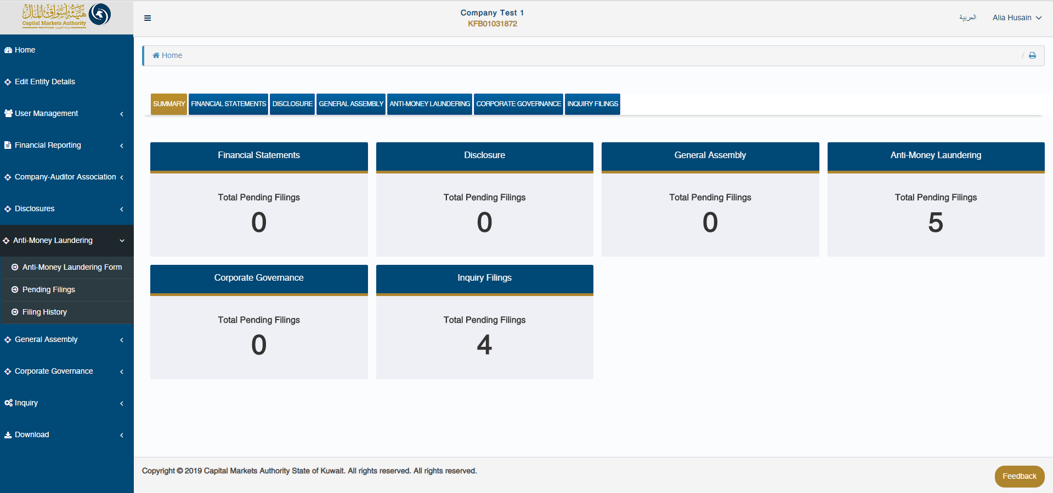

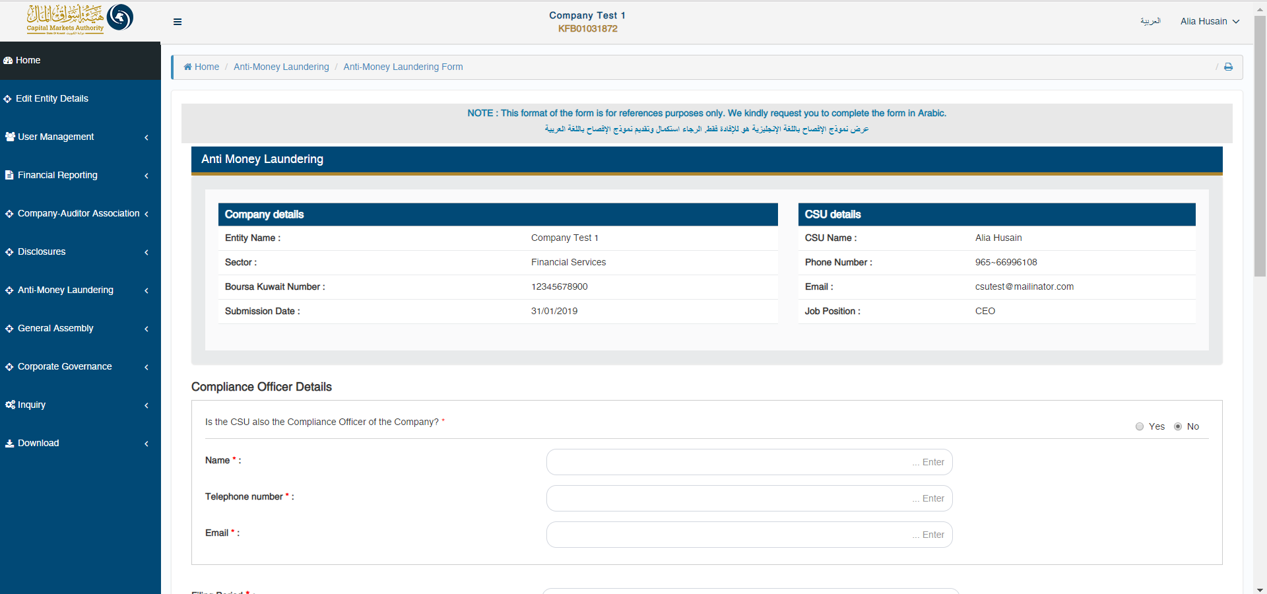

CSU can fill in required details in the AML template and either click on ‘Save’ option to save the filled in data for later use or click on ‘Submit’ button to submit data for approval by CMA.

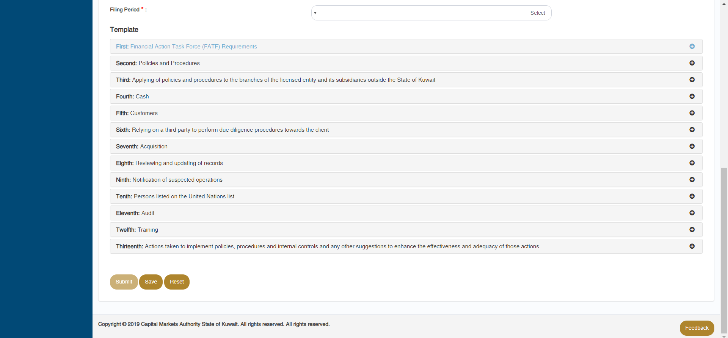

## Pending filing

The CSU can view filings pending his/her approval from by clicking on the ‘Anti Money Laundering – Pending Filings’ menu option, or by selecting either of the tabs on the Dashboard.



On the ‘Pending Filings’ page, the CSU can view the ‘Filing Status’ & ‘Submission Status’ for any of the filings submitted for their company. Here, the CSU can also filter records based on various filters.

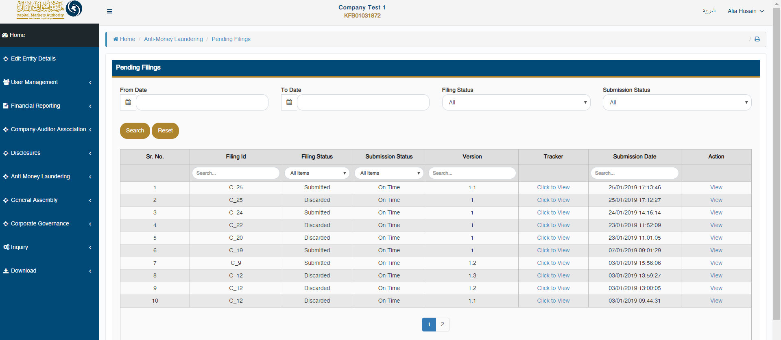

The CSU can view the complete flow of any specific filing by clicking on the ‘Click to View’ link available under ‘Tracker’ column.

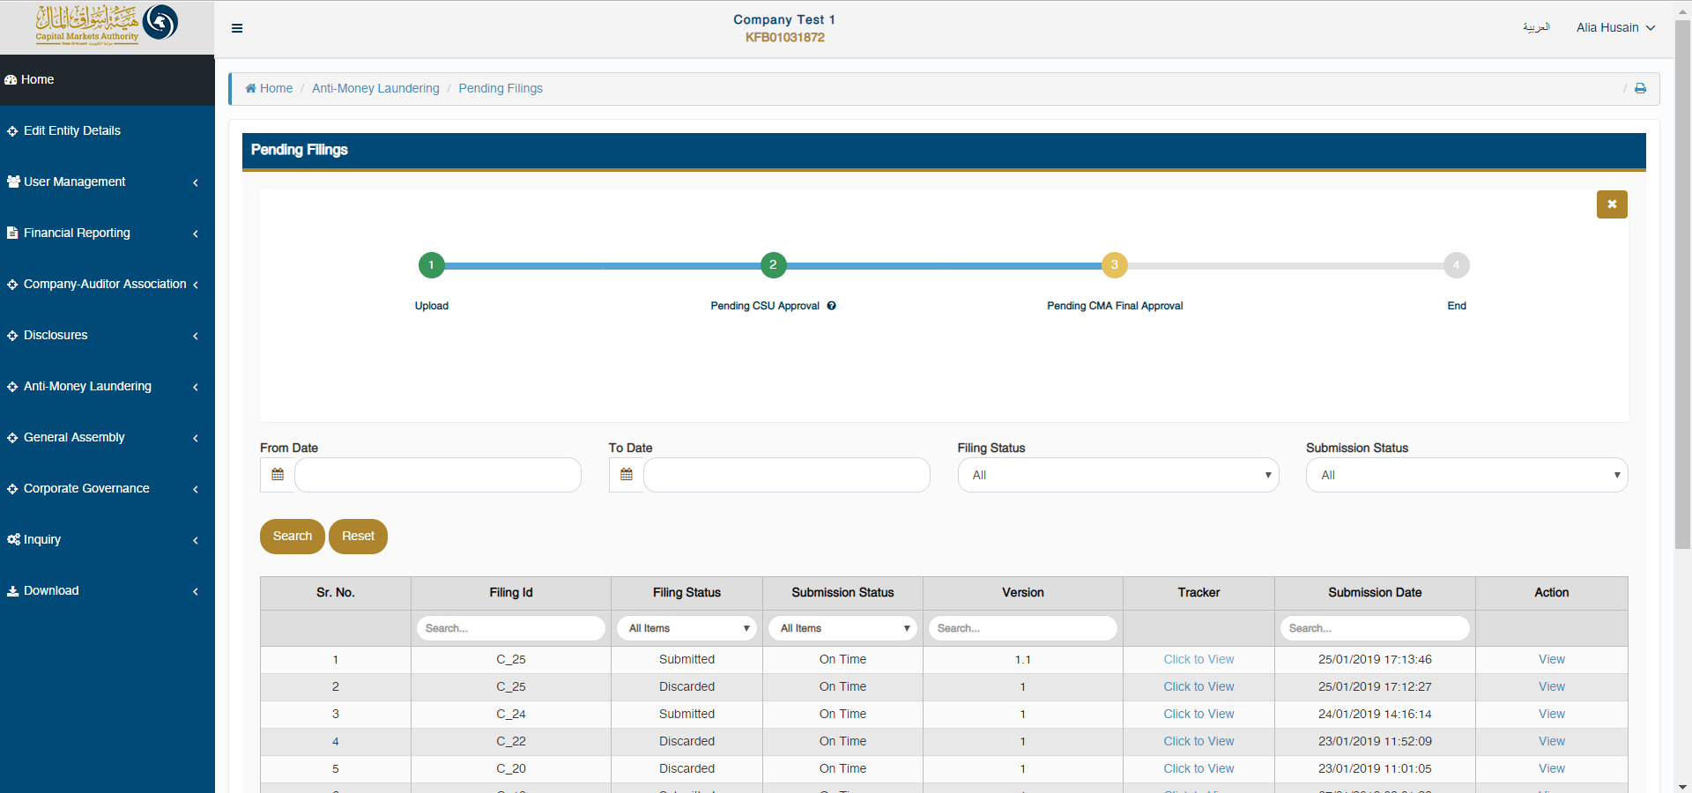

The CSU can also hover with the mouse on the number displayed in the tracker, to view who submitted the filing & when it was uploaded. The CSU can view the comments for each filing status by clicking on ‘?’ icon displayed under each number in the tracker.

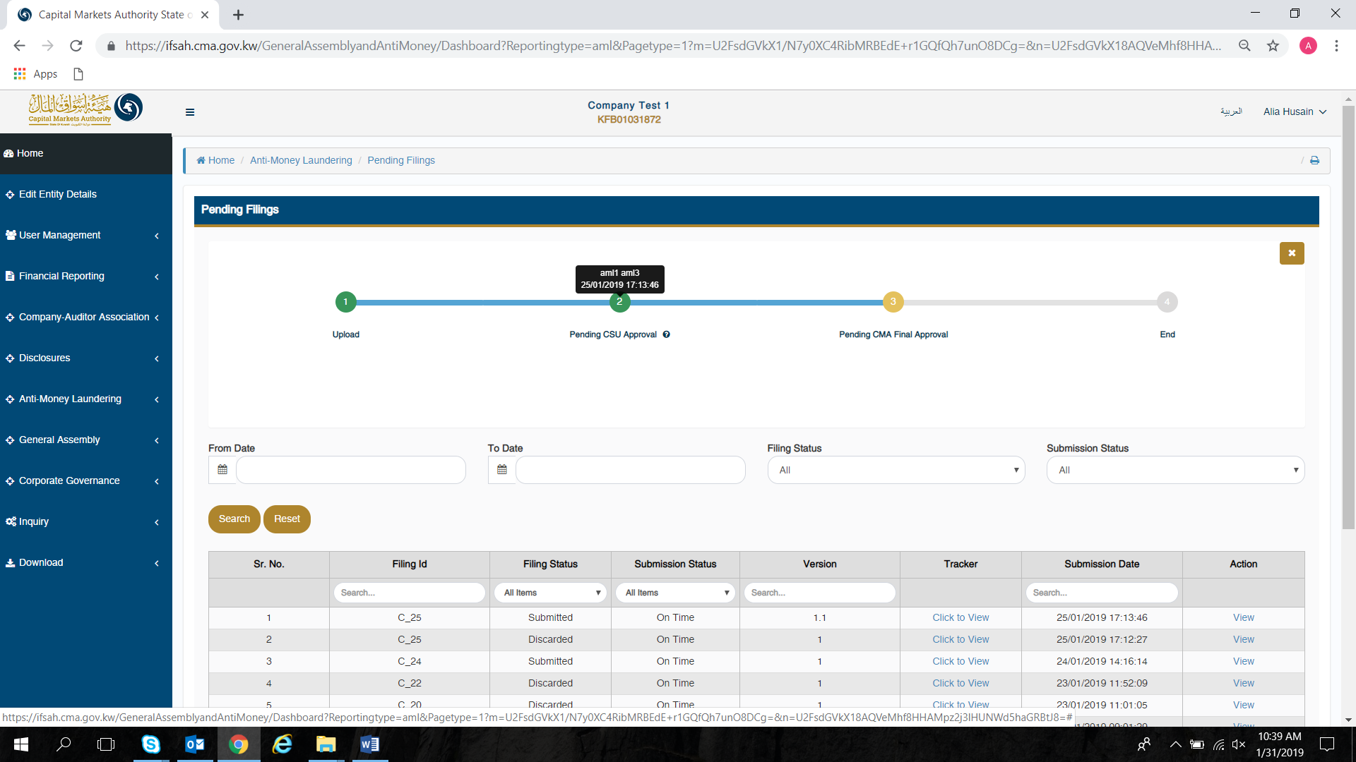

Lastly, the CSU can view/approve/reject the data in the submitted filing by clicking on ‘View’ or ‘Approve/Reject’ link available under ‘Action’ column on ‘Pending Filings’ page.

On doing so, the CSU will be able to view all the details of the company, and the filing.

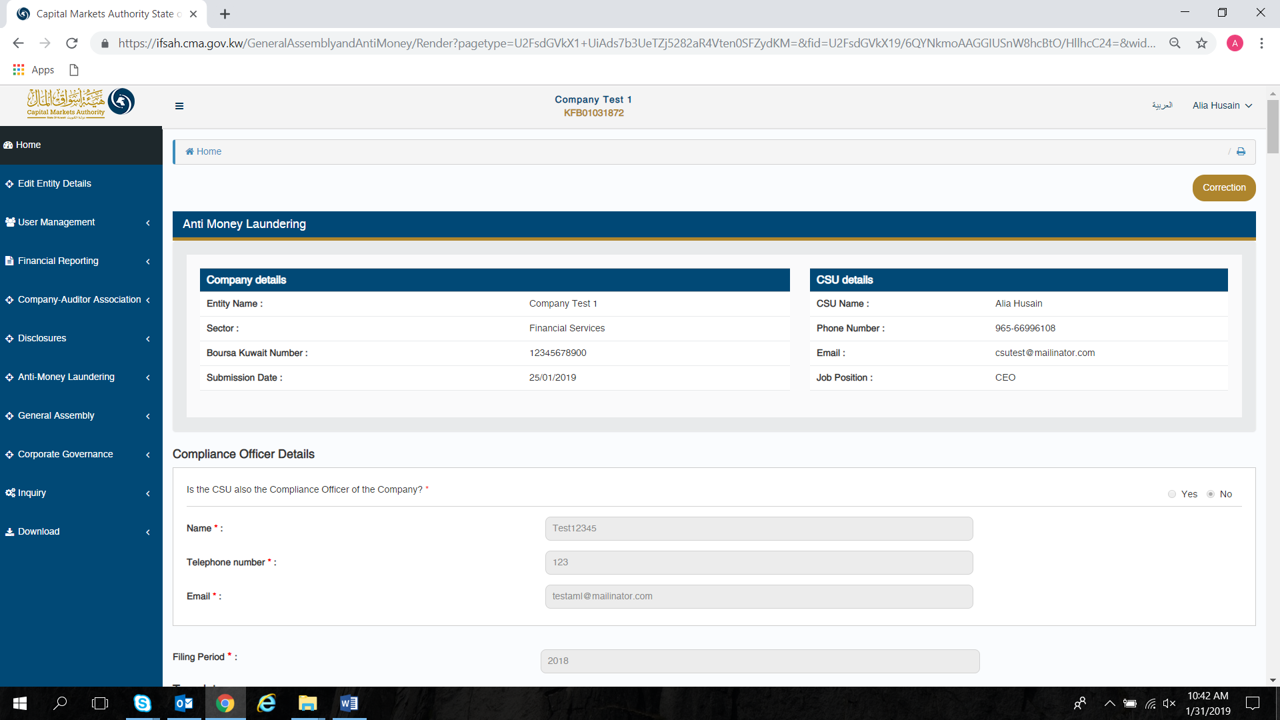

Additionally, the CSU can approve or reject the filing at this stage.

## Viewing history of the filings

The CSU can view the history of all the filings for their company, which have been approved or rejected by clicking on the ‘Anti Money Laundering – Filing History’ menu option, or by selecting either of the tabs on the Dashboard.



By clicking on either of the options listed above, the CSU will be able to view the filing history of all submissions.

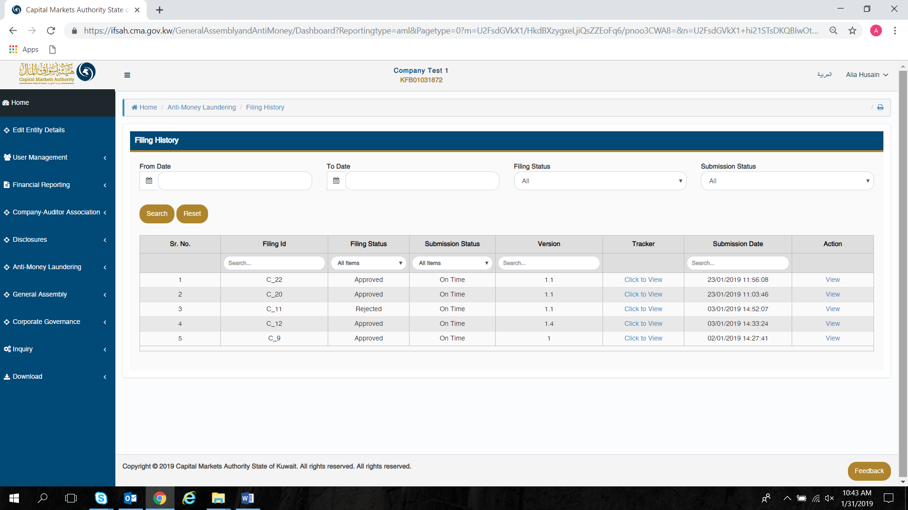

## Inquiry module

The CSU can submit inquiries to the CMA via the inquiry module. This can be accessed by clicking on ‘Inquiry’ in the menu option. The status of closed inquiries and pending inquiries can be viewed by clicking on the ‘Inquiry filings’ tab on the dashboard.

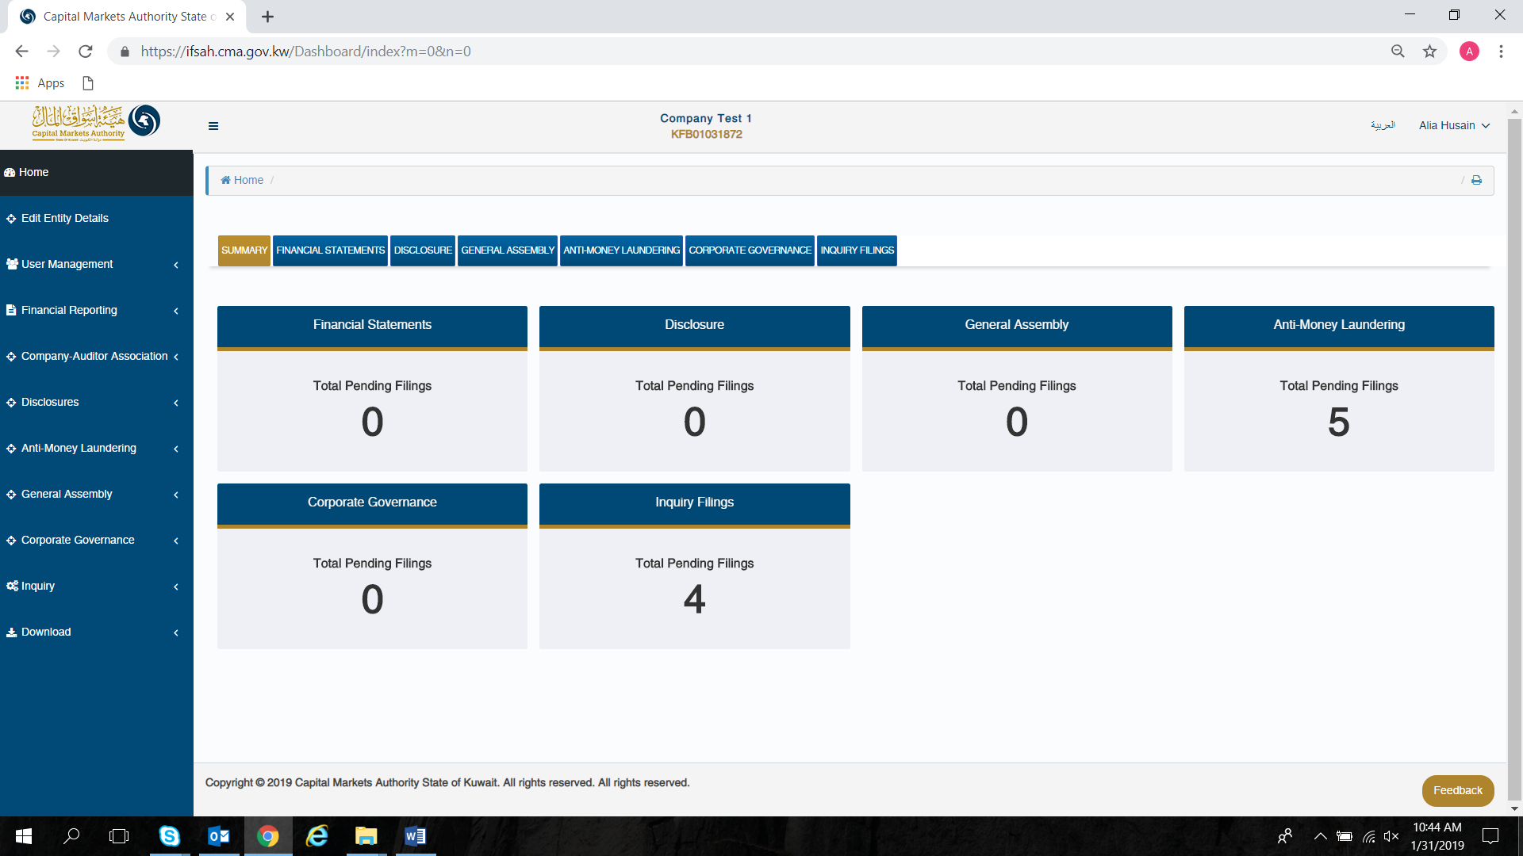

The CSU can access the inquiry form by selecting the ‘Inquiry form’ dropdown under the ‘Inquiry’ option in the menu. Here, the CSU has to select the domain and form name for which the inquiry is being submitted, whilst entering the inquiry in the comment section. The CSU has the option to enter the Filing ID and attachment if relevant and required.

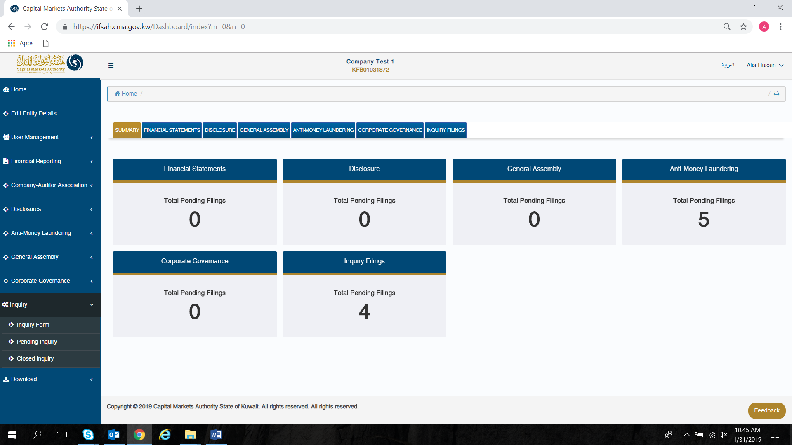

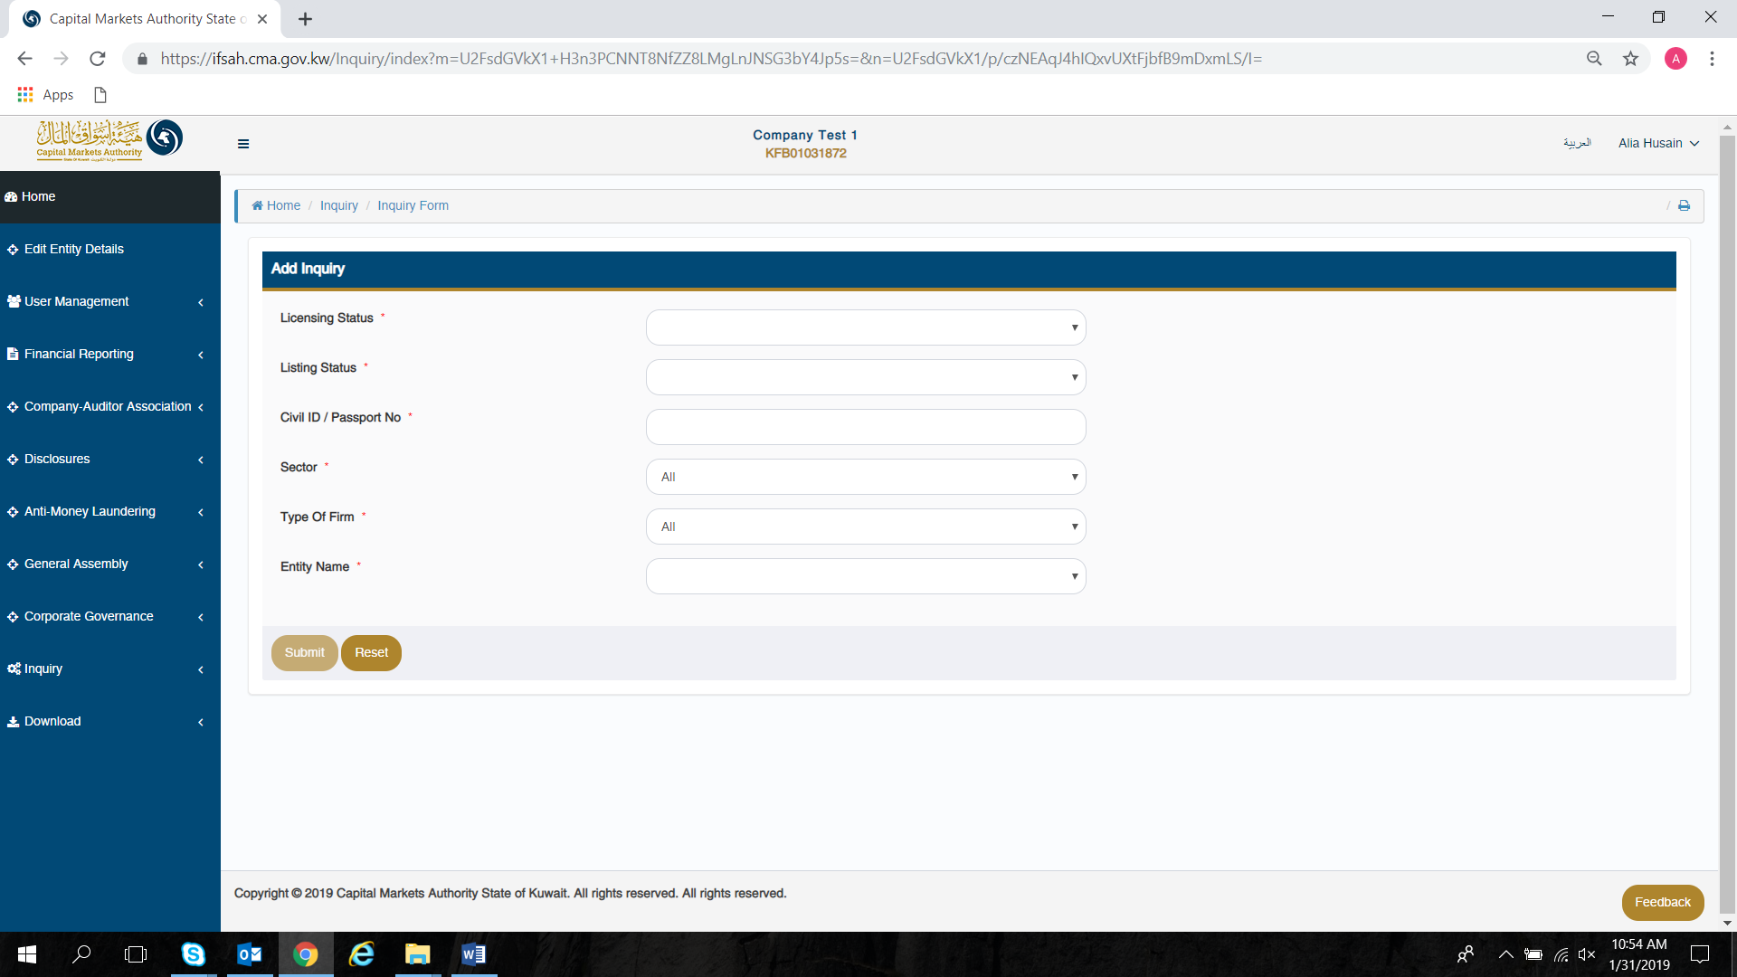

The CSU can review all received/submitted inquiries in a tabular format, while filtering which filing to view based on the following criteria:

* Query Id
* Filing Id
* From Date
* To Date
* Filing Status



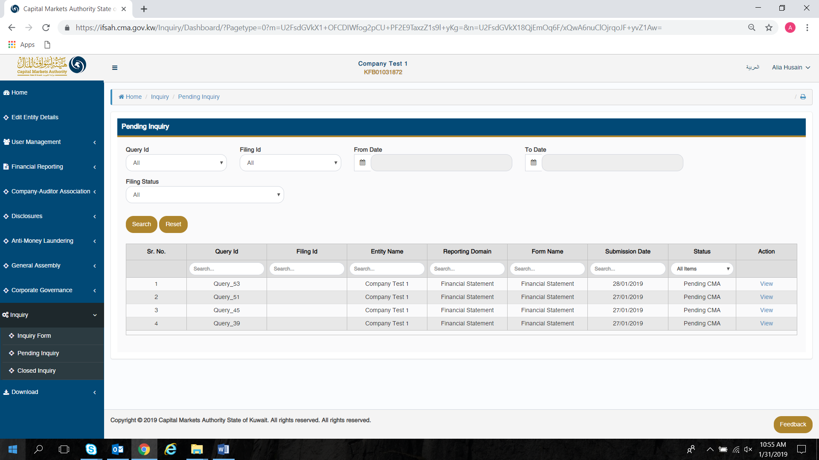

The CSU can review all closed inquiries in a tabular format, while filtering which filing to view based on the following criteria:

* Query Id
* Filing Id
* From Date
* To Date
* Filing Status



