**CMA’s XBRL Based Electronic Filing Platform**

**IFSAH**

**Frequently Asked Questions**

**Registration**

Version 1.0



Contents

Users Registration and Accessibility 3

Can the Company Super User (CSU) or Company User (CU) in the fund manager's account also serve as users for the fund itself? 3

Can the Company Super User (CSU) or Company User (CU) access the system as an individual? 3

Should each company user (CU) register individually, or is user registration managed by the Company Super User (Admin User)? 3

Is the legal representative of the fund manager the same as the legal representative of the fund? 4

Funds under Liquidation 5

Is a fund under liquidation linked to an auditor? 5

A fund under liquidation does not have an executive committee or objectives. Is it possible to leave these sections unfilled? 5

# Users Registration and Accessibility

## Can the Company Super User (CSU) or Company User (CU) in the fund manager's account also serve as users for the fund itself?

**Answer:** No, the Company Super User (CSU) or Company User (CU) in the fund manager's account cannot also serve as users for the fund itself. Each entity—the fund manager and the fund—must have distinct users with separate credentials to ensure clear separation of roles and compliance with regulatory standards. This distinction is crucial because both the fund manager and the fund will be making submissions on behalf of their respective entities. However, the fund manager still has the ability to view the funds it manages, ensuring effective oversight while preserving distinct operational responsibilities.

## Can the Company Super User (CSU) or Company User (CU) access the system as an individual?

**Answer:** Yes, the CSU or CU can access the system as an individual. To do so, the user must first register as an individual using the same email address by visiting the [individual registration](https://ifsah.cma.gov.kw/selfuserreg) page and completing the form. Once registered, the user can choose their role on the landing login page. To access the company role, the user selects "Company / Fund / Auditor," and to access the individual role, the user selects "Individual." This allows the same user to switch between different roles within the system.

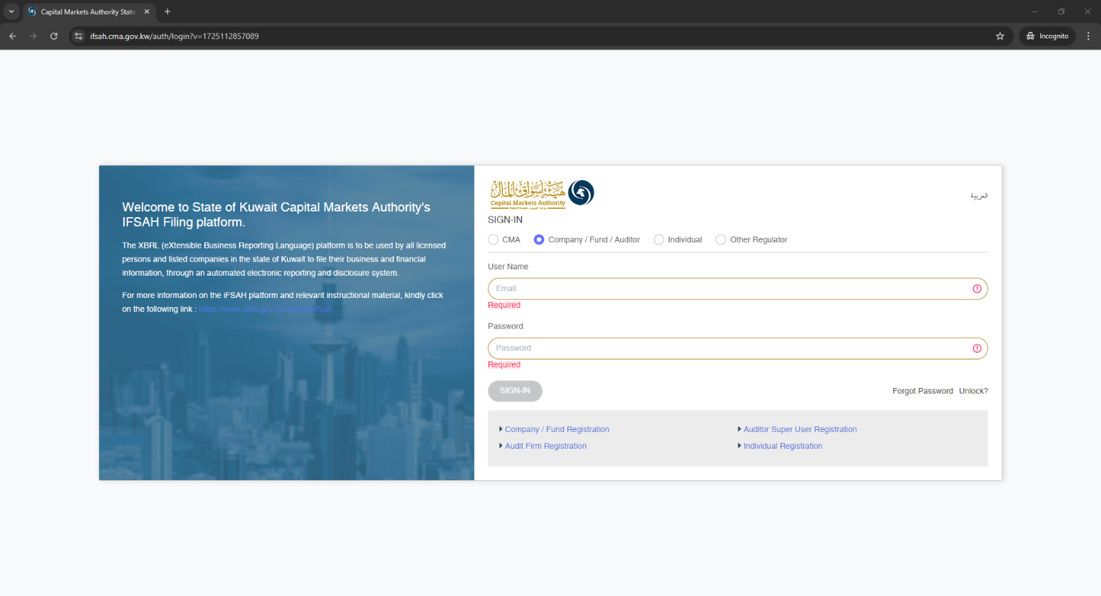

## Should each company user (CU) register individually, or is user registration managed by the Company Super User (Admin User)?

**Answer:** The Company Super User (Admin User) can only manage the registration of users within the company by setting up accounts and assigning roles as needed. The Super User can do this by navigating through the home bar to the "Add/Edit User" section, where they fill in the required fields and user information. Once the user is added, they will receive an activation email. After setting their password, the user can then access the IFSAH Portal.

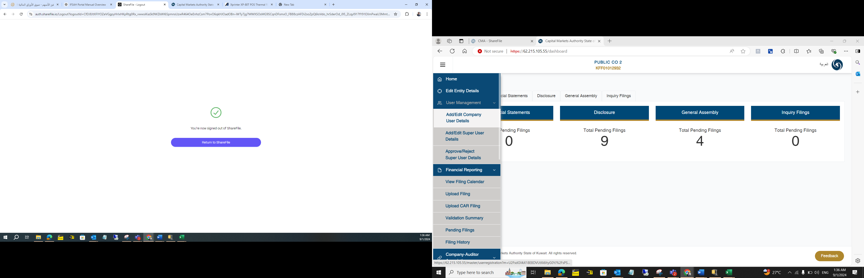

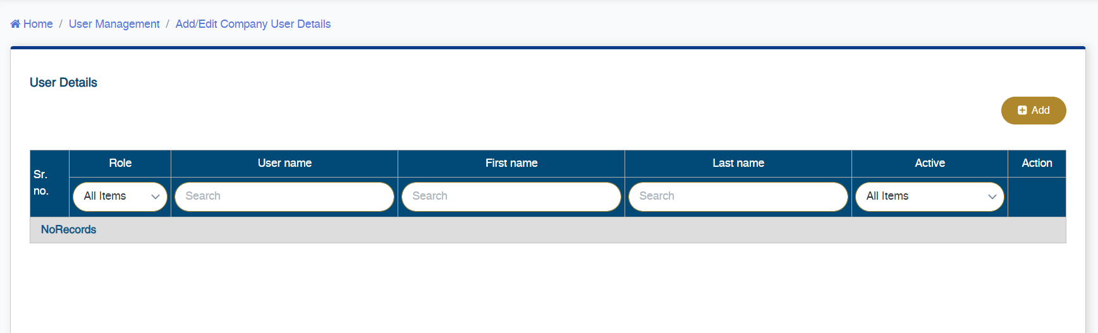

## Is the legal representative of the fund manager the same as the legal representative of the fund?

**Answer:** No, the legal representative of the fund manager is not necessarily the same as the legal representative of the fund. Each entity typically has its own designated legal representative to ensure clear and distinct responsibilities and compliance with regulatory requirements.

# Funds under Liquidation

## Is a fund under liquidation linked to an auditor?

**Answer:** Yes, a fund under liquidation has its own account like any other fund. It is required to submit financial statements as per its bylaws and must be associated with an auditor to validate these financials.

## A fund under liquidation does not have an executive committee or objectives. Is it possible to leave these sections unfilled?

**Answer:** Yes, these sections are not required for a fund under liquidation. These sections are mandatory only for licensed funds. There are two scenarios to consider:

1. **Changing from Licensed Fund to Under Liquidation:** If a fund transitions from being licensed to under liquidation, the executive committee and objectives will be locked with the previous information from when the fund was licensed.
2. **Direct Registration Under Liquidation:** If the fund is registering directly as under liquidation, these sections will be required to fill initially, but it will be locked while remaining empty.